Lesson 14 Practice Problems
- Lin is working on a science experiment. She wants to determine whether salt water boils faster than freshwater. She collects 10 samples of 100 milliliters of salt water and 10 samples of 100 milliliters of freshwater. She places each sample in a beaker on a hot plate. She then records the time it takes to boil for each group and find that the difference in mean times for the groups is 24 seconds.
- Lin writes a computer program to recombine all the data into all 184,756 possible different groupings and finds that 4,008 of the different groupings have a difference in means of at least 24 grams. Is there enough evidence for Lin to conclude that the difference in means is due to the addition of salt to the water? Explain or show your reasoning.
- A company produces 10,000 plastic toys each day. A sample of 25 toys are analyzed, and 2 of them are found to not meet the standards of the company, so they are labeled defective. A simulation is run in which 25 toys are chosen out of 10,000 so that each toy chosen has an 8% chance of being defective. The simulation is run 200 times, and the mean proportion of defective toy is 0.081 with a standard deviation of 0.007.
  - What is the margin of error based on this simulation?
  - Based on a population proportion estimate and margin of error, is 0.091 a plausible value for the population proportion of toys that are defective? Explain your reasoning.
- (From Unit 7, Lesson 10.)
- Technology required
- Researchers are tagging sharks using two different types of devices and want to know if the devices affect the heart rate of the sharks. They tag one group of 8 sharks with a small device that collects a small amount of data and they tag another group of 8 sharks with a larger device that collects a large amount of data. They then measure the mean heart rate of the different groups and find that the difference in means is 2.5 beats per minute.
- Researchers run 1,000 simulations regrouping the data into 2 groups at random and record the differences in means for the groups in each simulation. The histogram shows the differences in means from the simulations.
- 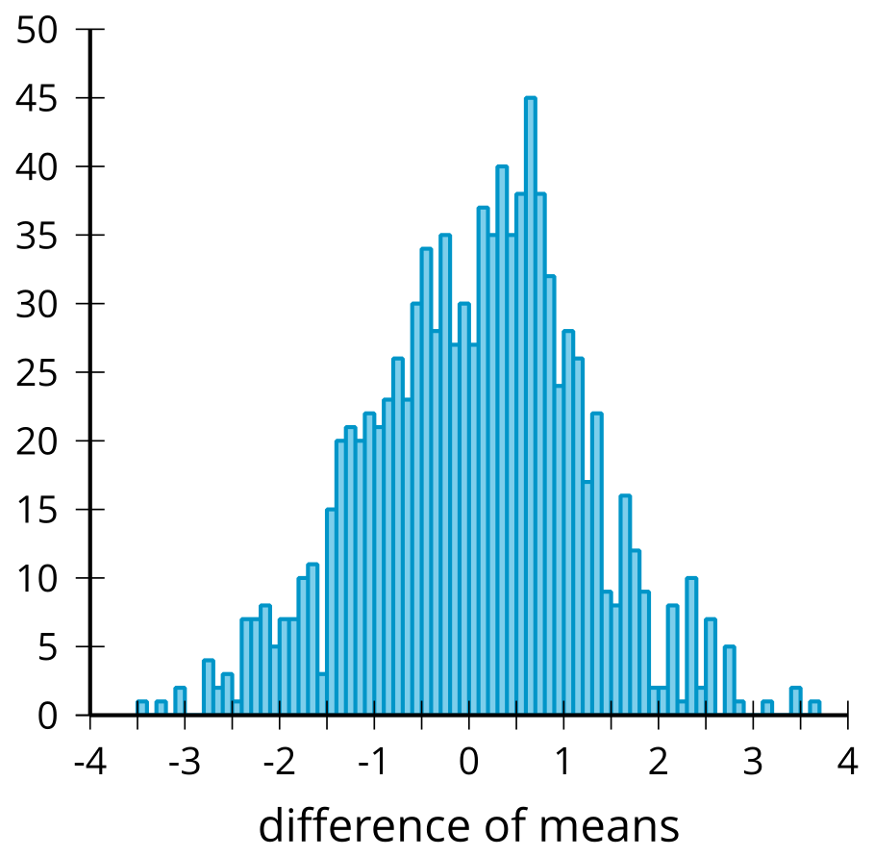
- They determine that the mean of the differences of means from the simulations is 0.028 grams and the standard deviation for the differences of means from the simulations is 1.124 grams.
  - What features of the distribution in the histogram let you know that modeling with a normal distribution is reasonable?
  - Model the simulations using a normal distribution with a mean of 0.028 and a standard deviation of 1.124. What is the area under this normal curve that is more extreme than 2.5?
  - Based on the area under the normal curve, is there evidence that the original difference in means is likely due to the type of device used to tag the sharks? Explain your reasoning.
- A human resources experiment about job satisfaction takes 10 subjects and divides them into 2 groups using a random process. The control group contains 5 subjects and the treatment group contains 5 subjects. Each group is asked to rate their job satisfaction on a scale from 1 to 10. The control group results in the data: 3, 7, 8, 10, and 10. The treatment group results in the data: 5, 6, 7, 7, and 9.
- Statisticians run 100 simulations regrouping the data into 2 groups at random and record the differences in means for the groups in each simulation. The histogram shows the differences in means from the simulations.
- 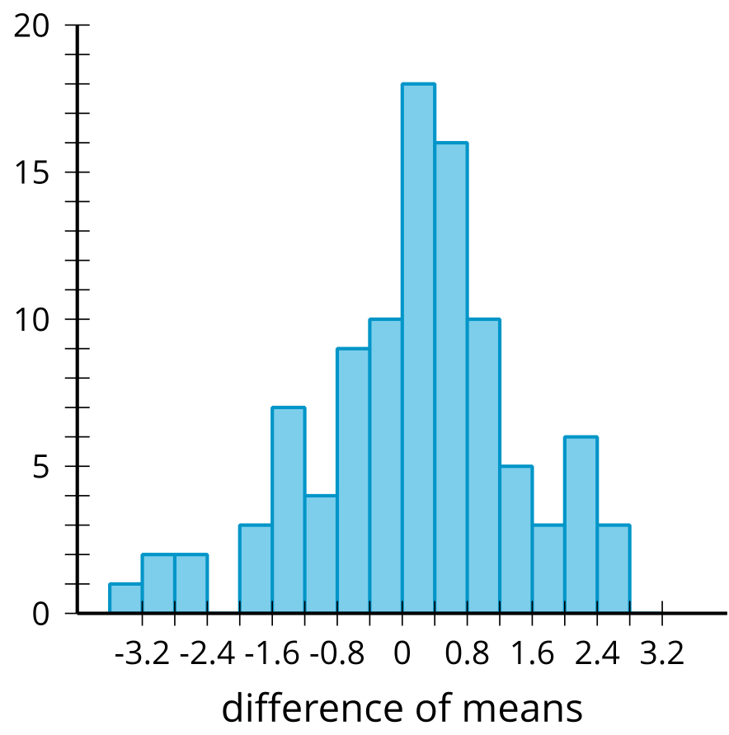
  - What is the difference in means between the two groups?
  - What proportion of the difference in means from the simulation have a difference at least as great as the difference in means between the control and treatment groups?
  - Is there enough evidence to support a claim that the original difference in means is likely due to the treatment?
- A plant company is growing plants in the laboratory using their regular soil mix and a new soil mix. The company wants to know which process causes the plants to grow taller at the end of 2 months. The mean height of the 25 plants grown using the regular soil mix is 14.6 inches. The mean height of the 25 plants grown using the new soil mix is 15.1 inches. The company's statistician uses simulations to get a randomization distribution to determine if the results happened by chance. The randomization distribution is displayed in the histogram.
- 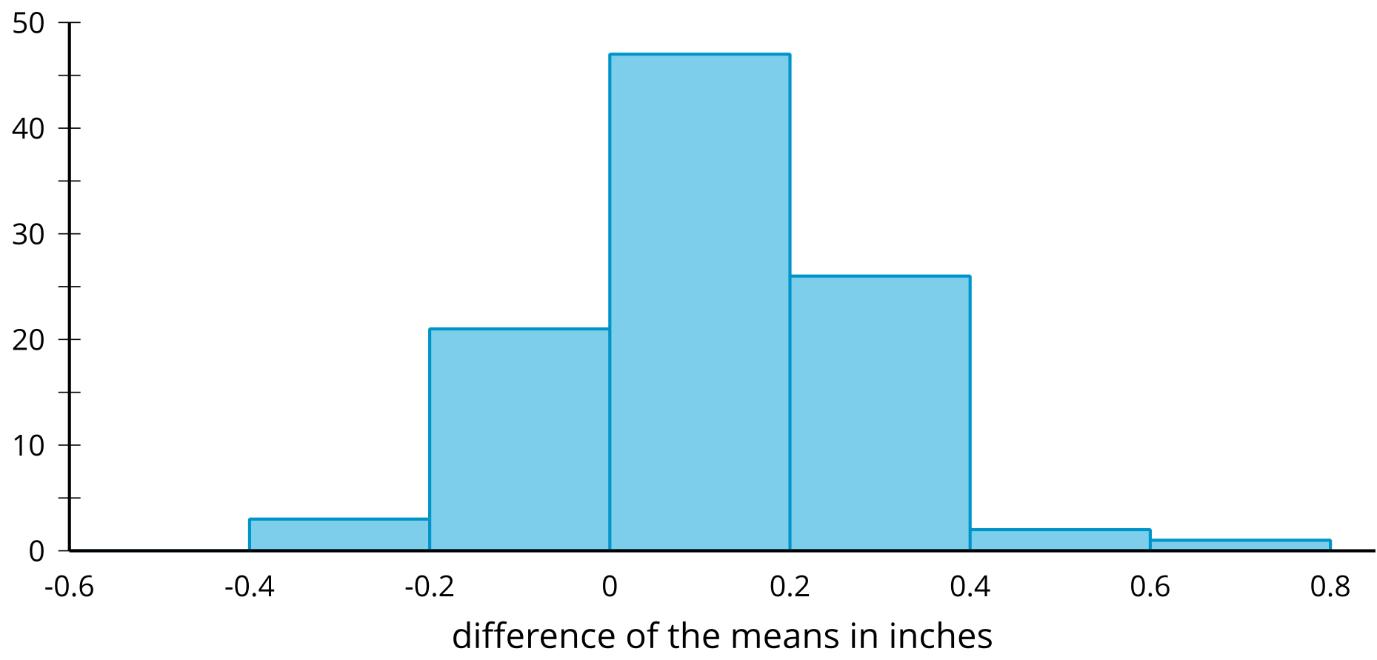
- Is it reasonable to conclude that the mean difference between the 2 groups occurred by chance? Explain your reasoning.
- (From Unit 7, Lesson 13.)
- The histogram displays the results from 100 simulations of redistributing data from an experiment to create a randomization distribution comparing the weight, in milligrams, of two different groups.
- 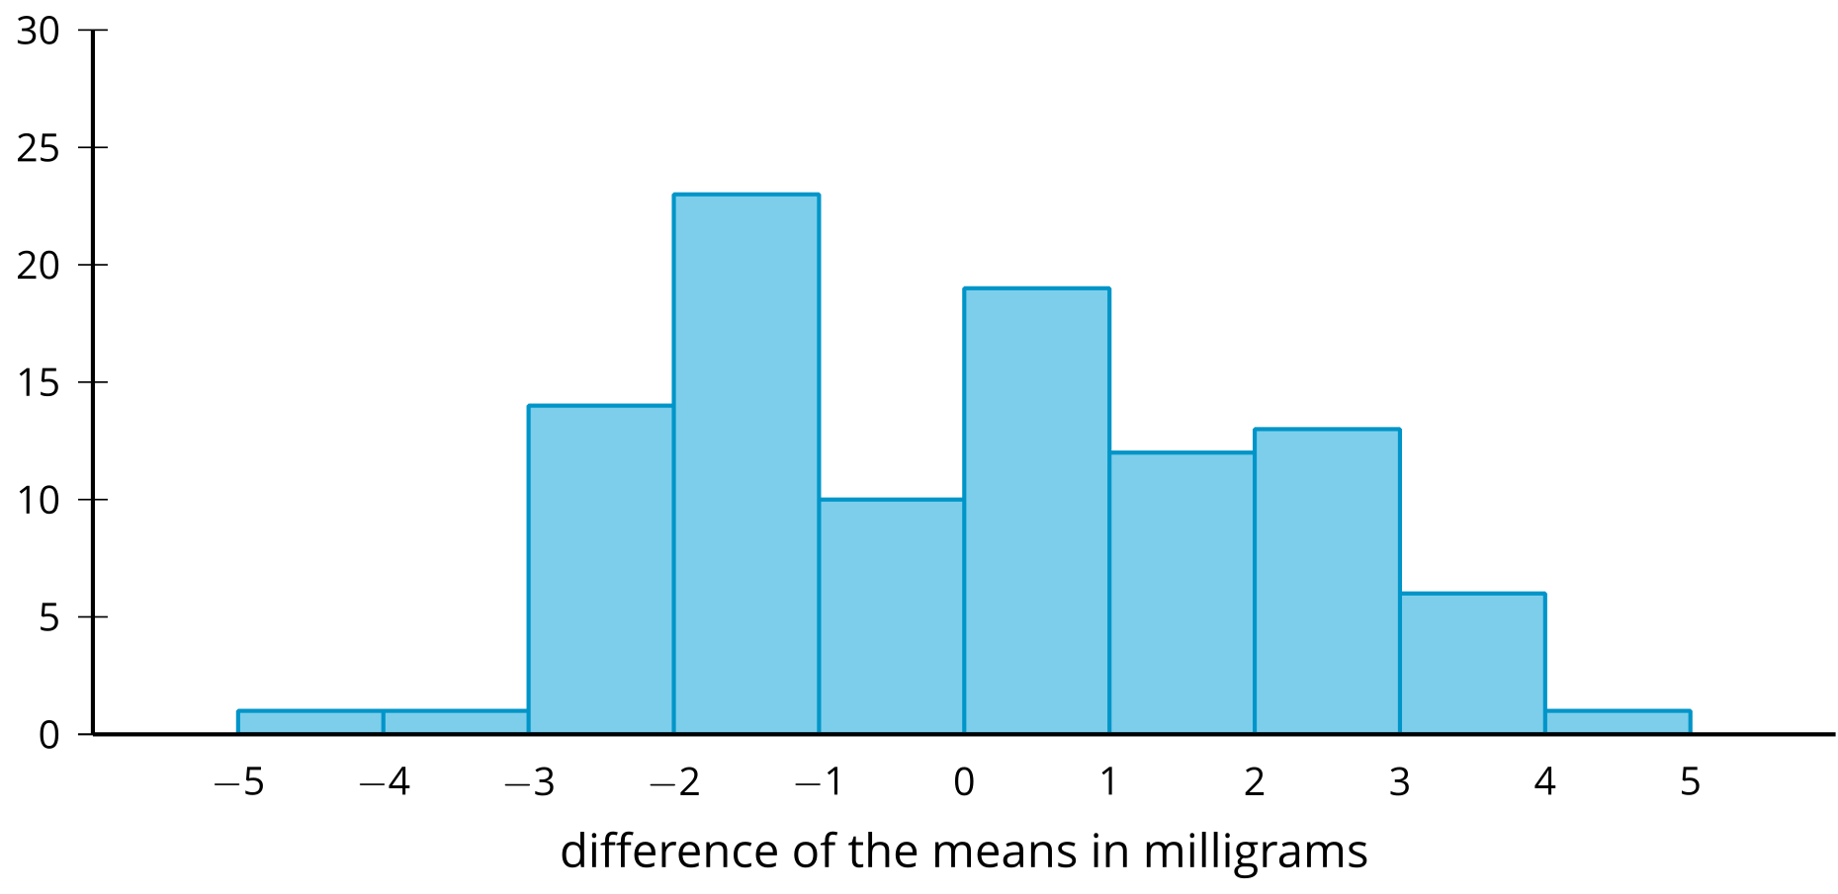
- The difference between the mean weights of the two groups being studied is 1.8 milligrams.
  - Use information in the histogram to support the claim that a mean difference of 1.8 milligrams is likely to occur by chance. Explain your reasoning.
  - What is a value of a mean difference that would be unlikely to occur by chance?
- (From Unit 7, Lesson 13.)
© CC BY 2019 by Illustrative Mathematics®

