Lesson 20 Practice Problems

  - Draw a line that you think is a good fit for this data. For this data, the inputs are the horizontal values, and the outputs are the vertical values.
  - 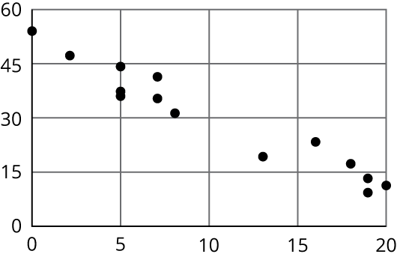
  - Use your line of fit to estimate what you would expect the output value to be when the input is 10.
- Here is a scatter plot that shows the most popular videos in a 10-year span.
- 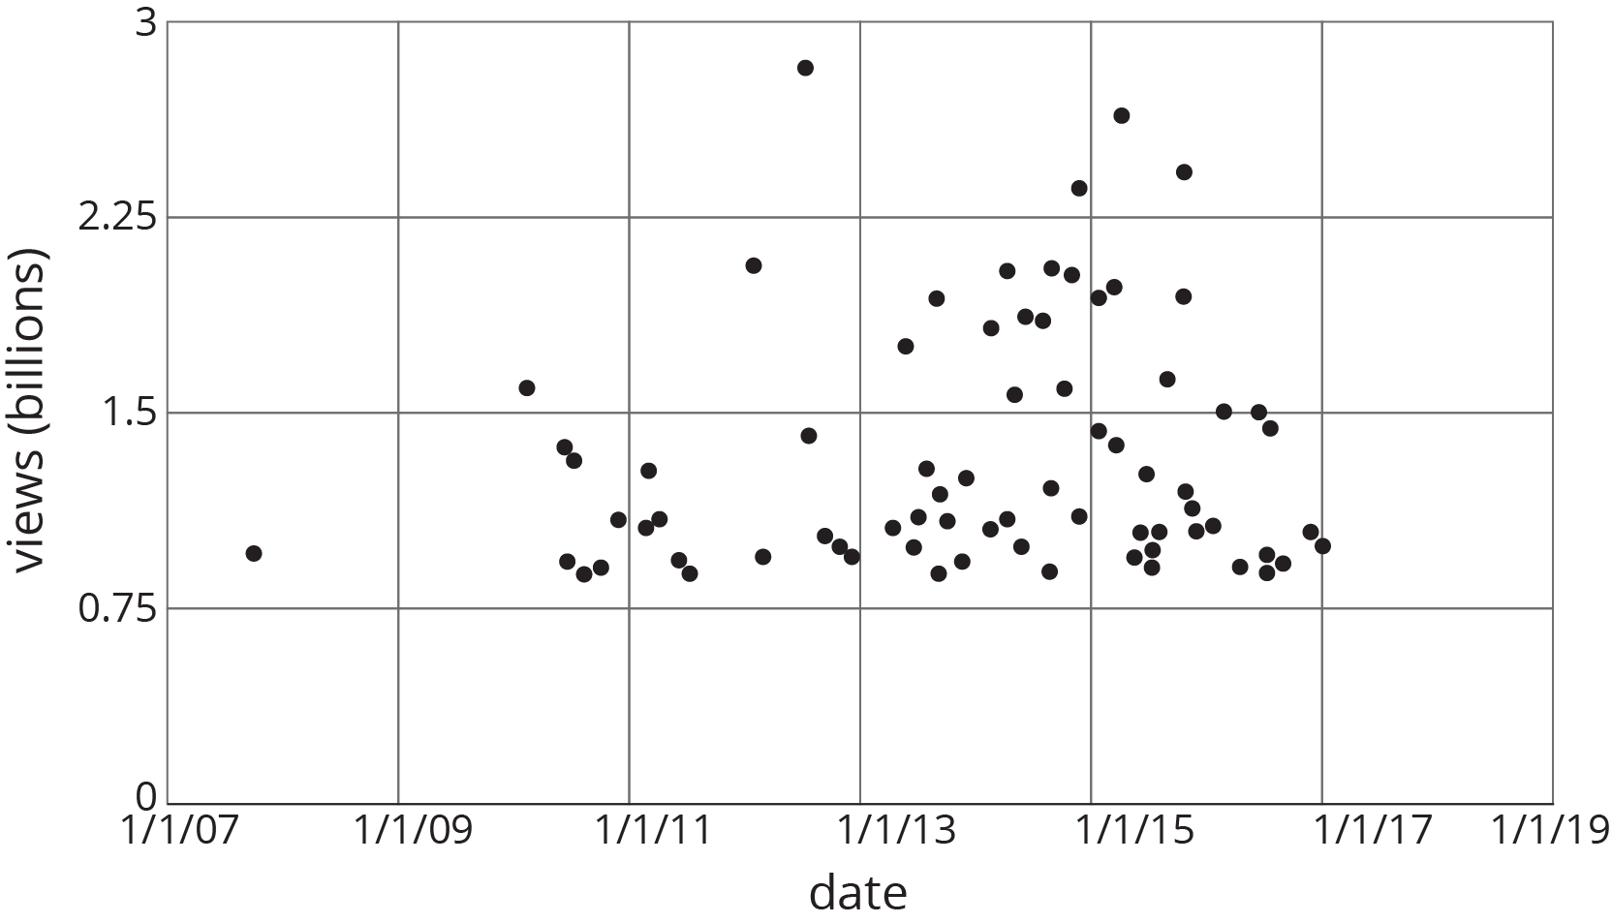
  - Use the scatter plot to estimate the number of views for the most popular video in this 10-year span.
  - Estimate when the 4th most popular video was released.
- (From Unit 5, Lesson 18.)
- Here are Circles $c$ and $d$. Point $O$ is the center of dilation, and the dilation takes Circle $c$ to Circle $d$.
- 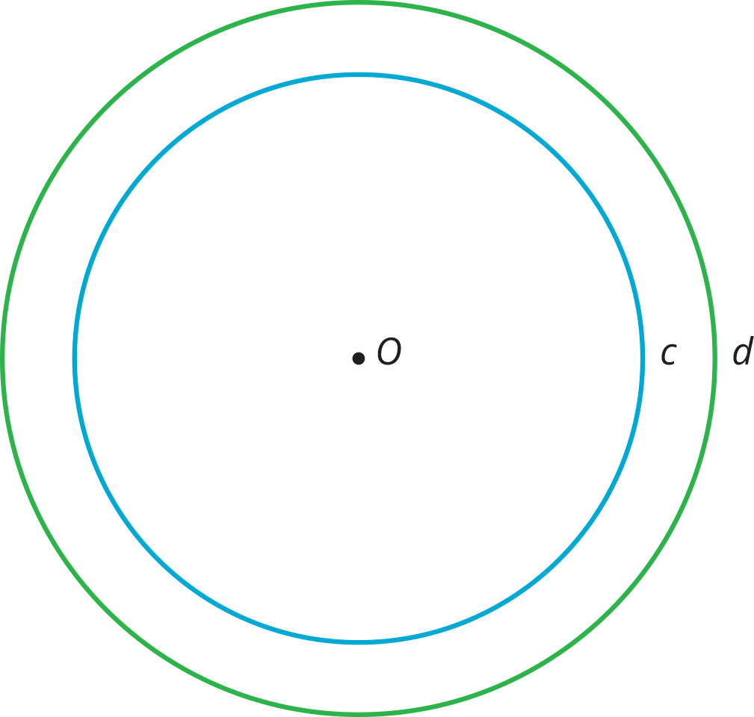

  - Plot a point on Circle $c$. Label the point $P$. Plot where $P$ goes when the dilation is applied.
  - Plot a point on Circle $d$. Label the point $Q$. Plot a point that the dilation takes to $Q$.
- (From Unit 2, Lesson 9.)
- Triangle $A$ is an isosceles triangle with two angles of measure $x$ degrees and one angle of measure $y$ degrees.
  - Find three combinations of $x$ and $y$ that make this sentence true.
  - Write an equation relating $x$ and $y$.
  - If you were to sketch the graph of this linear equation, what would its slope be? How can you interpret the slope in the context of the triangle?
- (From Unit 5, Lesson 11.)
- Mai earns $7 per hour mowing her neighbors' lawns. She also earned $14 for hauling away bags of recyclables for some neighbors.
- Priya babysits her neighbor’s children. The table shows the amount of money $m$ she earns in $h$ hours. Priya and Mai have agreed to go to the movies the weekend after they have earned the same amount of money for the same number of work hours.
- $h$ | - $m$
- 1 | - $8.40
- 2 | - $16.80
- 4 | - $33.60
  - How many hours do they each have to work before they go to the movies?
  - How much will each of them have earned?
  - Explain where the solution can be seen in tables of values, graphs, and equations that represent Priya's and Mai's hourly earnings.
- (From Unit 5, Lesson 12.)
© CC BY Open Up Resources. Adaptations CC BY IM.

