Lesson 2: Adjacent Angles
Let’s look at some special pairs of angles.

2.1: Estimating Angle Measures
Estimate the degree measure of each indicated angle.
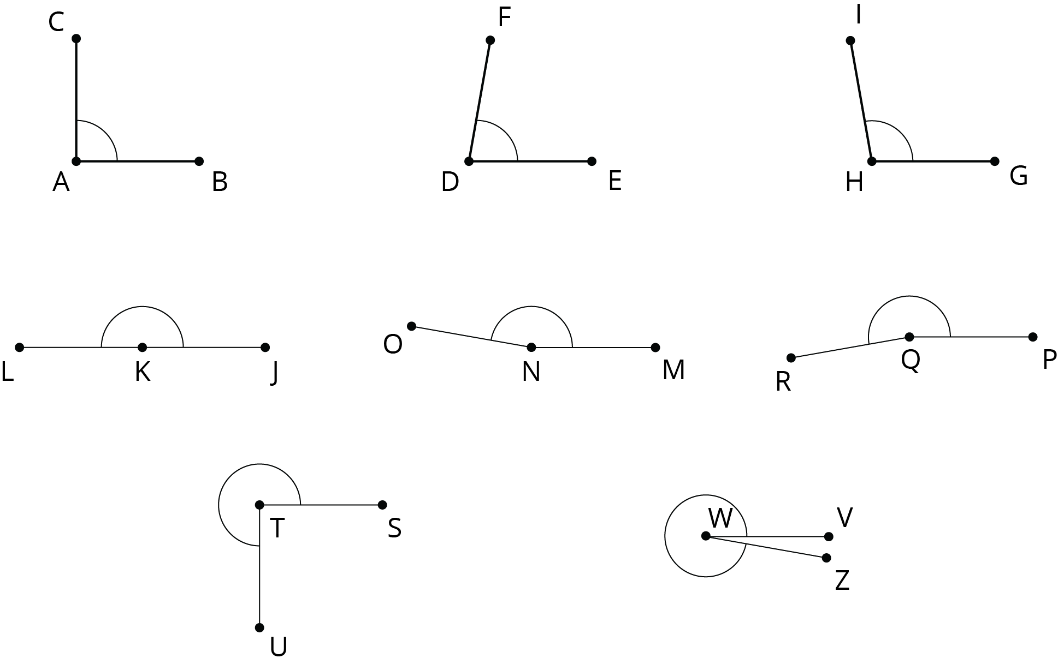

2.2: Cutting Rectangles
Your teacher will give you two small, rectangular papers.
- On one of the papers, draw a small half-circle in the middle of one side.
- Cut a straight line, starting from the center of the half-circle, all the way across the paper to make 2 separate pieces. (Your cut does not need to be perpendicular to the side of the paper.)
- On each of these two pieces, measure the angle that is marked by part of a circle. Label the angle measure on the piece.
- What do you notice about these angle measures?
- Clare measured 70 degrees on one of her pieces. Predict the angle measure of her other piece.
- On the other rectangular paper, draw a small quarter-circle in one of the corners.
- Repeat the previous steps to cut, measure, and label the two angles marked by part of a circle.
- What do you notice about these angle measures?
- Priya measured 53 degrees on one of her pieces. Predict the angle measure of her other piece.

2.3: Is It a Complement or Supplement?
- Use the protractor in the picture to find the measure of angles $BCA$ and $BCD$.
- 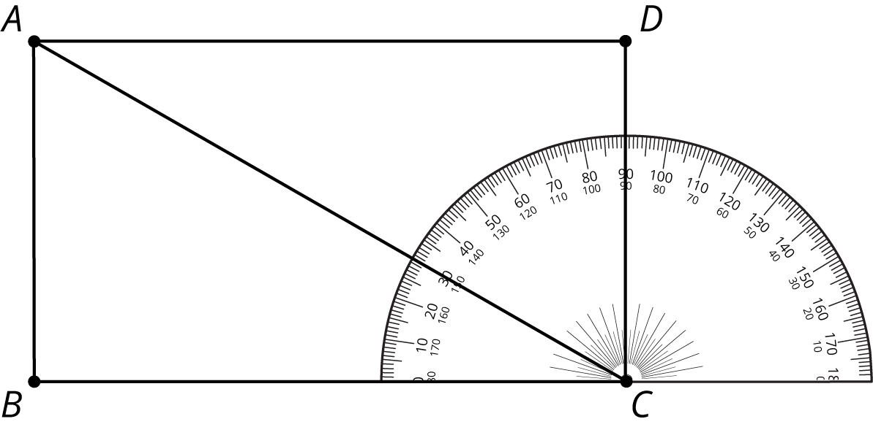
- Explain how to find the measure of angle $ACD$ without repositioning the protractor.
- Use the protractor in the picture to find the measure of angles $LOK$ and $LOM$.
- 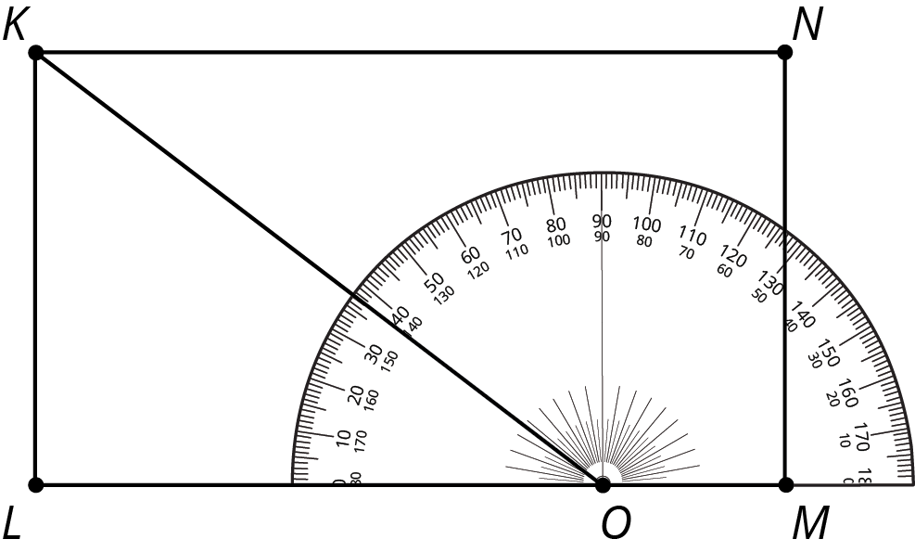
- Explain how to find the measure of angle $KOM$ without repositioning the protractor.
- Angle $BAC$ is a right angle. Find the measure of angle $CAD$.
- 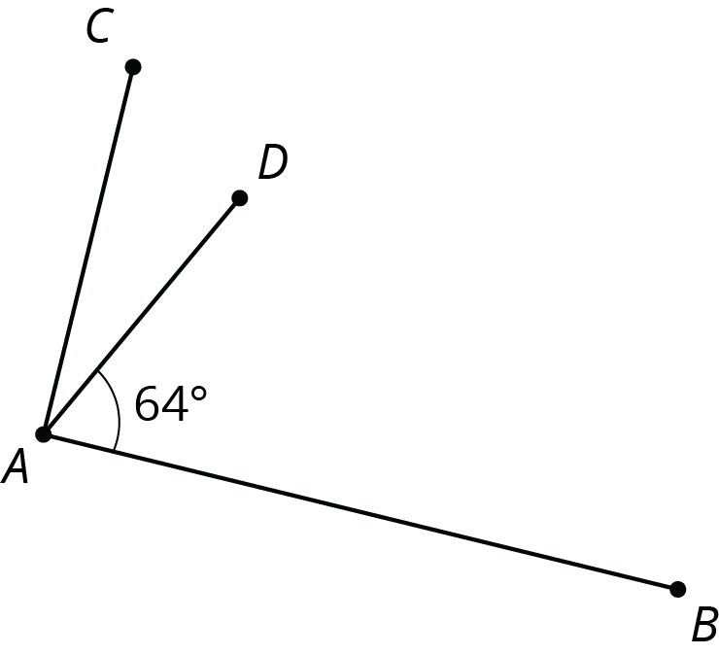
- ​​​​​
- Point $O$ is on line $RS$. Find the measure of angle $SOP$.
- 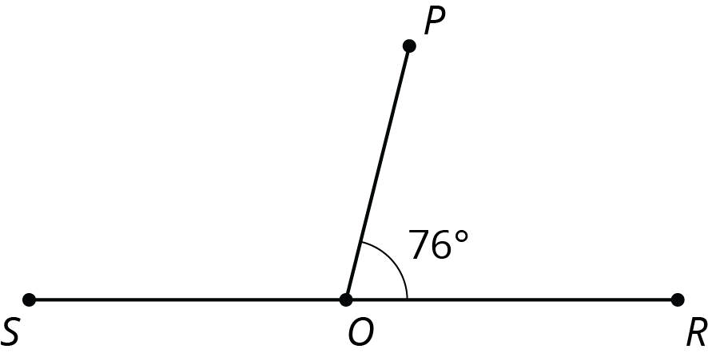

Are you ready for more?
Clare started with a rectangular piece of paper. She folded up one corner, and then folded up the other corner, as shown in the photos.
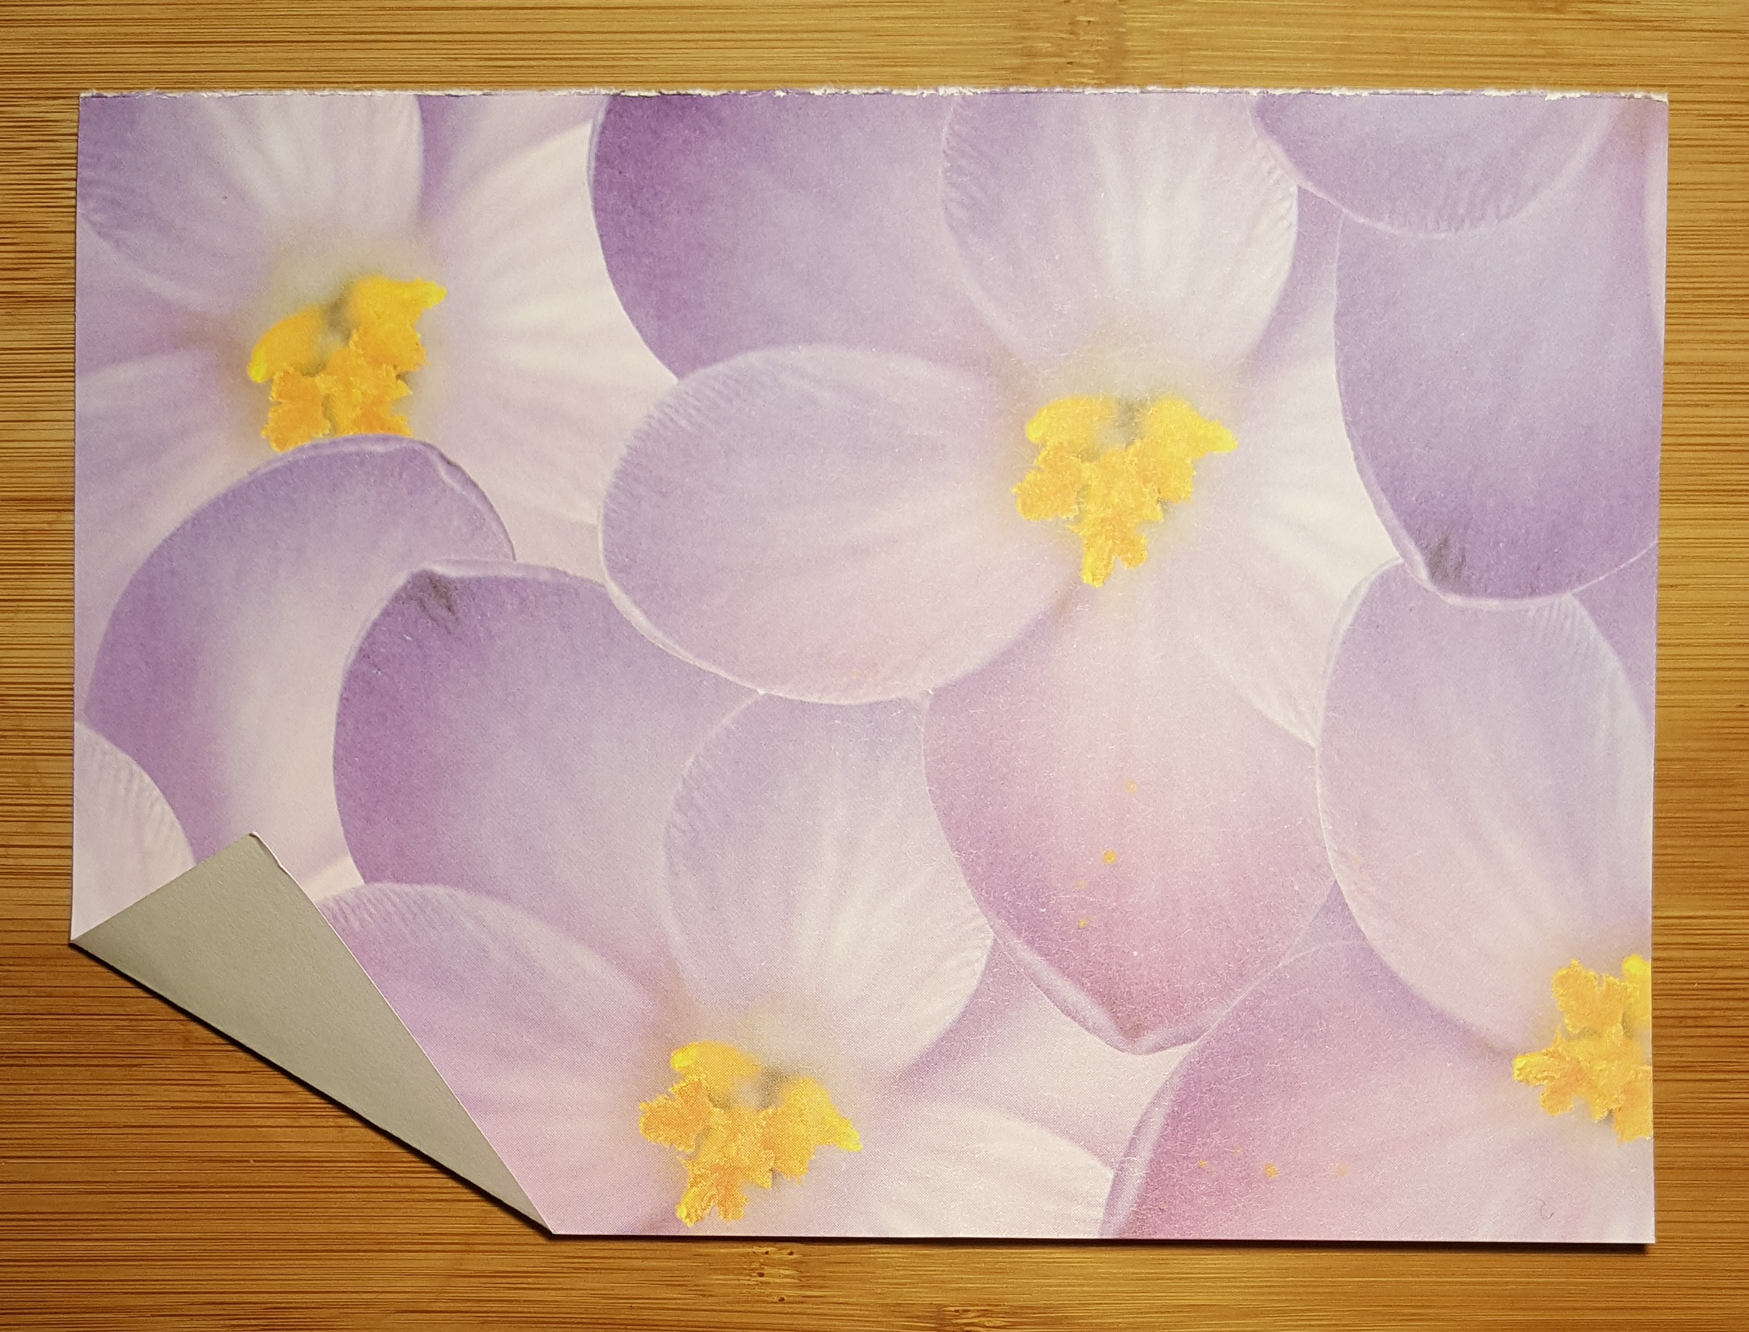
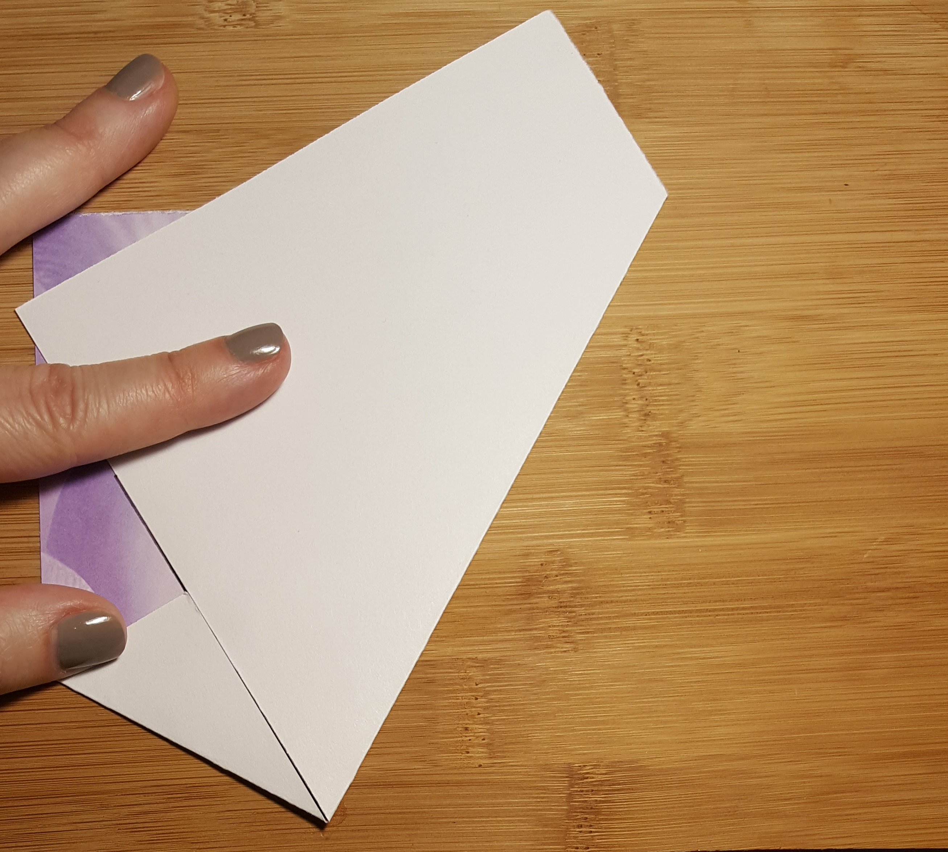
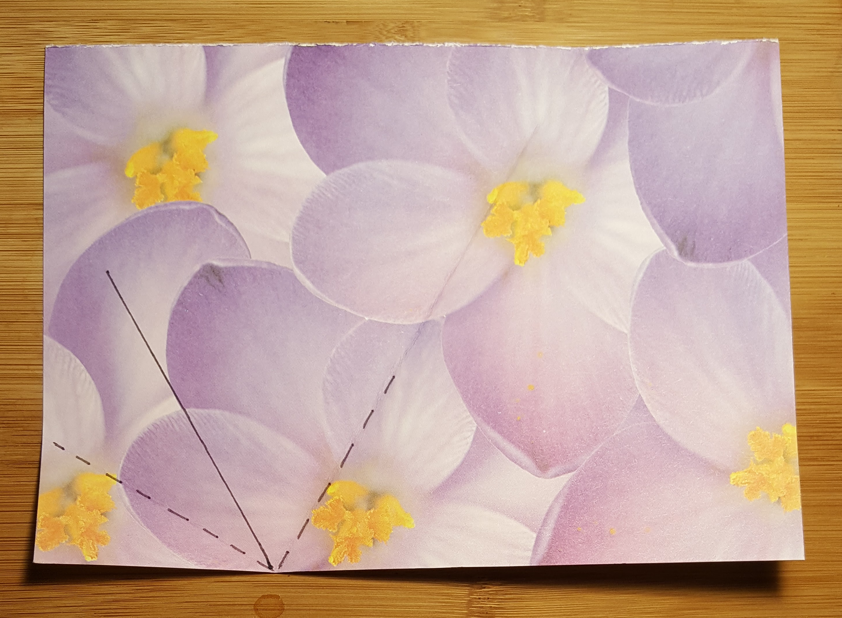
- Try this yourself with any rectangular paper. Fold the left corner up at any angle, and then fold the right corner up so that the edges of the paper meet.
- Clare thought that the angle at the bottom looked like a 90 degree angle. Does yours also look like it is 90 degrees?
- Can you explain why the bottom angle always has to be 90 degrees? Hint: the third photo shows Clare’s paper, unfolded. The crease marks have dashed lines, and the line where the two paper edges met have a solid line. Mark these on your own paper as well.

Lesson 2 Summary
If two angle measures add up to ${90}^{∘}$, then we say the angles are complementary. Here are three examples of pairs of complementary angles.
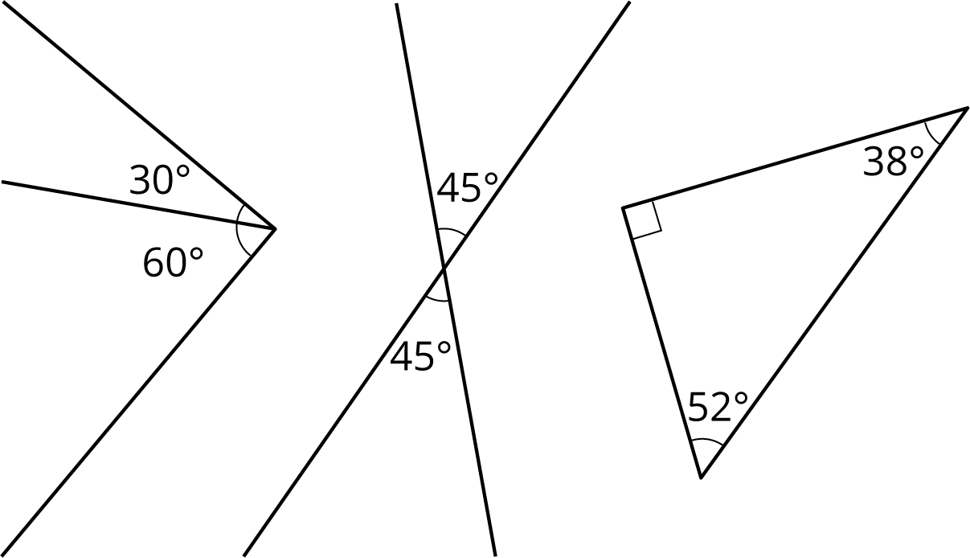
If two angle measures add up to ${180}^{∘}$, then we say the angles are supplementary. Here are three examples of pairs of supplementary angles.
© CC BY Open Up Resources. Adaptations CC BY IM.

