Unit 9 Lesson 9: Sort the Story Problems

WU Number Talk: Use Place Value to Subtract (Warm up)

Student Task Statement
Find the value of each expression mentally.
- $10−6$
- $14−6$
- $54−6$
- $54−26$

1 Card Sort: Story Problems

Student Task Statement
Sort the story problems in a way that makes sense to you.

2 Solve Story Problems

Student Task Statement
Choose one of the story problems from the first activity to solve. Show your thinking using diagrams, symbols, or other representations.

Images for Activity Synthesis
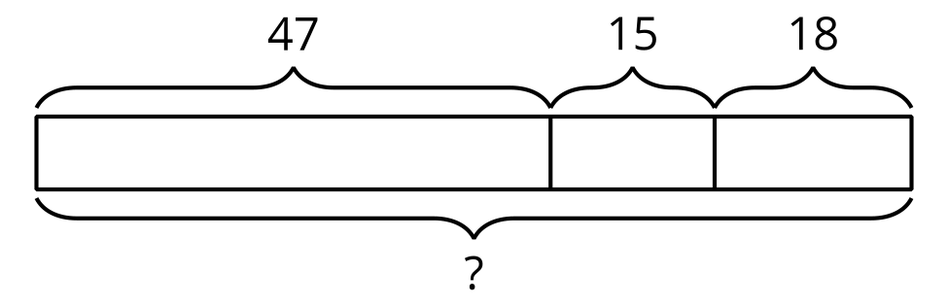
© CC BY 2021 Illustrative Mathematics®

