Lesson 3: Representing Exponential Growth
Let’s explore exponential growth.

3.1: Math Talk: Exponent Rules
Rewrite each expression as a power of 2.
$2^{3}⋅2^{4}$
$2^{5}⋅2$
$2^{10}÷2^{7}$
$2^{9}÷2$

3.2: What Does $x^{0}$ Mean?
- Complete the table. Take advantage of any patterns you notice.
- $x$ | - 4 | - 3 | - 2 | - 1 | - 0
- $3^{x}$ | - 81 | - 27
- Here are some equations. Find the solution to each equation using what you know about exponent rules. Be prepared to explain your reasoning.
  - $9^{?}⋅9^{7}=9^{7}$
  - $\frac{9^{12}}{9^{?}}=9^{12}$
- What is the value of $5^{0}$? What about $2^{0}$?

Are you ready for more?
We know, for example, that $\left(2+3\right)+5=2+\left(3+5\right)$ and $2⋅\left(3⋅5\right)=\left(2⋅3\right)⋅5$. The grouping with parentheses does not affect the value of the expression.
Is this true for exponents? That is, are the numbers $2^{\left(3^{5}\right)}$ and ${\left(2^{3}\right)}^{5}$ equal? If not, which is bigger? Which of the two would you choose as the meaning of the expression $2^{3^{5}}$ written without parentheses?

3.3: Multiplying Microbes
- In a biology lab, 500 bacteria reproduce by splitting. Every hour, on the hour, each bacterium splits into two bacteria.
  - Write an expression to show how to find the number of bacteria after each hour listed in the table.
  - Write an equation relating $n$, the number of bacteria, to $t$, the number of hours.
  - Use your equation to find $n$ when $t$ is 0. What does this value of $n$ mean in this situation?
- hour | - number of bacteria
- 0 | - 500
- 1
- 2
- 3
- 6
- t
- In a different biology lab, a population of single-cell parasites also reproduces hourly. An equation which gives the number of parasites, $p$, after $t$ hours is $p=100⋅3^{t}.$ Explain what the numbers 100 and 3 mean in this situation.

3.4: Graphing the Microbes
- Refer back to your work in the table of the previous task. Use that information and the given coordinate planes to graph the following:
- a. Graph $\left(t,n\right)$ when $t$ is 0, 1, 2, 3, and 4.
- 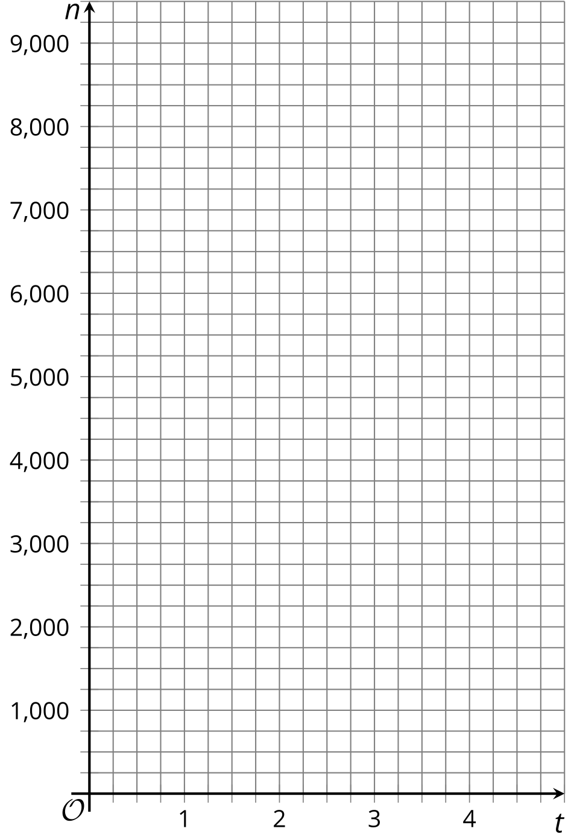
- b. Graph $\left(t,p\right)$ when $t$ is 0, 1, 2, 3, and 4. (If you get stuck, you can create a table.)
- 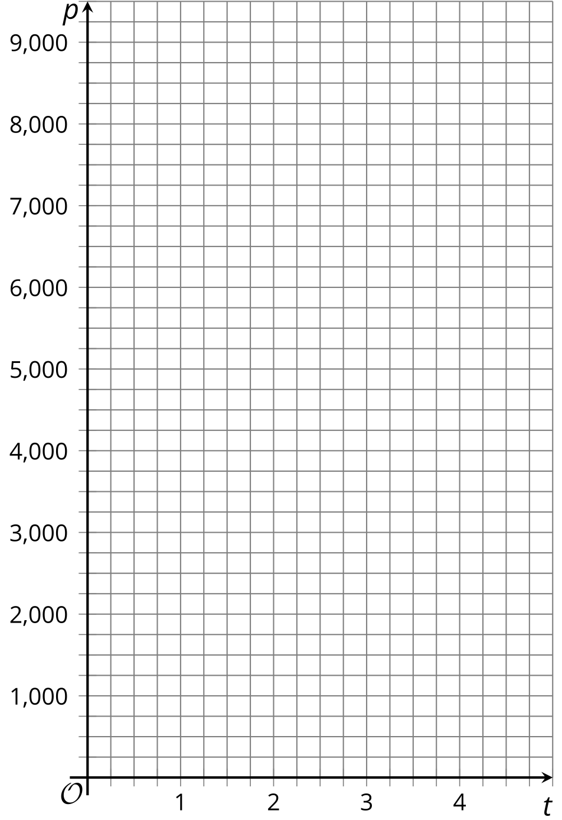
- On the graph of $n$, where can you see each number that appears in the equation?
- On the graph of $p$, where can you see each number that appears in the equation?

Lesson 3 Summary
In relationships where the change is exponential, a quantity is repeatedly multiplied by the same amount. The multiplier is called the growth factor.
Suppose a population of cells starts at 500 and triples every day. The number of cells each day can be calculated as follows:
number of days | number of cells
0 | 500
1 | 1,500 (or $500⋅3$)
2 | 4,500 (or $500⋅3⋅3$, or $500⋅3^{2}$)
3 | 13,500 (or $500⋅3⋅3⋅3$, or $500⋅3^{3}$)
$d$ | $500⋅3^{d}$
We can see that the number of cells ($p$) is changing exponentially, and that $p$ can be found by multiplying 500 by 3 as many times as the number of days ($d$) since the 500 cells were observed. The growth factor is 3. To model this situation, we can write this equation: $p=500⋅3^{d}$.
The equation can be used to find the population on any day, including day 0, when the population was first measured. On day 0, the population is $500⋅3^{0}$. Since $3^{0}=1$, this is $500⋅1$ or 500.
Here is a graph of the daily cell population. The point $\left(0,500\right)$ on the graph means that on day 0, the population starts at 500.
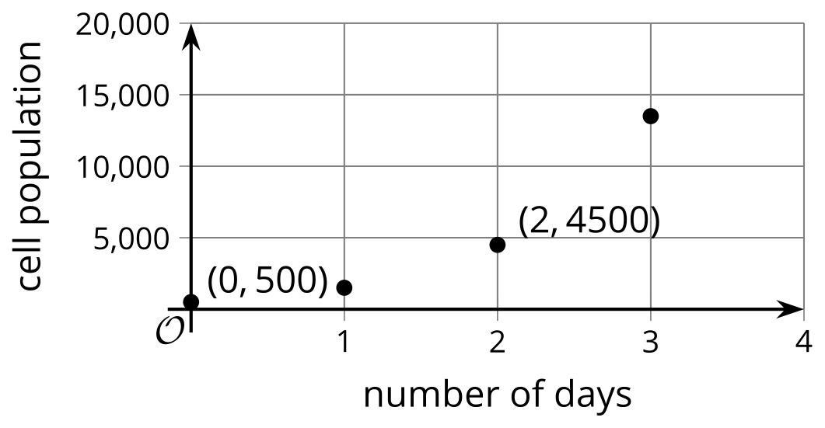
Each point is 3 times higher on the graph than the previous point. $\left(1,1500\right)$ is 3 times higher than $\left(0,500\right)$, and $\left(2,4500\right)$ is 3 times higher than $\left(1,1500\right)$.
© CC BY 2019 by Illustrative Mathematics®

