Lesson 1: Rigid Transformations in the Plane
- Let’s try transformations with coordinates.

1.1: Traversing the Plane
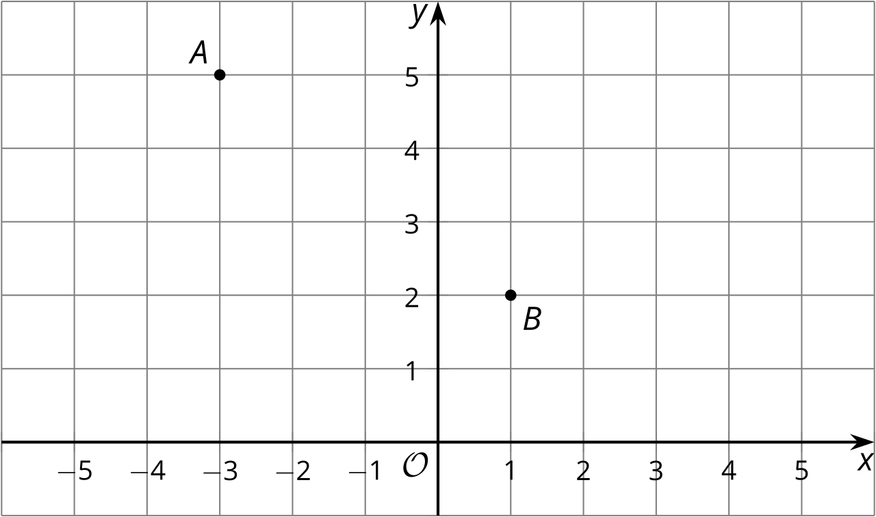
- How far is point $A$ from point $B$?
- What transformations will take point $A$ to point $B$?

1.2: Transforming with Coordinates
First, predict where each transformation will land. Next, carry out the transformation.
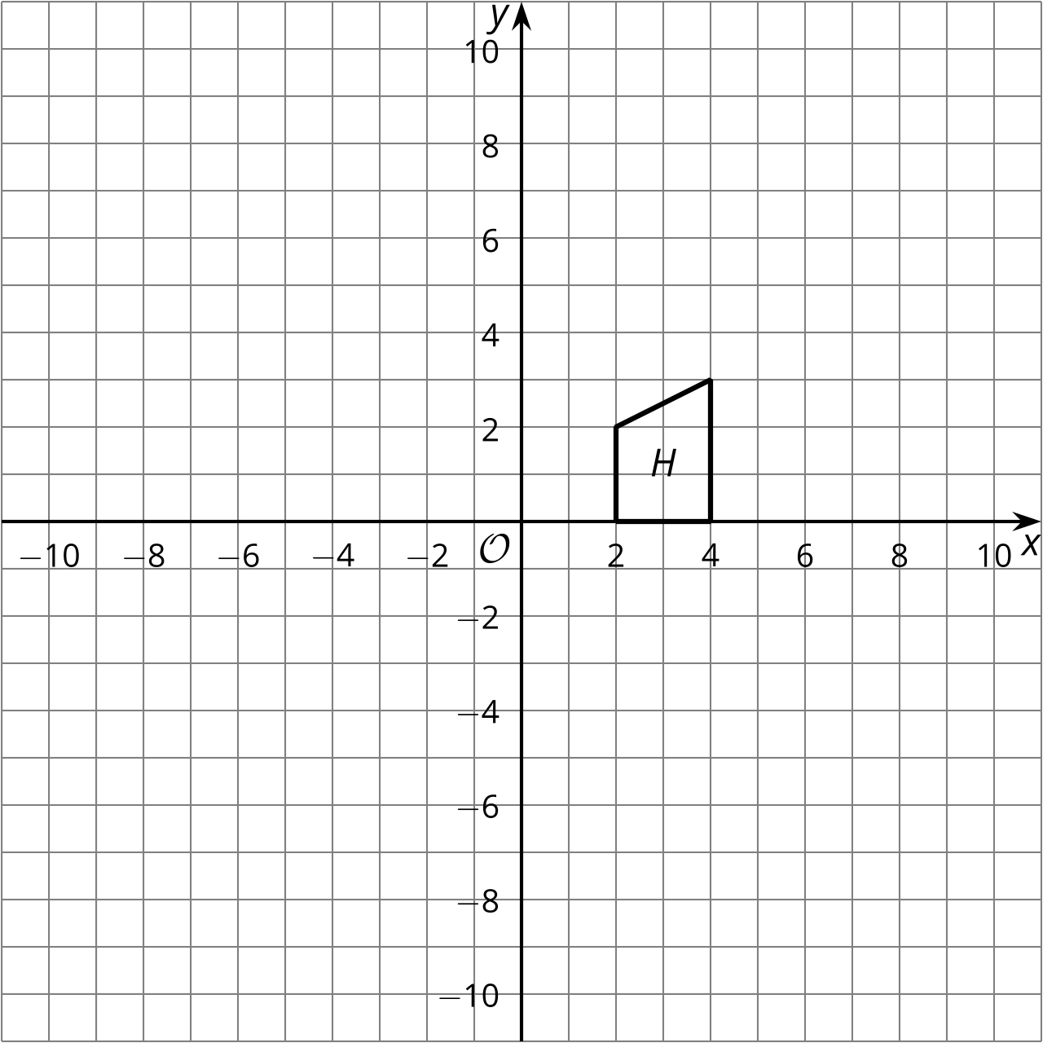
- Rotate Figure $H$ clockwise using center $\left(2,0\right)$ by 90 degrees.
Translate the image by the directed line segment from $\left(2,0\right)$ to $\left(3,\text{-}4\right)$.
Label the result $R$.
- Reflect Figure $H$ across the $y$-axis.
Rotate the image counterclockwise using center $\left(0,0\right)$ by 90 degrees.
Label the result $L$.

1.3: Congruent by Coordinates
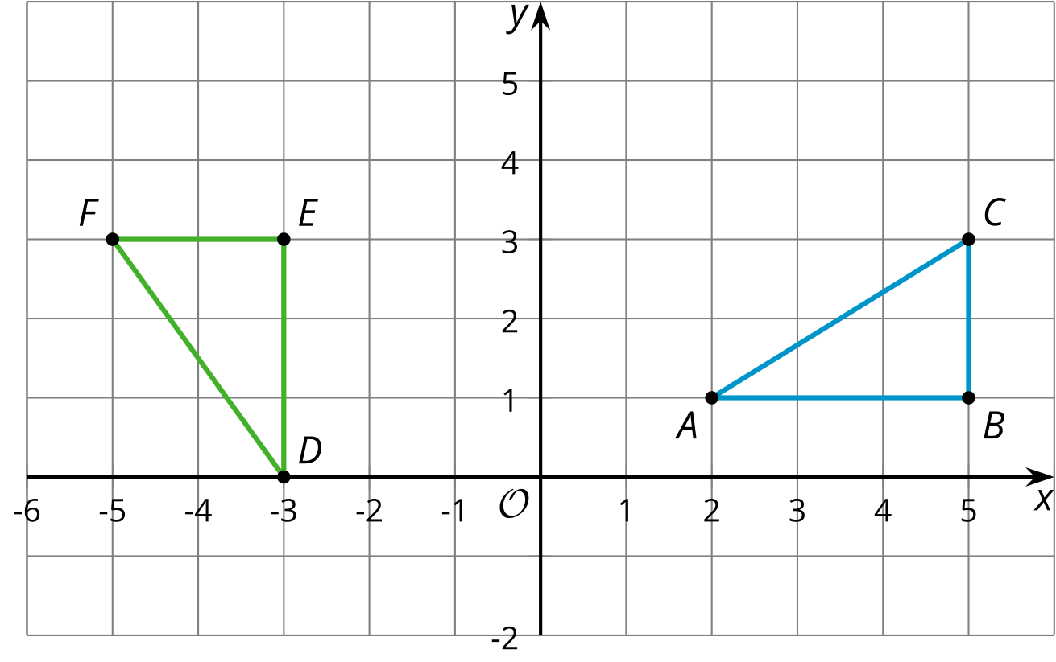
- Calculate the length of each side in triangles $ABC$ and $DEF$.
- Calculate the measure of each angle in triangles $ABC$ and $DEF$.
- The triangles are congruent. How do you know this is true?
- Because the triangles are congruent, there must be a sequence of rigid motions that takes one to the other. Find a sequence of rigid motions that takes triangle $ABC$ to triangle $DEF$.

Are you ready for more?
What single transformation would take triangle $ABC$ to triangle $DEF$?

Lesson 1 Summary
The triangles shown here look like they might be congruent. Since we know the coordinates of all the vertices, we can compare lengths using the Pythagorean Theorem. The length of segment $AB$ is $\sqrt{13}$ units because the segment is the hypotenuse of a right triangle with vertical side length 3 units and horizontal side length 2 units. The length of segment $DE$ is $\sqrt{13}$ units as well, because this segment is also the hypotenuse of a right triangle with leg lengths 3 and 2 units.
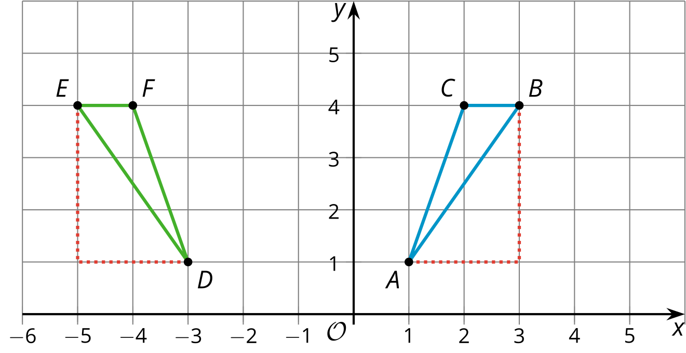
The other sides of the triangles are congruent as well: The lengths of segments $BC$ and $FE$ are 1 unit each, and the lengths of segments $AC$ and $DF$ are each $\sqrt{10}$ units, because they are both hypotenuses of right triangles with leg lengths 1 and 3 units. So triangle $ABC$ is congruent to triangle $DEF$ by the Side-Side-Side Triangle Congruence Theorem.
Since triangle $ABC$ is congruent to triangle $DEF$, there is a sequence of rigid motions that takes triangle $ABC$ to triangle $DEF$. Here is one possible sequence: First, reflect triangle $ABC$ across the $y$-axis. Then, translate the image by the directed line segment from $\left(\text{-}1,1\right)$ to $\left(\text{-}3,1\right)$.
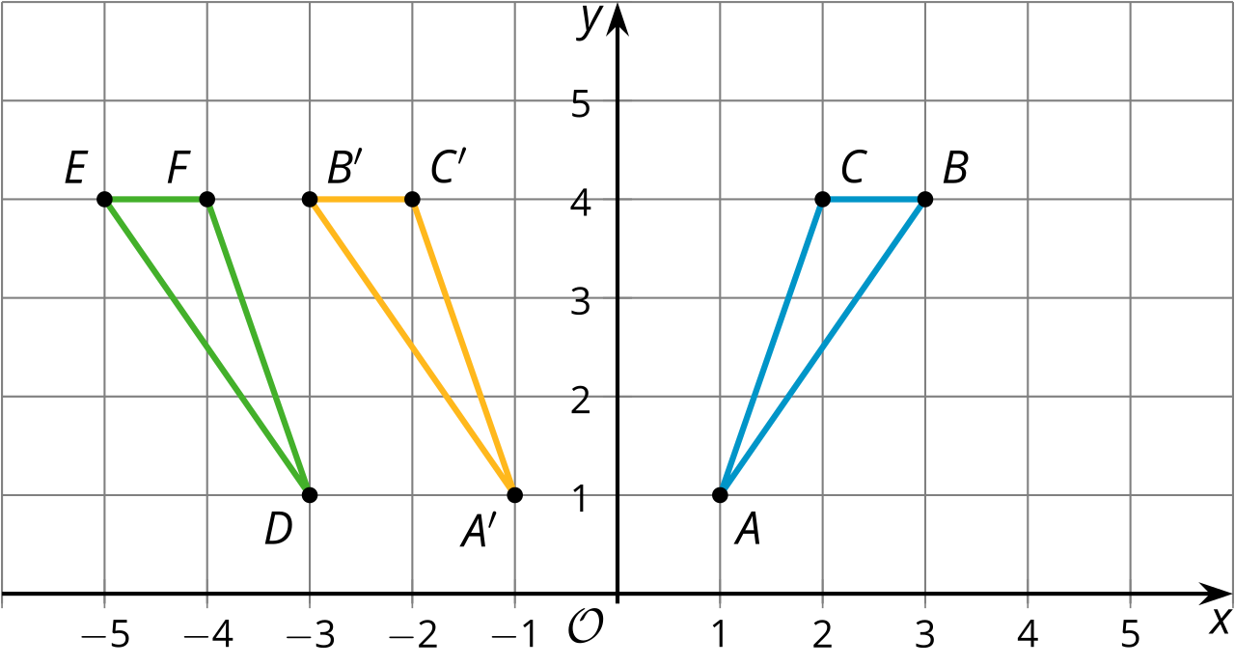
© CC BY 2019 by Illustrative Mathematics®

