Lesson 5 Practice Problems
- A rocket is launched in the air and its height, in feet, is modeled by the function $h$. Here is a graph representing $h$.
- Select all true statements about the situation.
- 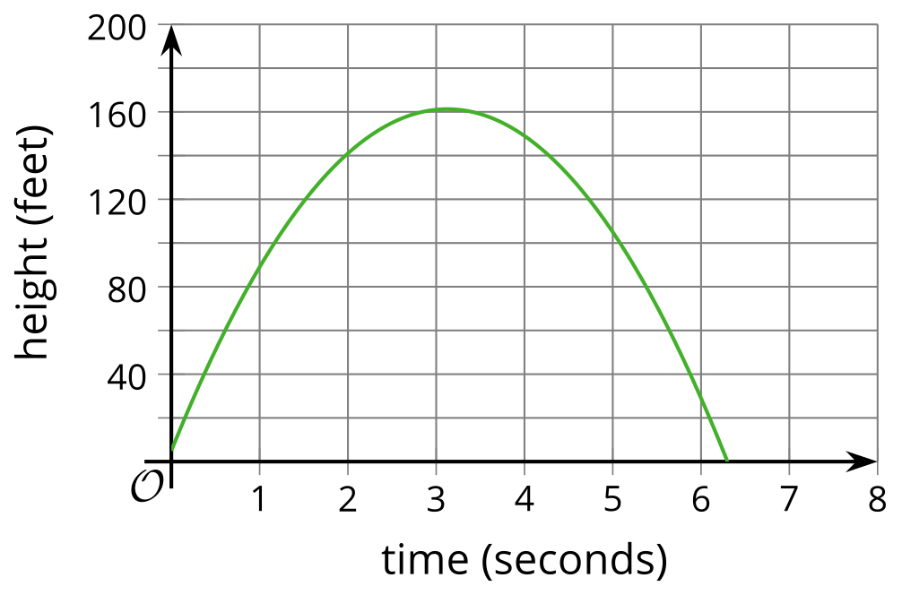
  - The rocket is launched from a height less than 20 feet above the ground.
  - The rocket is launched from about 20 feet above the ground.
  - The rocket reaches its maximum height after about 3 seconds.
  - The rocket reaches its maximum height after about 160 seconds.
  - The maximum height of the rocket is about 160 feet.
- A baseball travels $d$ meters $t$ seconds after being dropped from the top of a building. The distance traveled by the baseball can be modeled by the equation $d=5t^{2}$.
  - Complete the table and plot the data on the coordinate plane.
- $t$ (seconds) | - $d$ (meters)
  - 0
  - 0.5
  - 1
  - 1.5
  - 2
  - 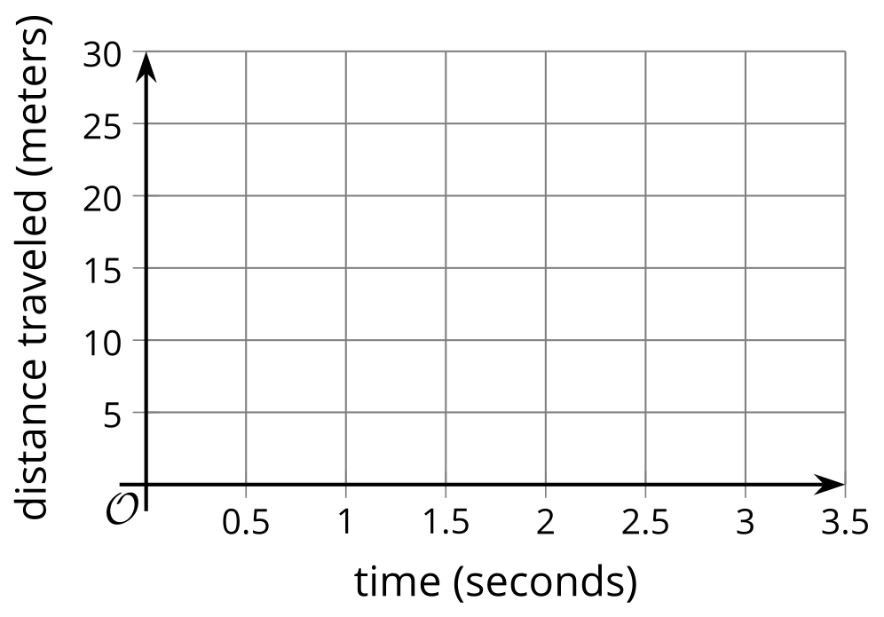
  - Is the baseball traveling at a constant speed? Explain how you know.
- A rock is dropped from a bridge over a river. Which table could represent the distance in feet fallen as a function of time in seconds?
- Table A
- time (seconds) | - distance fallen (feet)
- 0 | - 0
- 1 | - 48
- 2 | - 96
- 3 | - 144
- Table B
- time (seconds) | - distance fallen (feet)
- 0 | - 0
- 1 | - 16
- 2 | - 64
- 3 | - 144
- Table C
- time (seconds) | - distance fallen (feet)
- 0 | - 180
- 1 | - 132
- 2 | - 84
- 3 | - 36
- Table D
- time (seconds) | - distance fallen (feet)
- 0 | - 180
- 1 | - 164
- 2 | - 116
- 3 | - 36
  - Table A
  - Table B
  - Table C
  - Table D
- Determine whether $5n^{2}$ or $3^{n}$ will have the greater value when:
  - $n=1$
  - $n=3$
  - $n=5$
- (From Unit 6, Lesson 4.)
- Select all of the expressions that give the number of small squares in Step $n$.
- 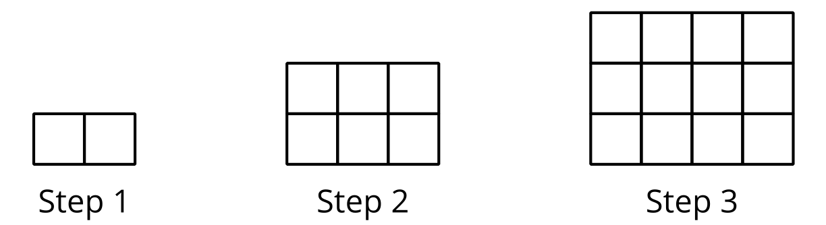
  - $2n$
  - $n^{2}$
  - $n+1$
  - $n^{2}+1$
  - $n\left(n+1\right)$
  - $n^{2}+n$
  - $n+n+1$
- (From Unit 6, Lesson 3.)
- A small ball is dropped from a tall building. Which equation could represent the ball’s height, $h$, in feet, relative to the ground, as a function of time, $t$, in seconds?
  - $h=100−16t$
  - $h=100−16t^{2}$
  - $h=100−{16}^{t}$
  - $h=100−\frac{16}{t}$
- Use the rule for function $f$ to draw its graph.
- $f\left(x\right)=\left\{\begin{matrix}2, & \text{-}5≤x<\text{-}2 \\ 6, & \text{-}2≤x<4 \\ x, & 4≤x<8\end{matrix}\right.$
- 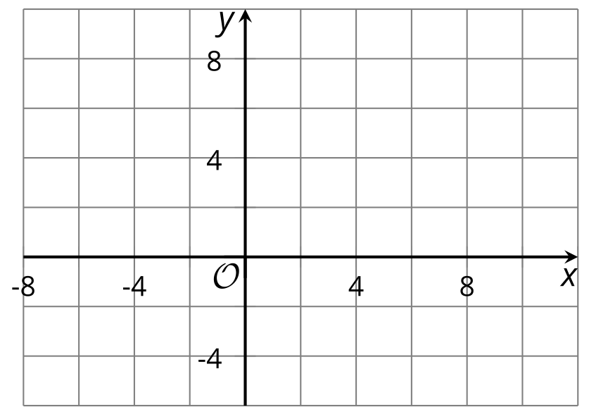
- (From Unit 4, Lesson 12.)
- Diego claimed that $10+x^{2}$ is always greater than $2^{x}$ and used this table as evidence.
- Do you agree with Diego?
- $x$ | - $10+x^{2}$ | - $2^{x}$
- 1 | - 11 | - 2
- 2 | - 14 | - 4
- 3 | - 19 | - 8
- 4 | - 26 | - 16
- (From Unit 6, Lesson 4.)
- The table shows the height, in centimeters, of the water in a swimming pool at different times since the pool started to be filled.
  - Does the height of the water increase by the same amount each minute? Explain how you know.
  - Does the height of the water increase by the same factor each minute? Explain how you know.
- minutes | - height
- 0 | - 150
- 1 | - 150.5
- 2 | - 151
- 3 | - 151.5
© CC BY 2019 by Illustrative Mathematics®

