Lesson 11 Practice Problems
- Han and Priya are studying the size of trees in the forest next to their school. They each take a random sample to find the proportion of trees that have a trunk circumference greater than 4 feet. Tyler’s sample contains 12 trees, and Priya’s sample contains 20 trees. After collecting data, they run 100 simulations each to determine an estimate for the proportion of trees with large trunk circumferences. How do you think Tyler’s reported margin of error compares to Priya’s? Explain your reasoning.
- Two reporters are both interested in finding the proportion of people in town who are unemployed. They each collect a random sample and use the proportion of unemployed people in the sample to run 100 simulations to determine a margin of error. The first reporter claims the proportion of unemployed people in town is 0.045 with a margin of error of 0.011. The second reporter claims the proportion of unemployed people in town is 0.037 with a margin of error of 0.02.
  - Why do you think the estimated proportion of unemployed people in town is different for the 2 reporters?
  - Why do you think the margin of error is different for the 2 reporters?
- An advertising agency uses a random sample of 100 television viewers and simulations to estimate the proportion of people who skip commercials when watching television is 0.653 with a margin of error of 0.082. They decide to check their results by collecting another random sample with 200 television viewers. Which of the results is most likely to be the estimates from the second random sample and simulations?
  - 0.812 with margin of error 0.01
  - 0.653 with margin of error 0.13
  - 0.664 with margin of error 0.051
  - 0.516 with margin of error 0.025
- A scientist uses a random sample of 30 electric companies and simulations from the sample to find that the proportion of electricity produced from renewable methods in the United States is 0.14 with a margin of error of 0.025. Which of these methods would be most likely to significantly reduce margin of error?
  - Run more simulations
  - Collect another sample using different electric companies
  - Collect another sample using fewer electric companies
  - Collect another sample using more electric companies
- A scientist captures bacteria samples from 100 different locations along a portion of the banks of the Mississippi River and measures the proportion of samples that are contaminated at each location. Describe how the scientist could use the data to estimate the proportion of samples of bacteria that are contaminated in the entire population along this portion of the river.
- (From Unit 7, Lesson 10.)
- This relative frequency histogram shows the distribution of daily rainfall (in centimeters) for a mountainous area over the last 50 days.
- 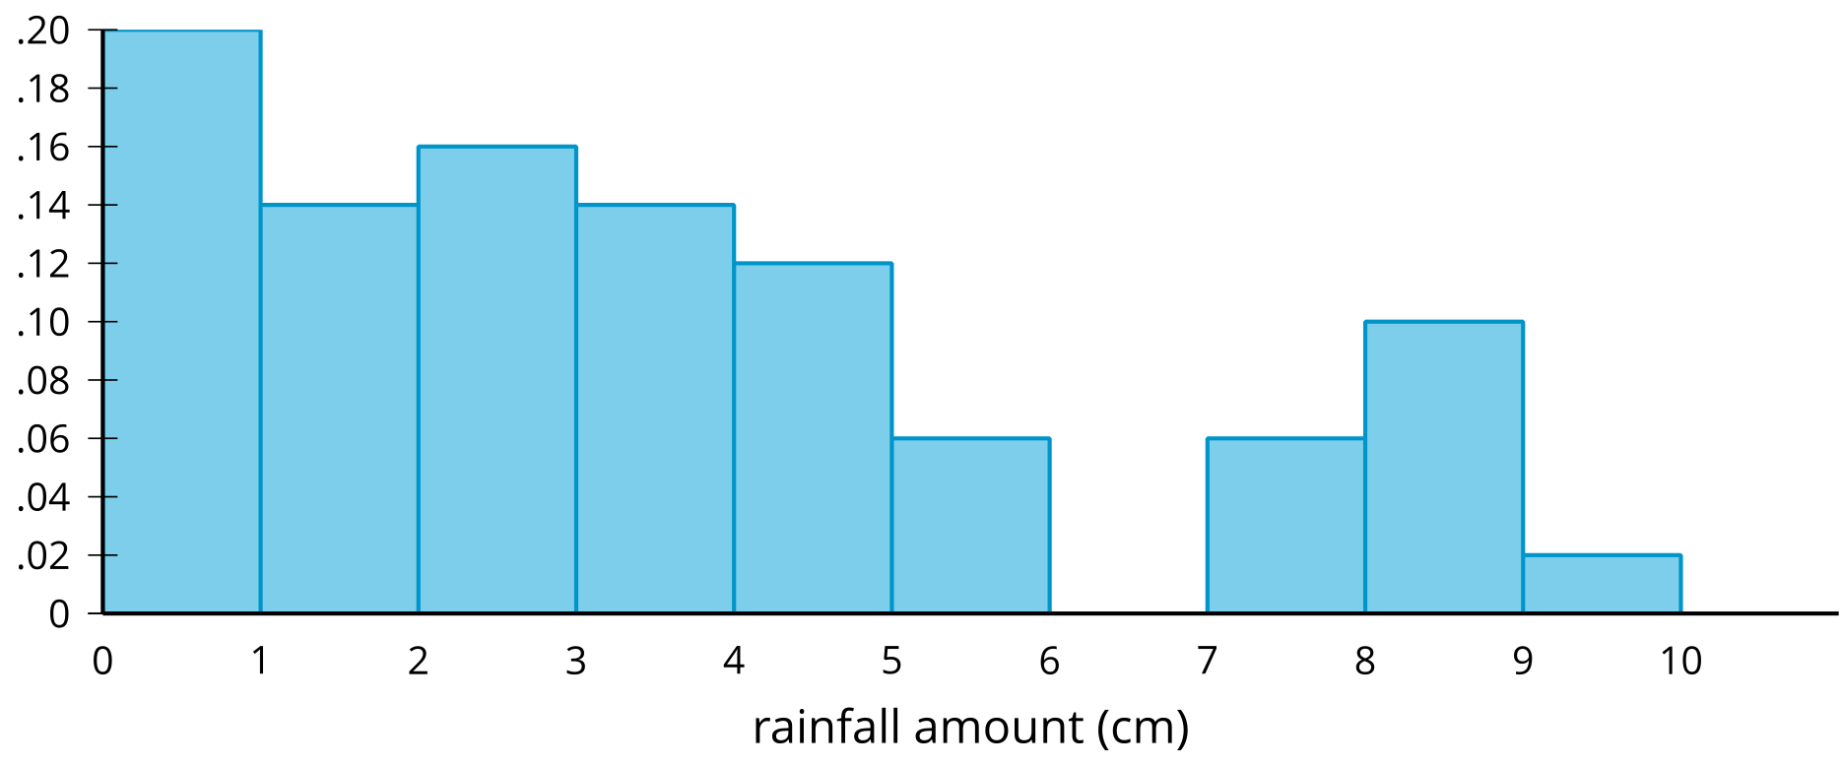
- Match each rainfall interval with the proportion of days over the 50 days whose rainfall amount fell in that interval.
  - 0 to 1 centimeter
  - 2 to 3 centimeters
  - 3 to 5 centimeters
  - 5 to 7 centimeters
  - 7 to 10 centimeters
  - 0.06
  - 0.16
  - 0.18
  - 0.2
  - 0.26
- (From Unit 7, Lesson 5.)
© CC BY 2019 by Illustrative Mathematics®

