Lesson 2 Practice Problems
- Here are several function rules. Calculate the output for each rule when you use -6 as the input.
- 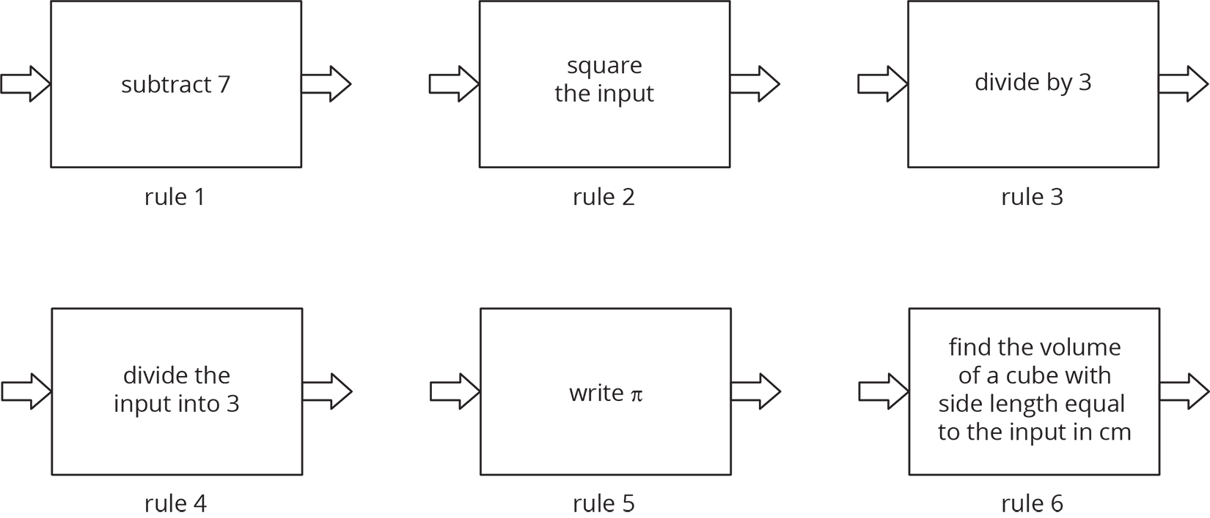
- A group of students is timed while sprinting 100 meters. Each student’s speed can be found by dividing 100 m by their time. Is each statement true or false? Explain your reasoning.
  - Speed is a function of time.
  - Time is a function of distance.
  - Speed is a function of number of students racing.
  - Time is a function of speed.
- Diego’s history teacher writes a test for the class with 26 questions. The test is worth 123 points and has two types of questions: multiple choice worth 3 points each, and essays worth 8 points each. How many essay questions are on the test? Explain or show your reasoning.

- (From Unit 5, Lesson 16.)
- These tables correspond to inputs and outputs. Which of these input and output tables could represent a function rule, and which ones could not? Explain or show your reasoning.
- Table A:
- input | - output
- -2 | - 4
- -1 | - 1
- 0 | - 0
- 1 | - 1
- 2 | - 4
- Table B:
- input | - output
- 4 | - -2
- 1 | - -1
- 0 | - 0
- 1 | - 1
- 4 | - 2
- Table C:
- input | - output
- 1 | - 0
- 2 | - 0
- 3 | - 0
- Table D:
- input | - output
- 0 | - 1
- 0 | - 2
- 0 | - 3
© CC BY Open Up Resources. Adaptations CC BY IM.

