Unit 8 Lesson 2: Chance Experiments

1 Which is More Likely? (Warm up)

Student Task Statement
Which is more likely to happen?
- When reaching into a dark closet and pulling out one shoe from a pile of 20 pairs of shoes, you pull out a left shoe.
- When listening to a playlist—which has 5 songs on it—in shuffle mode, the first song on the playlist plays first.

2 How Likely Is It?

Student Task Statement
- Label each event with one of these options:
- impossible, unlikely, equally likely as not, likely, certain
  - You will win grand prize in a raffle if you purchased 2 out of the 100 tickets.
  - You will wait less than 10 minutes before ordering at a fast food restaurant.
  - You will get an even number when you roll a standard number cube.
  - A four-year-old child is over 6 feet tall.
  - No one in your class will be late to class next week.
  - The next baby born at a hospital will be a boy.
- g. It will snow at our school on July 1.
- h. The Sun will set today before 11:00 p.m.
- i. Spinning this spinner will result in green.
- j. Spinning this spinner will result in red.
- 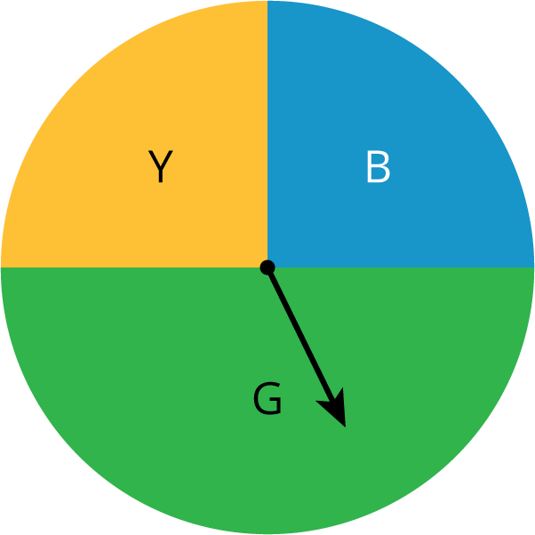
- Discuss your answers to the previous question with your partner. If you disagree, work to reach an agreement.
- Invent another situation for each label, for a total of 5 more events.

3 Take a Chance

Student Task Statement
Your teacher will have 2 students play a short game.
- When the first person chose 3 numbers, did they usually win?
- When the person chose 4 numbers, did you expect them to win? Explain your reasoning.

4 Card Sort: Likelihood

Student Task Statement
- Your teacher will give you some cards that describe events. Order the events from least likely to most likely.
- After ordering the first set of cards, pause here so your teacher can review your work. Then, your teacher will give you a second set of cards.
- Add the new set of cards to the first set so that all of the cards are ordered from least likely to most likely.
© CC BY Open Up Resources. Adaptations CC BY IM.

