Unit 1 Lesson 2: Introducing Geometric Sequences

1 Notice and Wonder: A Pattern in Lists (Warm up)

Student Task Statement
What do you notice? What do you wonder?
- 40, 120, 360, 1080, 3240
- 2, 8, 32, 128, 512
- 1000, 500, 250, 125, 62.5
- 256, 192, 144, 108, 81

2 Paper Slicing

Student Task Statement
Clare takes a piece of paper, cuts it in half, then stacks the pieces. She takes the stack of two pieces, then cuts in half again to form four pieces, stacking them. She keeps repeating the process.
number  of cuts | number  of pieces | area in square inches  of each piece
0
1
2
3
4
5
- The original piece of paper has length 8 inches and width 10 inches. Complete the table.
- Describe in words how you can use the results after 5 cuts to find the results after 6 cuts.
- On the given axes, sketch a graph of the number of pieces as a function of the number of cuts. How can you see on the graph how the number of pieces is changing with each cut?
- On the given axes, sketch a graph of the area of each piece as a function of the number of cuts. How can you see how the area of each piece is changing with each cut?
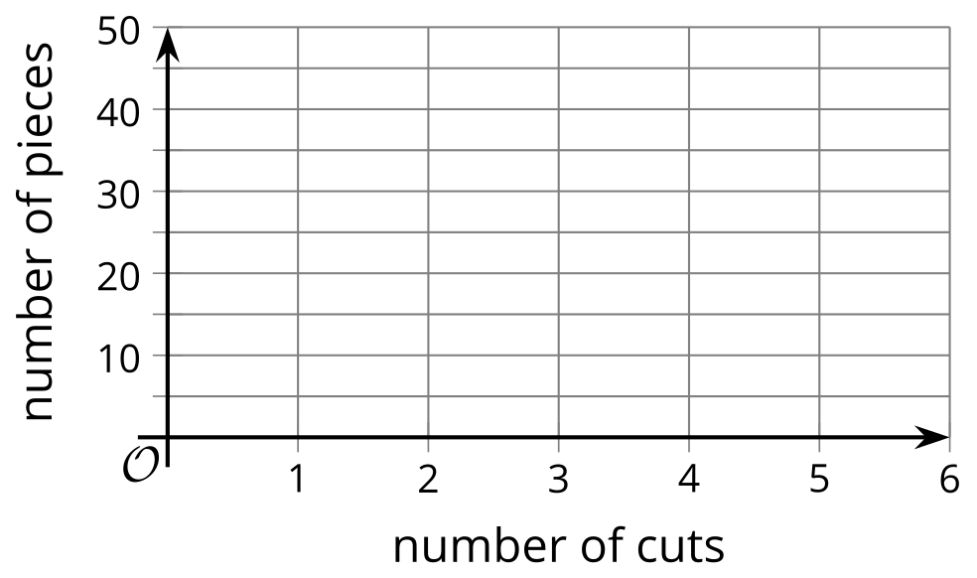

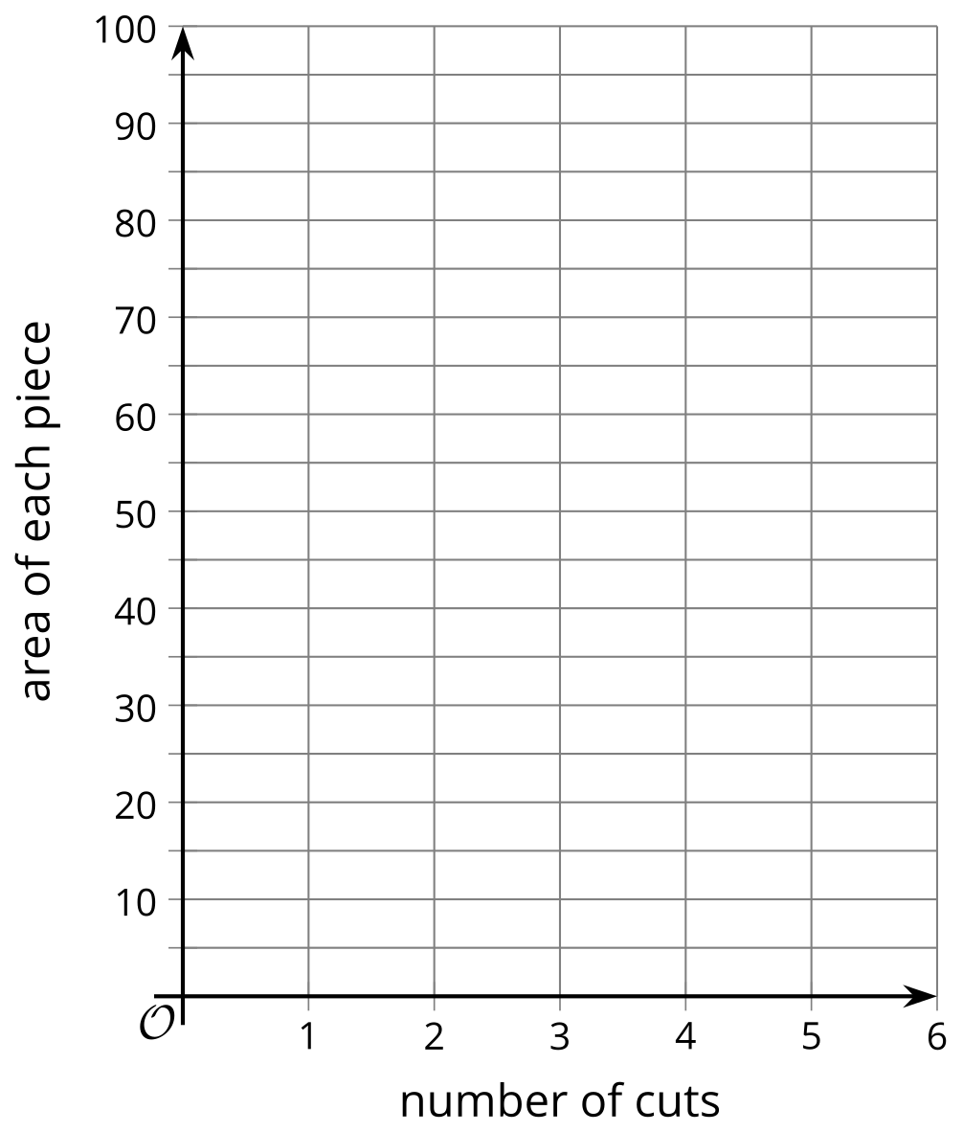

3 Complete the Sequence

Student Task Statement
- Complete each geometric sequence.
  - 1.5, 3, 6, ___, 24, ___
  - 40, 120, 360, ___, ___
  - 200, 20, 2, ___, 0.02, ___
  - $\frac{1}{7}$, ___, $\frac{9}{7}$, $\frac{27}{7}$, ___
  - 24, 12, 6, ___, ___
- For each sequence, find its growth factor.
© CC BY 2019 by Illustrative Mathematics®

