Lesson 3: Types of Transformations
- Let’s analyze transformations that produce congruent and similar figures.

3.1: Why is it a Dilation?
Point $B$ was transformed using the coordinate rule $\left(x,y\right)→\left(3x,3y\right)$.
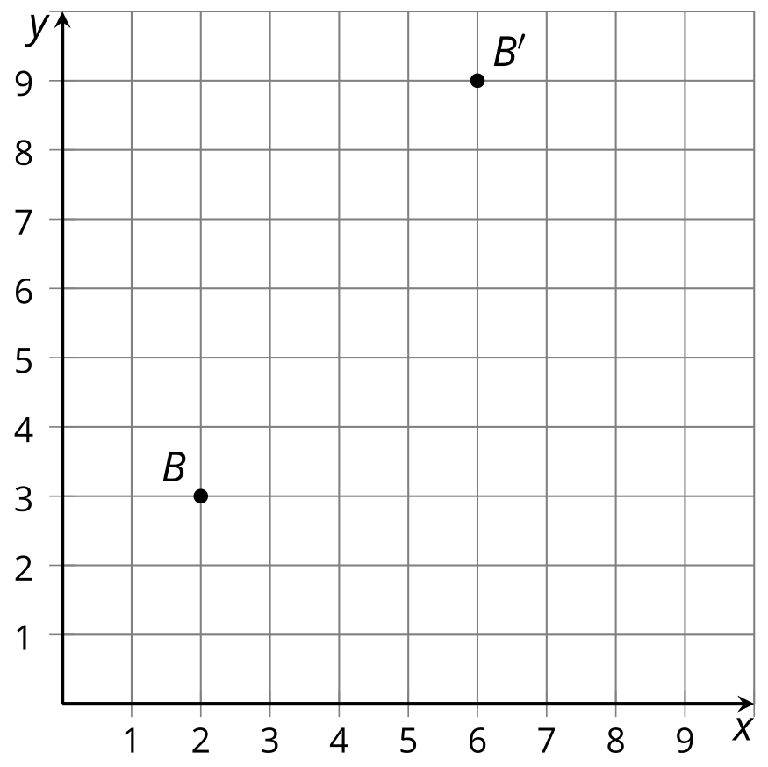
- Add these auxiliary points and lines to create 2 right triangles: Label the origin $P$. Plot points $M=\left(2,0\right)$ and $N=\left(6,0\right)$. Draw segments $PB^{′},MB,$ and $NB^{′}$.
- How do triangles $PMB$ and $PNB^{′}$ compare? How do you know?
- What must be true about the ratio $PB:PB^{′}$?

3.2: Congruent, Similar, Neither?
Match each image to its rule. Then, for each rule, decide whether it takes the original figure to a congruent figure, a similar figure, or neither. Explain or show your reasoning.

A
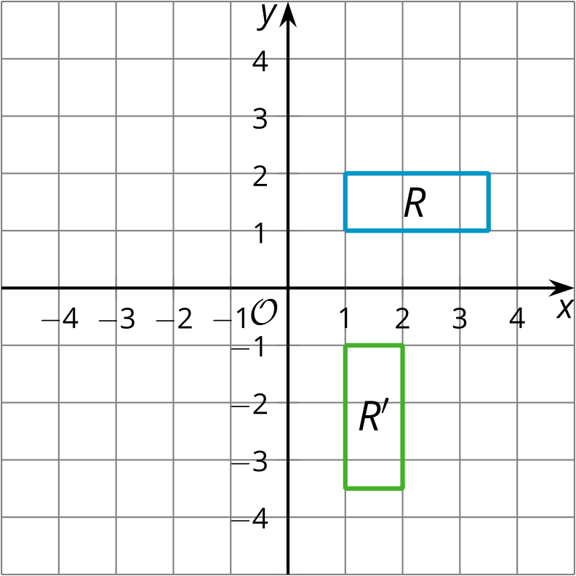
B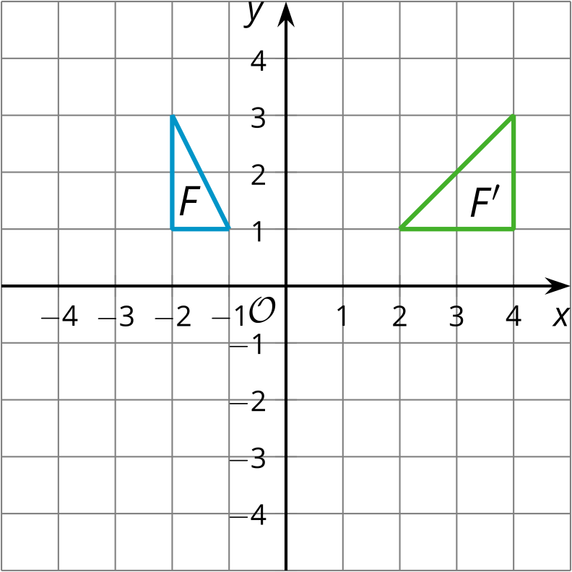

C
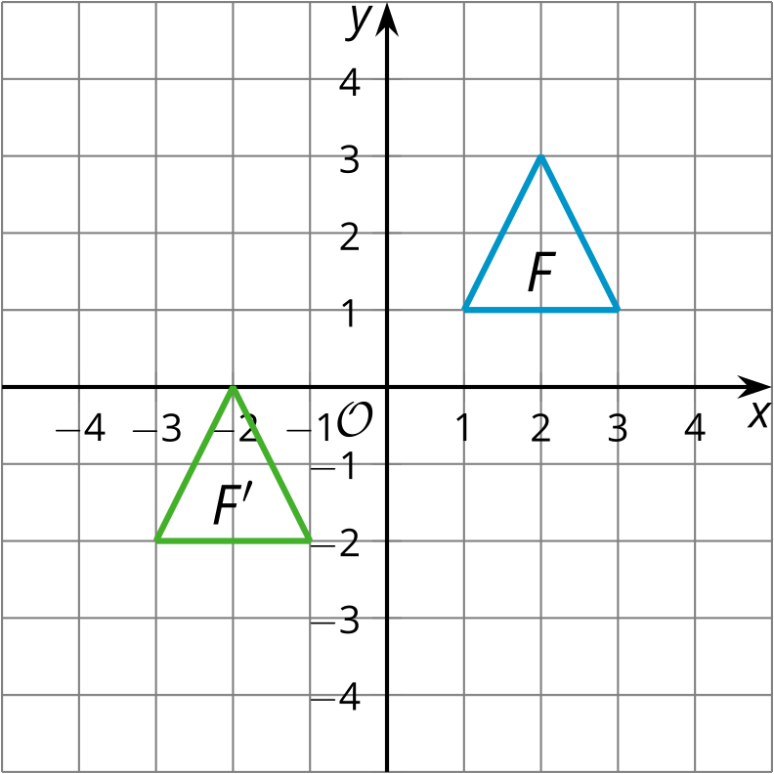

D
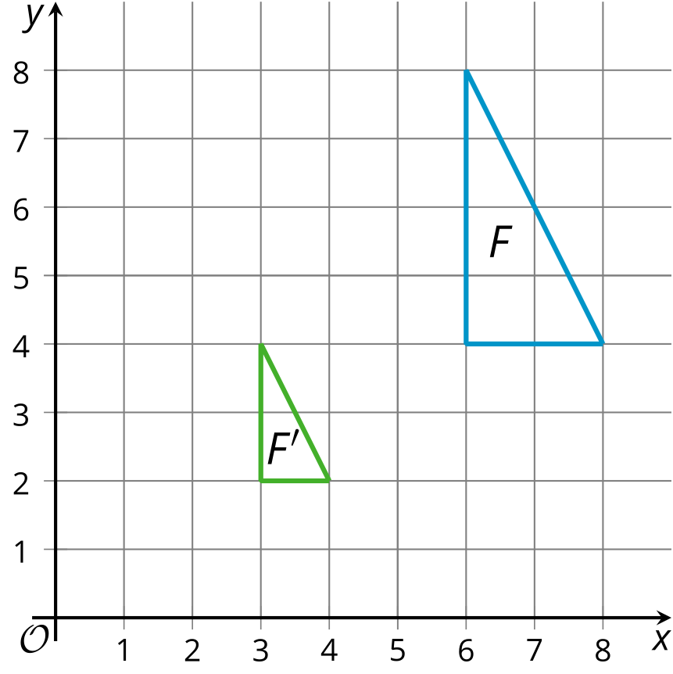
- $\left(x,y\right)→\left(\frac{x}{2},\frac{y}{2}\right)$
- $\left(x,y\right)→\left(y,\text{-}x\right)$
- $\left(x,y\right)→\left(\text{-}2x,y\right)$
- $\left(x,y\right)→\left(x−4,y−3\right)$

Are you ready for more?
Here is triangle $A$.
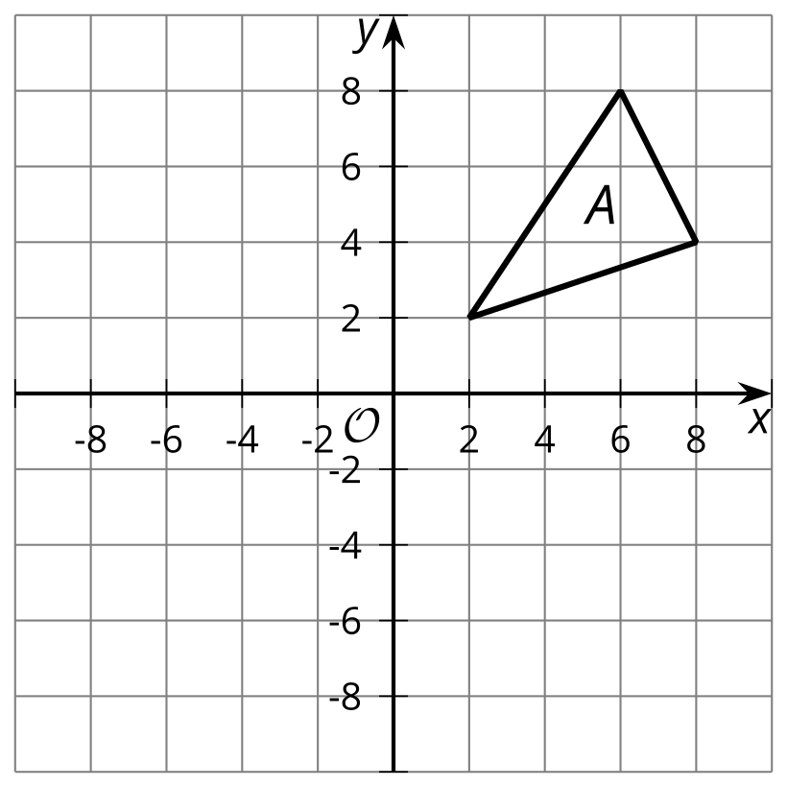
- Reflect triangle $A$ across the line $x=2$.
- Write a single rule that reflects triangle $A$ across the line $x=2$.

3.3: You Write the Rules
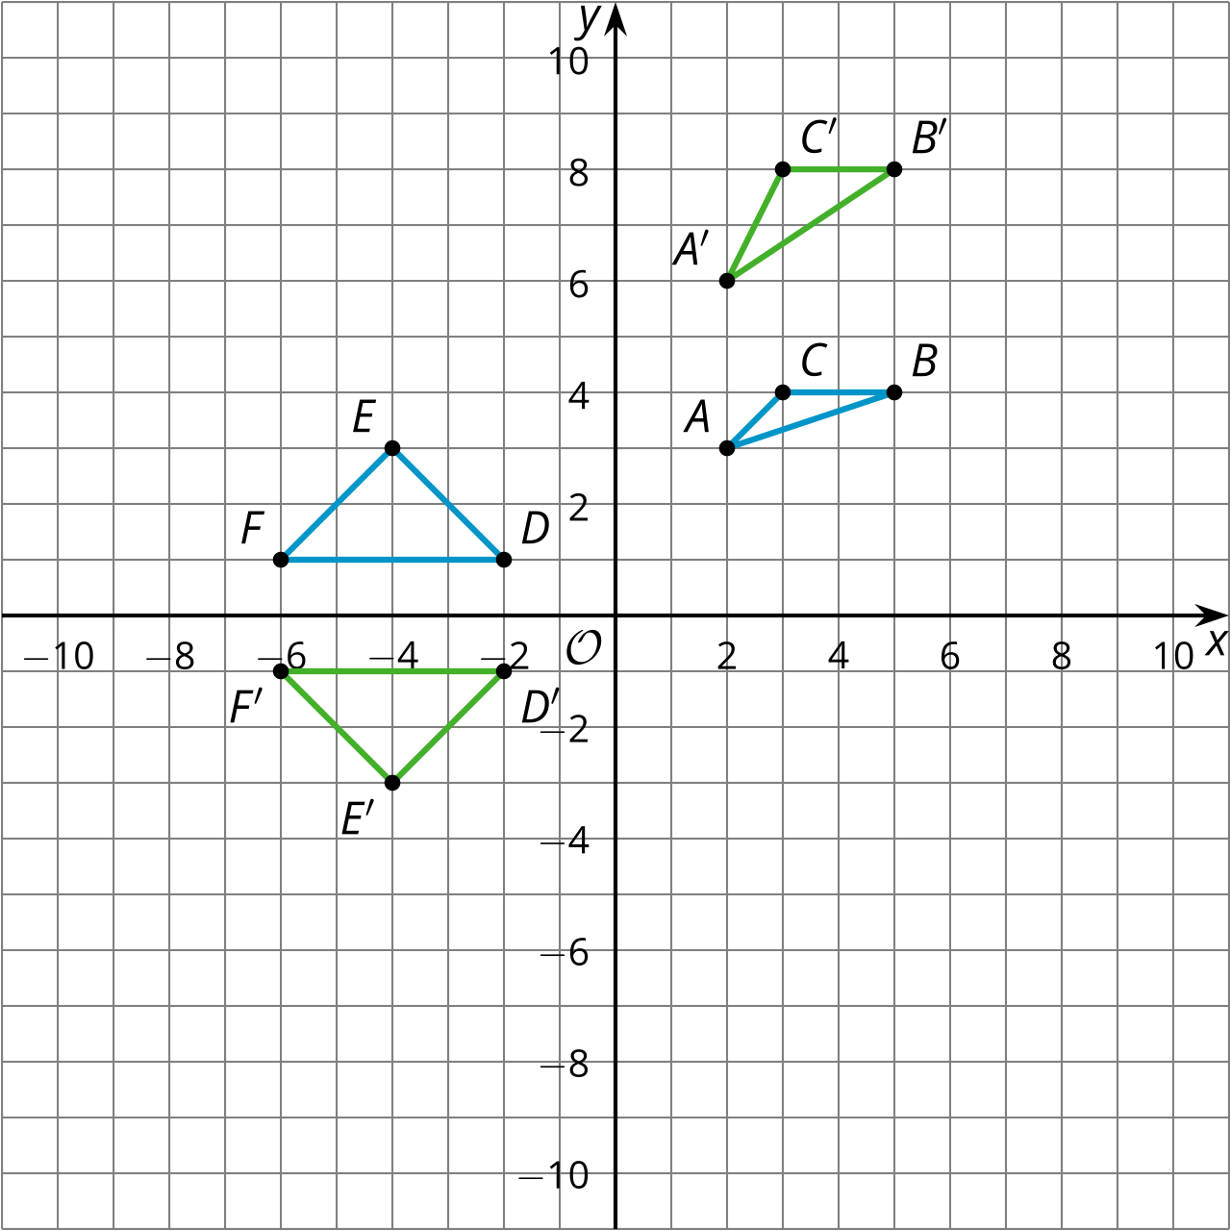
- Write a rule that will transform triangle $ABC$ to triangle $A^{′}B^{′}C^{′}$.
- Are $ABC$ and $A^{′}B^{′}C^{′}$ congruent? Similar? Neither? Explain how you know.
- Write a rule that will transform triangle $DEF$ to triangle $D^{′}E^{′}F^{′}$.
- Are $DEF$ and $D^{′}E^{′}F^{′}$ congruent? Similar? Neither? Explain how you know.

Lesson 3 Summary
Triangle $ABC$ has been transformed in two different ways:
- $\left(x,y\right)→\left(\text{-}y,x\right)$, resulting in triangle $DEF$
- $\left(x,y\right)→\left(x,3y\right)$, resulting in triangle $XYC$
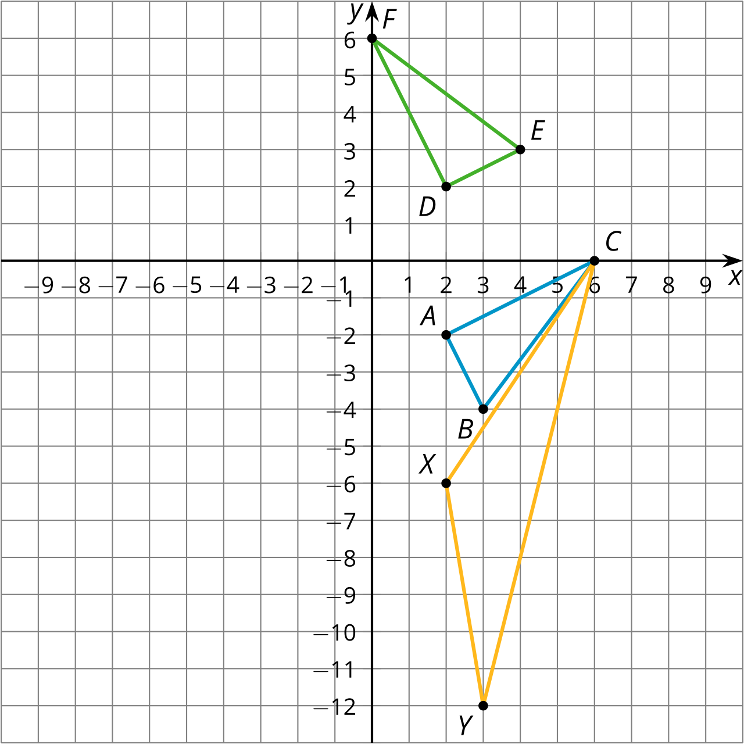
Let’s analyze the effects of the first transformation. If we calculate the lengths of all the sides, we find that segments $AB$ and $DE$ each measure $\sqrt{5}$ units, $BC$ and $EF$ each measure 5 units, and $AC$ and $DF$ each measure $\sqrt{20}$ units. The triangles are congruent by the Side-Side-Side Triangle Congruence Theorem. That is, this transformation leaves the lengths and angles in the triangle the same—it is a rigid transformation.
Not all transformations keep lengths or angles the same. Compare triangles $ABC$ and $XYC$. Angle $X$ is larger than angle $A$. All of the side lengths of $XYC$ are larger than their corresponding sides. The transformation $\left(x,y\right)→\left(x,3y\right)$ stretches the points on the triangle 3 times farther away from the $x$-axis. This is not a rigid transformation. It is also not a dilation since the corresponding angles are not congruent.
© CC BY 2019 by Illustrative Mathematics®

