Lesson 7 Practice Problems
- Based on past musical productions, a theater predicts selling $400−8p$ tickets when each ticket is sold at $p$ dollars.
  - Complete the table to find out how many tickets the theater expects to sell and what revenues it expects to receive at the given ticket prices.
- ticket price (dollars) | - number of tickets sold | - revenue (dollars)
  - 5
  - 10
  - 15
  - 20
  - 30
  - 45
  - 50
  - $p$
  - For which ticket prices will the theater earn no revenue? Explain how you know.
  - At what ticket prices should the theater sell the tickets if it must earn at least $3,200 in revenue to break even (to not lose money) on the musical production? Explain how you know.
- A company sells running shoes. If the price of a pair of shoes in dollars is $p$, the company estimates that it will sell $50,​000−400p$ pairs of shoes.
- Write an expression that represents the revenue in dollars from selling running shoes if a pair of shoes is priced at $p$ dollars.
- The function $f$ represents the revenue in dollars the school can expect to receive if it sells $220−12x$ coffee mugs for $x$ dollars each.
- Here is the graph of $f$.
- Select all the statements that describe this situation.
- 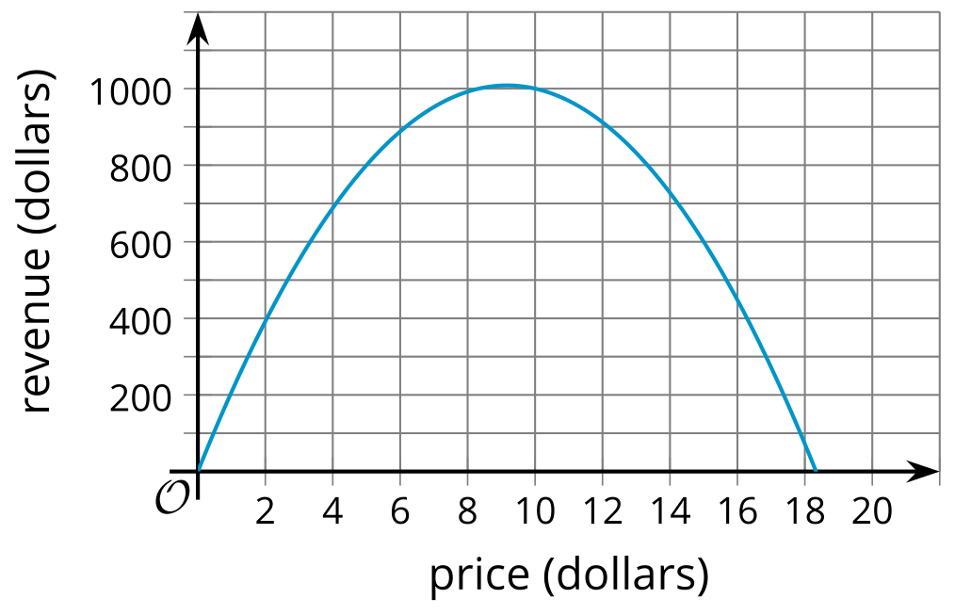
  - At $2 per coffee mug, the revenue will be $196.
  - The school expects to sell 160 mugs if the price is $5 each.
  - The school will lose money if it sells the mugs for more than $10 each.
  - The school will earn about $1,000 if it sells the mugs for $10 each.
  - The revenue will be more than $700 if the price is between $4 and $14.
  - The expected revenue will increase if the price per mug is greater than $10.

  - Write an equation to represent the relationship between the step number, $n$, and the number of small squares, $y$.
  - Briefly describe how each part of the equation relates to the pattern.
  - 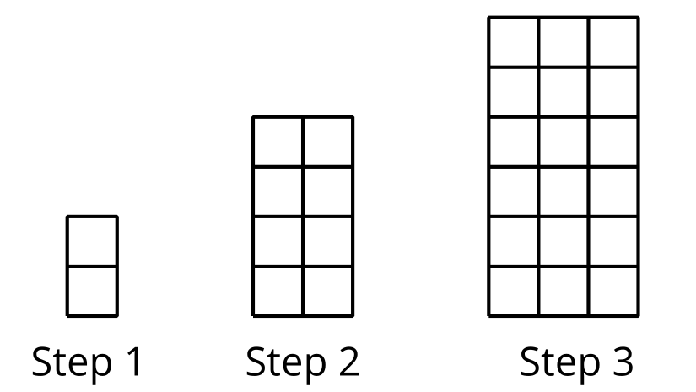
  - Is the relationship between the step number and number of small squares quadratic? Explain how you know.
- (From Unit 6, Lesson 3.)
- Technology required. A small marshmallow is launched straight up in the air with a slingshot. The function $h$, given by the equation $h\left(t\right)=5+20t−5t^{2}$, describes the height of the marshmallow in meters as a function of time, $t$, in seconds since it was launched.
  - Use graphing technology to graph the function $h$.
  - About when does the marshmallow reach its maximum height?
  - About how long does it take before the marshmallow hits the ground?
  - What domain makes sense for the function $h$ in this situation?
- (From Unit 6, Lesson 5.)
- A rock is dropped from a bridge over a river. Which graph could represent the distance fallen, in feet, as a function of time in seconds?

- Graph A
- 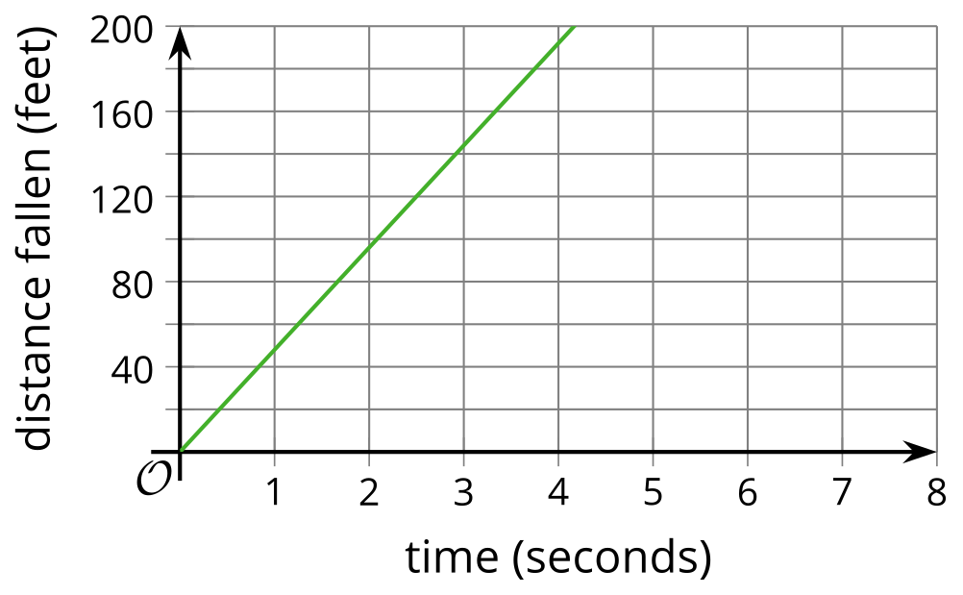

- Graph B
- 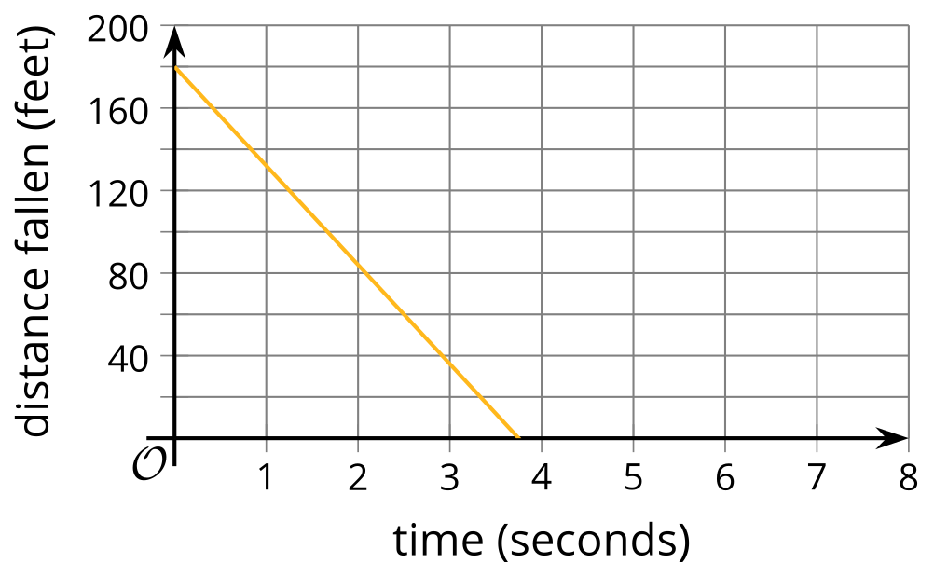

- Graph C
- 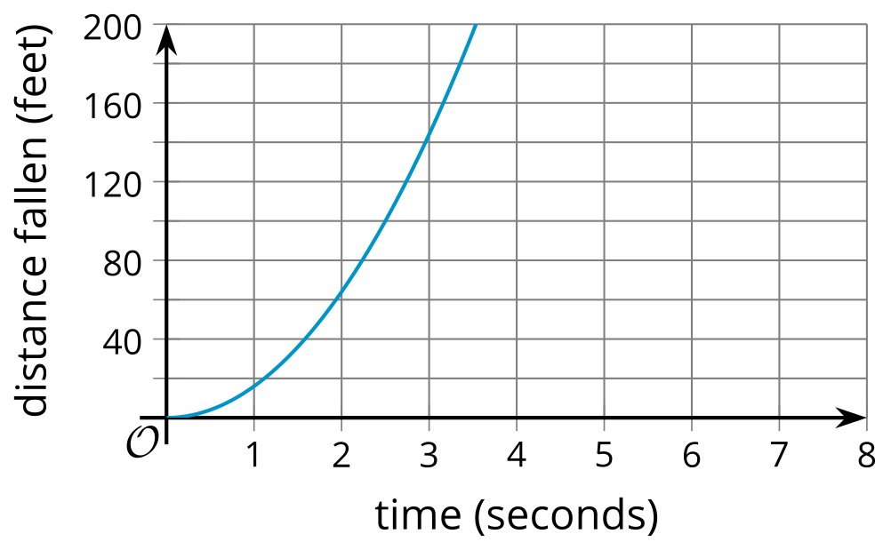

- Graph D
- 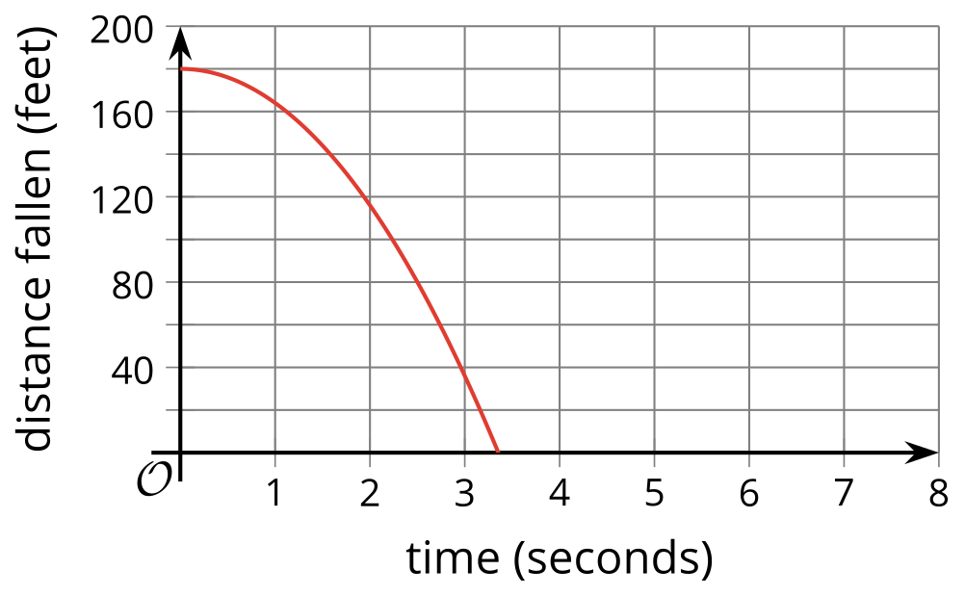
  - Graph A
  - Graph B
  - Graph C
  - Graph D
- (From Unit 6, Lesson 5.)
- A bacteria population, $p$, is modeled by the equation $p=100,​000⋅2^{d}$, where $d$ is the number of days since the population was first measured.
- Select all statements that are true in this situation.
  - $100,​000⋅2^{\text{-}2}$ represents the bacteria population 2 days before it was first measured.
  - The bacteria population 3 days before it was first measured was 800,000.
  - The population was more than 1,000 one week before it was first measured.
  - The population was more than 1,000,000 one week after it was first measured.
  - The bacteria population 4 days before it was first measured was 6,250.
- (From Unit 5, Lesson 7.)
© CC BY 2019 by Illustrative Mathematics®

