Lesson 4: Understanding Decay
Let’s look at exponential decay.

4.1: Notice and Wonder: Two Tables
What do you notice? What do you wonder?
Table A
$x$ | $y$
0 | 2
1 | $3\frac{1}{2}$
2 | 5
3 | $6\frac{1}{2}$
4 | 8
Table B
$x$ | $y$
0 | 2
1 | 3
2 | $\frac{9}{2}$
3 | $\frac{27}{4}$
4 | $\frac{81}{8}$

4.2: What's Left?
- Here is one way to think about how much Diego has left after spending $\frac{1}{4}$ of $100. Explain each step.
  - Step 1: $100−\frac{1}{4}⋅100$
  - Step 2: $100\left(1−\frac{1}{4}\right)$
  - Step 3: $100⋅\frac{3}{4}$
  - Step 4: $\frac{3}{4}⋅100$
- A person makes $1,800 per month, but $\frac{1}{3}$ of that amount goes to her rent. What two numbers can you multiply to find out how much she has after paying her rent?
- Write an expression that only uses multiplication and that is equivalent to $x$ reduced by $\frac{1}{8}$ of $x$.

4.3: Value of a Vehicle
Every year after a new car is purchased, it loses $\frac{1}{3}$ of its value. Let’s say that a new car costs $18,000.
- A buyer worries that the car will be worth nothing in three years. Do you agree? Explain your reasoning.
- Write an expression to show how to find the value of the car for each year listed in the table.
- year | - value of car (dollars)
- 0 | - 18,000
- 1
- 2
- 3
- 6
- $t$
- Write an equation relating the value of the car in dollars, $v$, to the number of years, $t$.
- Use your equation to find $v$ when $t$ is 0. What does this value of $v$ mean in this situation?
- A different car loses value at a different rate. The value of this different car in dollars, $d$, after $t$ years can be represented by the equation $d=10,​000⋅{\left(\frac{4}{5}\right)}^{t}$. Explain what the numbers 10,000 and $\frac{4}{5}$ mean in this situation.

Are you ready for more?
Start with an equilateral triangle with area 1 square unit, divide it into 4 congruent pieces as in the figure, and remove the middle one. Then, repeat this process with each of the remaining pieces. Repeat this process over and over for the remaining pieces. The figure shows the first two steps of this construction.
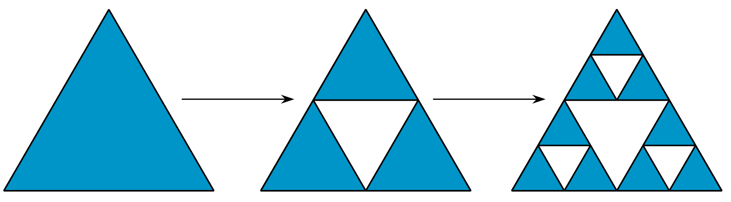
What fraction of the area is removed each time? How much area is removed after the $n$-th step? Use a calculator to find out how much area remains in the triangle after 50 such steps have been taken.

Lesson 4 Summary
Sometimes a quantity grows by the same factor at regular intervals. For example, a population doubles every year. Sometimes a quantity decreases by the same factor at regular intervals. For example, a car might lose one third of its value every year.
Let's look at a situation where the quantity decreases by the same factor at regular intervals. Suppose a bacteria population starts at 100,000 and $\frac{1}{4}$ of the population dies each day. The population one day later is $100,​000−\frac{1}{4}⋅100,​000$, which can be written as $100,​000\left(1−\frac{1}{4}\right)$. The population after one day is $\frac{3}{4}$ of 100,000 or 75,000. The population after two days is $\frac{3}{4}⋅75,​000$. Here are some further values for the bacteria population
number  of days | bacteria population
0 | 100,000
1 | 75,000 (or $100,​000⋅\frac{3}{4}$)
2 | 56,250 (or $100,​000⋅\frac{3}{4}⋅\frac{3}{4}$, or $100,​000⋅{\left(\frac{3}{4}\right)}^{2}$)
3 | about 42,188 (or $100,​000⋅\frac{3}{4}⋅\frac{3}{4}⋅\frac{3}{4}$, or $100,​000⋅{\left(\frac{3}{4}\right)}^{3}$)
In general, $d$ days after the bacteria population was 100,000, the population $p$ is given by the equation: $p=100,​000⋅{\left(\frac{3}{4}\right)}^{d},$ with one factor of $\frac{3}{4}$ for each day.
Situations with quantities that decrease exponentially are described with exponential decay. The multiplier ($\frac{3}{4}$ in this case) is still called the growth factor, though sometimes people call it the decay factor instead.
© CC BY 2019 by Illustrative Mathematics®

