Lesson 1 Practice Problems
- The videography team entered a contest and won a monetary prize of $1,350.
- Which expression represents how much each person would get if there were $x$ people on the team?
  - $\frac{1350}{x}$
  - $1350+x$
  - $\frac{1350}{5}$
  - $1350−x$
- To support a local senior citizens center, a student club sent a flyer home to the $n$ students in the school. The flyer said, "Please bring in money to support the senior citizens center. Paper money and coins accepted!" Their goal is to raise $T$ dollars.
- Match each quantity to an expression, an equation, or an inequality that describes it.
  - the dollar amount the club would have if they reached half of their goal
  - the dollar amount the club would have if every student at the school donated 50 cents to the cause
  - the dollar amount the club could donate if they made $50 more than their goal
  - the dollar amount the club would still need to raise to reach its goal after every student at the school donated 50 cents
  - the dollar amount the club would have if half of the students at the school each gave 50 cents
  - $T+50$
  - $0.5T$
  - $0.25n$
  - $0.5n$
  - $T−0.5n$
- Each of the 10 students in the baking club made 2 chocolate cakes for a fundraiser. They all used the same recipe, using $C$ cups of flour in total.
- Write an expression that represents the amount of flour required for one cake.
- A student club started a fundraising effort to support animal rescue organizations. The club sent an information flyer home to the $n$ students in the school. It says, "We welcome donations of any amount, including any change you could spare!" Their goal is to raise $T$ dollars, and to donate to a cat shelter and a dog shelter.
- Match each quantity to an expression, an equation, or an inequality that describes it.
  - The dollar amount the club would have if they reached one-fourth of their goal.
  - The dollar amount the club would have if every student at the school donated a quarter to the cause.
  - The dollar amount the club could donate to the cat shelter if they reached their goal and gave a quarter of the total donation to a dog shelter.
  - The dollar amount the club would still need to raise to reach its goal after every student at the school donated a quarter.
  - The dollar amount the club would have if three-fourths of the students at the school each gave 50 cents.
  - $\frac{3}{4}n⋅\frac{1}{2}$
  - $\frac{1}{4}T$
  - $T−\frac{1}{4}n$
  - $\frac{3}{4}T$
  - $\frac{1}{4}n$
- A softball team is ordering pizza to eat after their tournament. They plan to order cheese pizzas that cost $6 each and four-topping pizzas that cost $10 each. They order $c$ cheese pizzas and $f$ four-topping pizzas.
- Which expression represents the total cost of all of the pizzas they order?
  - $6+10$
  - $c+f$
  - $6c+10f$
  - $6f+10c$
- The value of coins in the pockets of several students is recorded. What is the mean of the values: 10, 20, 35, 35, 35, 40, 45, 45, 50, 60
  - 10 cents
  - 35 cents
  - 37.5 cents
  - 50 cents
- (From Unit 1, Lesson 9.)
- The dot plot displays the number of hits a baseball team made in several games. The distribution is skewed to the left.
- 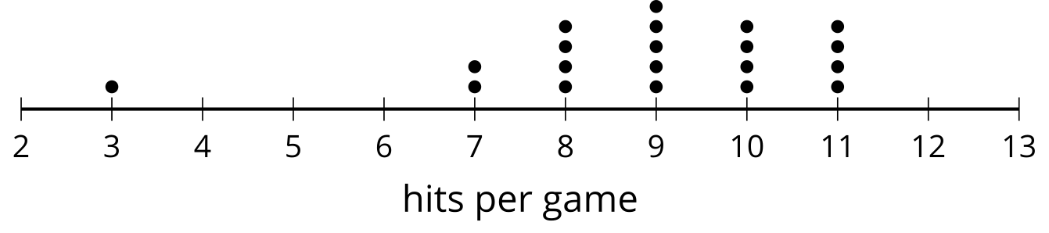
- If the game with 3 hits is considered to be recorded in error, it might be removed from the data set. If that happens:
  - What happens to the mean of the data set?
  - What happens to the median of the data set?
- (From Unit 1, Lesson 10.)
- A set of data has MAD 0 and one of the data values is 14. What can you say about the data values?
- (From Unit 1, Lesson 11.)
© CC BY 2019 by Illustrative Mathematics®

