Lesson 13 Practice Problems
- A scientist is growing single-crystal diamonds in the laboratory using a standard process and a new process. The scientist wants to know which process causes the diamonds to grow faster. The mean growth rate for 20 diamonds grown using the standard process is 0.7 micrometers per hour. The growth rate for 20 diamonds grown using the new process is 0.9 micrometers per hour. The scientist uses simulations to get a randomization distribution to determine if the results happened by chance. The randomization distribution is displayed in the histogram.
- 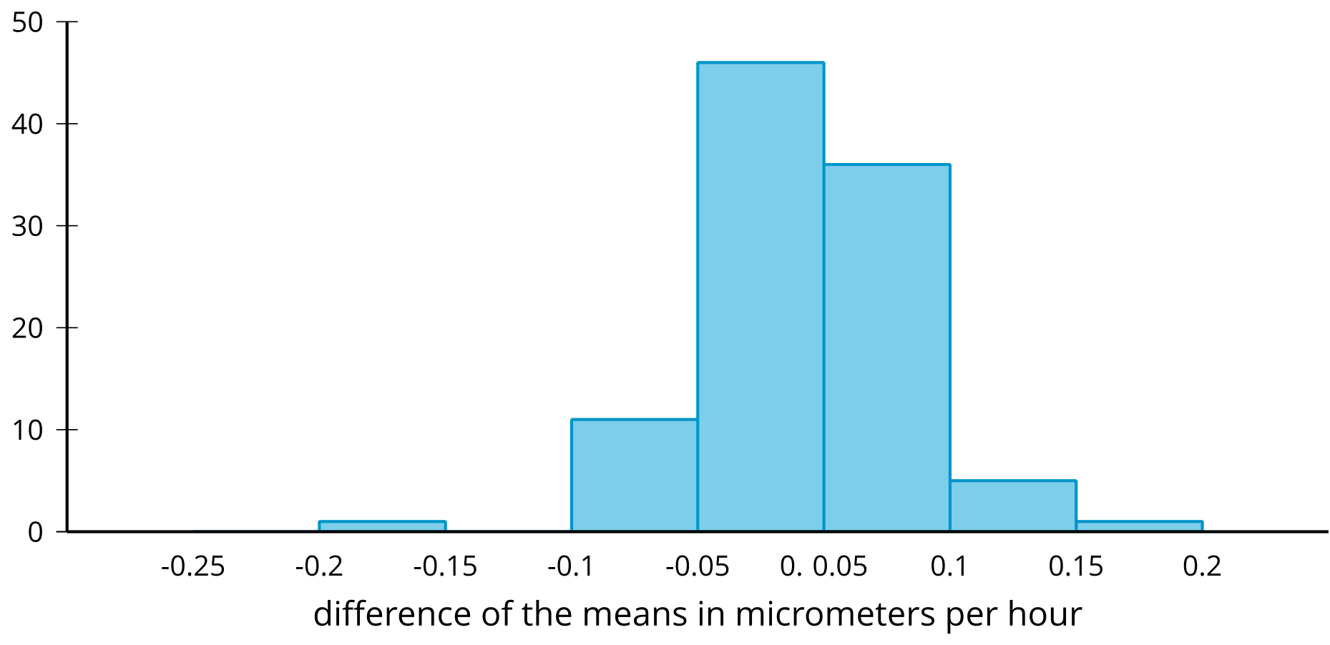
- Is it reasonable to conclude that the mean difference between the 2 groups occurred by chance? Explain your reasoning.
- The histogram displays the results from 200 simulations of redistributing data from an experiment to create a randomization distribution comparing the length, in centimeters, of two different groups.
- 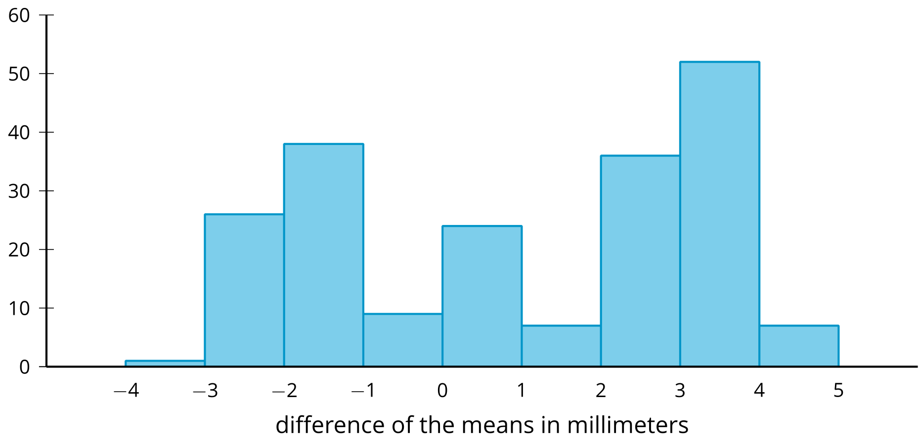
- The difference between the mean lengths of the two groups being studied is 2.5 millimeters.
  - Use information in the histogram to support the claim that a mean difference of 2.5 millimeters is likely to occur by chance. Explain your reasoning.
  - What is a value of a mean difference that would be unlikely to occur by chance?
- The dot plot displays a randomization distribution based on 325 simulations redistributing data from an experiment.
- 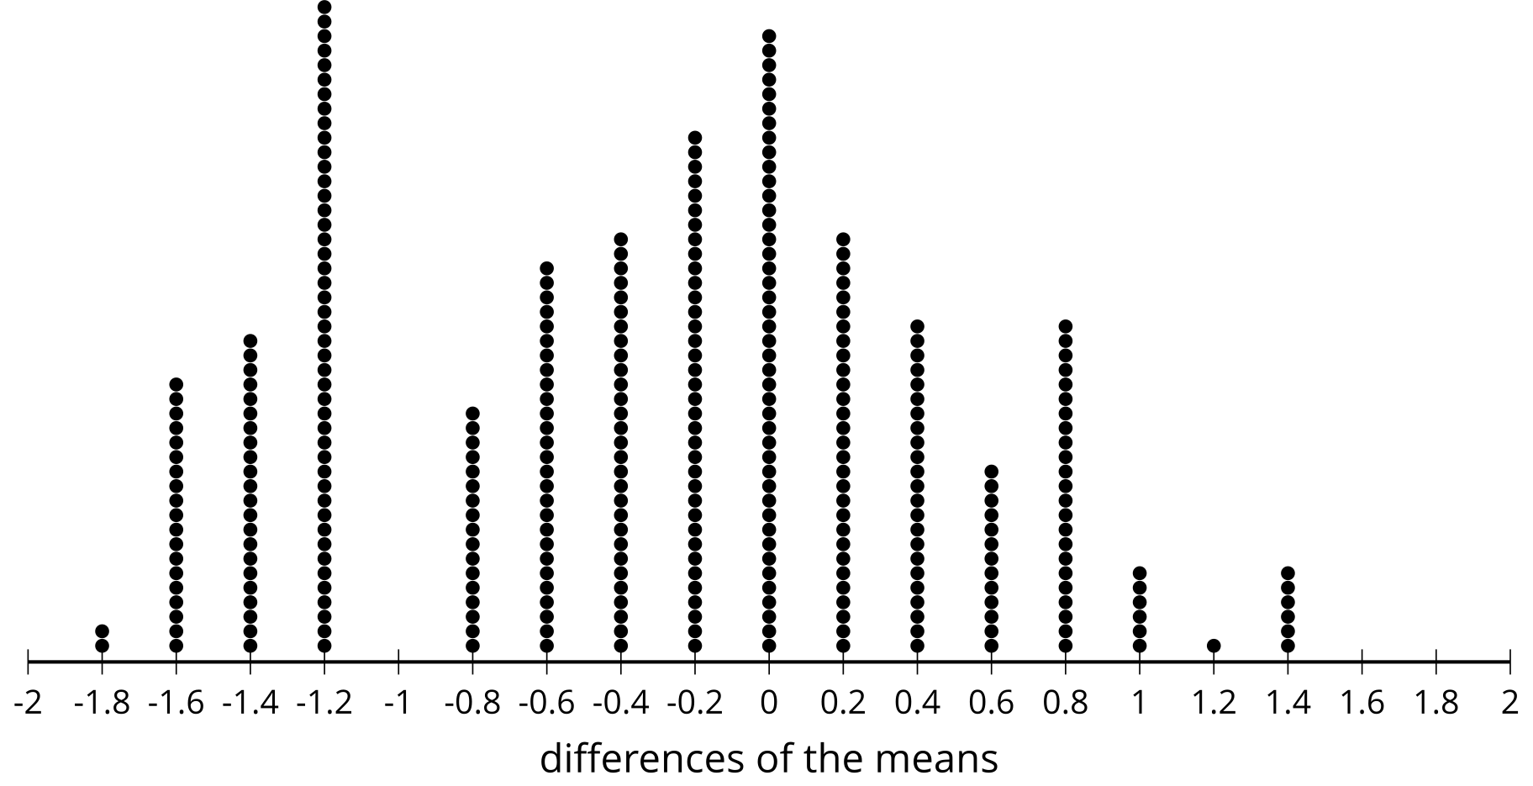
- Select all of the values that represent difference of the means where there is evidence to determine that the results are likely due to the treatment.
  - -1.8
  - -1.6
  - -0.8
  - 0
  - 2
- Technology required
- The mean amount of milk produced weekly by 12 random samples with 20 dairy cows in each sample are listed in gallons.
- 64.5 | - 62.7 | - 63.5 | - 65.0 | - 64.1 | - 62.7 | - 62.4 | - 63.5
- 60.7 | - 61.6 | - 63.0 | - 65.6

- Use the values to estimate the mean amount of milk produced weekly by the dairy cow population, and provide a margin of error.
- (From Unit 7, Lesson 12.)
- An internet company uses a random sample of 200 internet users and simulations to estimate the proportion of people who stream videos. The company estimates the proportion is 0.853 with a margin of error of 0.081. They decide to check their results by collecting another random sample with 300 internet users. Which of the results is most likely to be the estimates from the second random sample and simulations?
  - 0.613 with margin of error 0.022
  - 0.952 with margin of error 0.121
  - 0.853 with margin of error 0.093
  - 0.849 with margin of error 0.058
- (From Unit 7, Lesson 11.)
- Mai has a box of number cubes with each of the 6 faces marked with one of the numbers 1, 2, 3, 4, 5 and 6. She rolls one number cube and makes note of the number on the face that is facing up. After rolling this number cube 20 times, she notices that the number 4 appears nine times.
- Mai suspects that this number cube is weighted in some way to make 4 appear more often than the other numbers. Using another number cube from the box that she has confirmed is fair (all of the numbers tend to be rolled with equal frequency), explain a process Mai could use to gather evidence to show whether this number cube is also fair.
- (From Unit 7, Lesson 8.)
© CC BY 2019 by Illustrative Mathematics®

