Unit 9 Lesson 6: Represent Numbers with Expressions

WU True or False: Place Value (Warm up)

Student Task Statement
Decide if each statement true or false. Be prepared to explain your reasoning.
- 5 hundreds + 2 tens + 7 ones = 527
- 4 hundreds + 12 tens + 7 ones = 527
- 5 hundreds + 7 ones + 2 tens = 527

1 Make Equations True

Student Task Statement
Find the number that makes each equation true.
- 5 hundreds + _____ tens + 6 ones = 5 hundreds + 5 tens + 16 ones
- 1 hundred + 1 ten + 17 ones = 1 hundred + _____ tens + 7 ones
- 4 hundreds + 15 tens + 3 ones = _____ hundreds + 5 tens + 3 ones
- 4 hundreds + 3 tens + 7 ones = 3 hundreds + _____ tens + 7 ones
- 7 hundreds + 8 tens + 4 ones = 7 hundreds + 7 tens + _____ ones
- 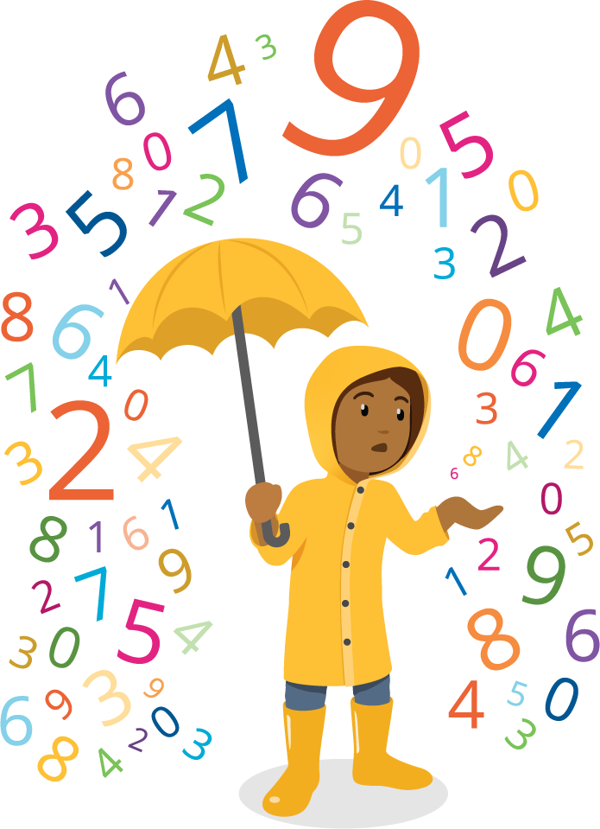
- 6 hundreds + 9 ones = 5 hundreds + _____ tens + 9 ones
- 2 hundreds + 9 tens + 17 ones = _____ hundreds + 7 ones
- 3 hundreds + 1 ten + 5 ones = 2 hundreds + 10 tens + _____ ones
If You Have Time: Make your own equation with a missing value for your partner.

2 Card Sort: Expressions with Three-digit Values

Student Task Statement
Group the cards into sets of expressions that have the same value. Record the letters of the matching cards. Write an expression that represents the same value.
- letters for matching expressions: __________________
- new expression:
- letters for matching expressions: __________________
- new expression:
- letters for matching expressions: __________________
- new expression:
- letters for matching expressions: __________________
- new expression:
© CC BY 2021 Illustrative Mathematics®

