Lesson 3 Practice Problems

  - Sketch or describe the figure in Step 4 and Step 15.
  - 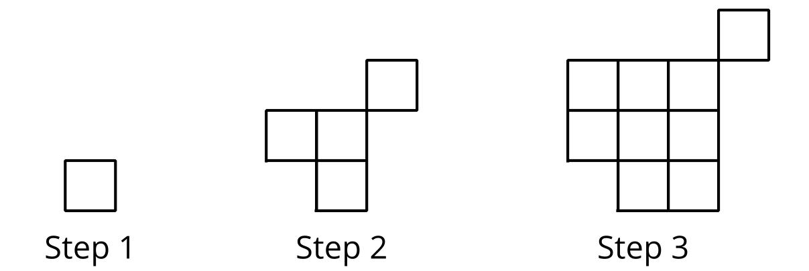

  - How many small squares will there be in each of these steps?
  - Write an equation to represent the relationship between the step number, $n$, and the number of small squares, $y$, in each step.
  - Explain how your equation relates to the pattern.
- Which expression represents the relationship between the step number $n$ and the total number of small squares in the pattern?
- 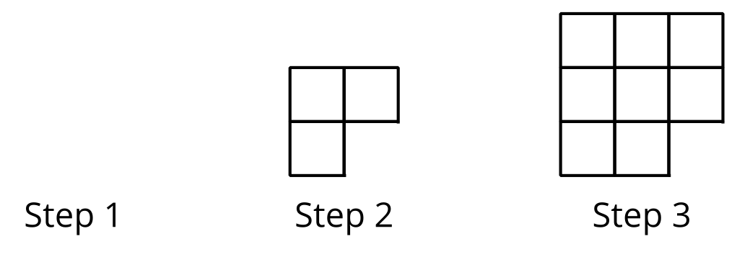
  - $n^{2}+1$
  - $n^{2}−1$
  - $n^{2}−n$
  - $n^{2}+n$
- Each figure is composed of large squares and small squares. The side length of the large square is $x$. Write an expression for the area of the shaded part of each figure.

- Figure A
- 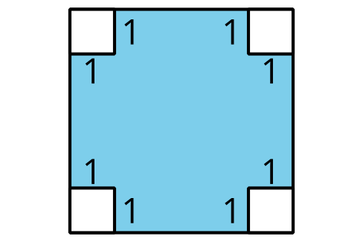

- Figure B

- Here are a few pairs of positive numbers whose difference is 5.
  - Find the product of each pair of numbers. Then, plot some points to show the relationship between the first number and the product.
- first  number | - second  number | - product
- 1 | - 6
- 2 | - 7
- 3 | - 8
- 5 | - 10
- 7 | - 12
  - 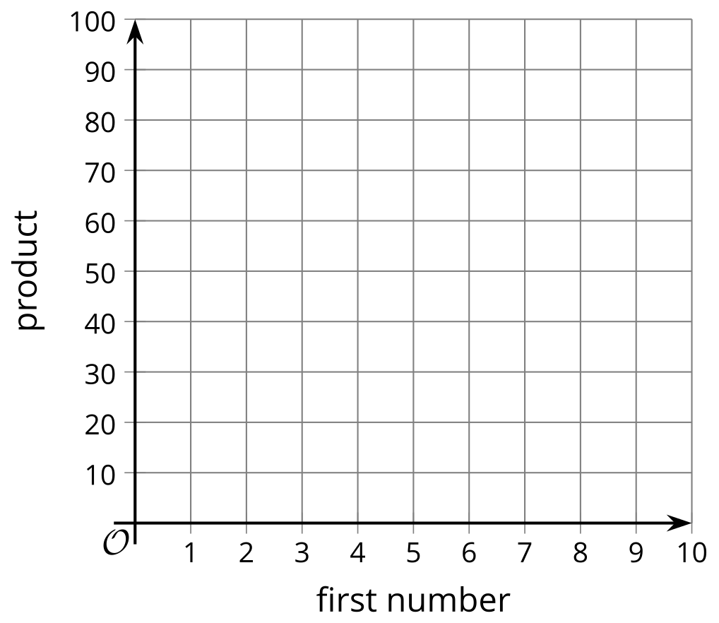
  - Is the relationship between the first number and the product exponential? Explain how you know.
- (From Unit 6, Lesson 1.)
- Here are some lengths and widths of a rectangle whose perimeter is 20 meters.
  - Complete the table. What do you notice about the areas?
- length  (meters) | - width  (meters) | - area  (square meters)
- 1 | - 9
- 3 | - 7
  - 5
  - 7
  - 9
  - Without calculating, predict whether the area of the rectangle will be greater or less than 25 square meters if the length is 5.25 meters.
  - On the coordinate plane, plot the points for length and area from your table.
  - Do the values change in a linear way? Do they change in an exponential way?
  - 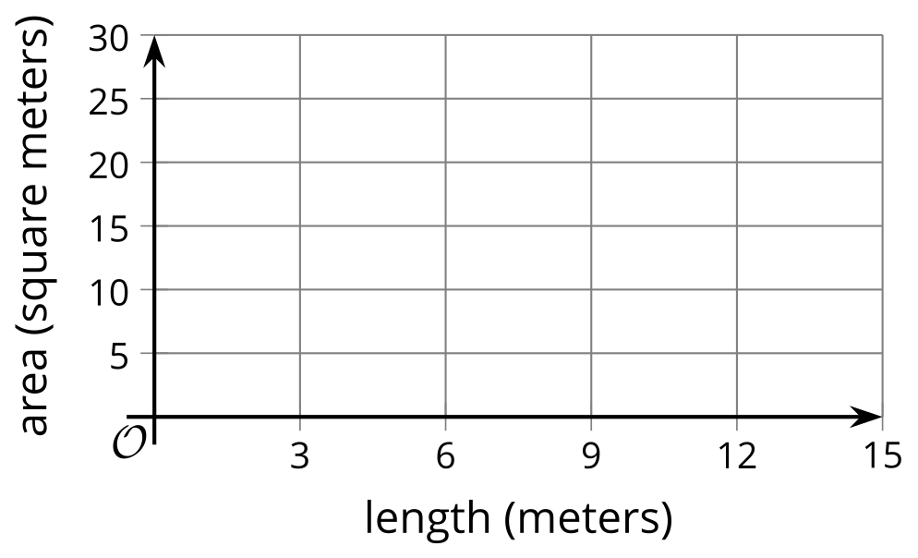
- (From Unit 6, Lesson 1.)
- Here is a pattern of dots.
- 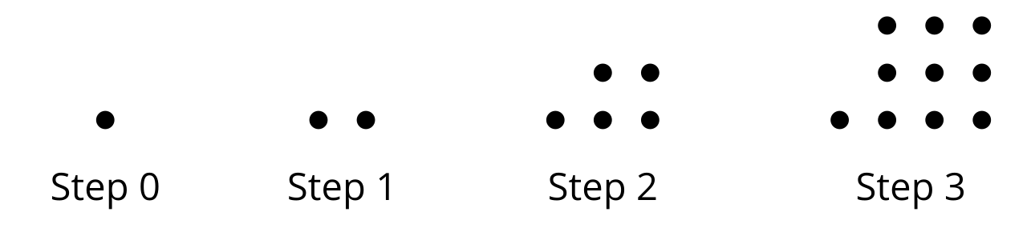
  - Complete the table.
  - How many dots will there be in Step 10?
  - How many dots will there be in Step $n$?
- step | - total number  of dots
- 0
- 1
- 2
- 3
- (From Unit 6, Lesson 2.)
- Mai has a jar of quarters and dimes. She takes at least 10 coins out of the jar and has less than $2.00.
  - Write a system of inequalities that represents the number of quarters, $q$, and the number of dimes, $d$, that Mai could have.
  - Is it possible that Mai has each of the following combinations of coins? If so, explain or show how you know. If not, state which constraint—the amount of money or the number of coins—it does not meet.
    - 3 quarters and 12 dimes
    - 4 quarters and 10 dimes
    - 2 quarters and 5 dimes
- (From Unit 2, Lesson 25.)
- A stadium can seat 63,026 people. For each game, the amount of money that the organization brings in through ticket sales is a function of the number of people, $n$, in attendance.
- If each ticket costs $30.00, find the domain and range of this function.
- (From Unit 4, Lesson 10.)
© CC BY 2019 by Illustrative Mathematics®

