Unit 9 Lesson 5: Compose and Decompose Numbers Within 1,000

WU What Do You Know About 308? (Warm up)

Student Task Statement
What do you know about 308?

1 How Many Did You Get?

Student Task Statement
- Start with 2 hundreds. Grab a handful of tens and of ones.
  - What number do your base-ten blocks represent? _______
  - Represent the same number in another way. Show your thinking using diagrams, symbols, or other representations.
- Combine your blocks with your partner’s blocks.
  - What number do your base-ten blocks represent? _______
  - Represent the same number in another way. Show your thinking using diagrams, symbols, or other representations.
- Represent your group’s number in the following ways:
  - without hundreds
  - without tens
  - without hundreds or tens

Activity Synthesis
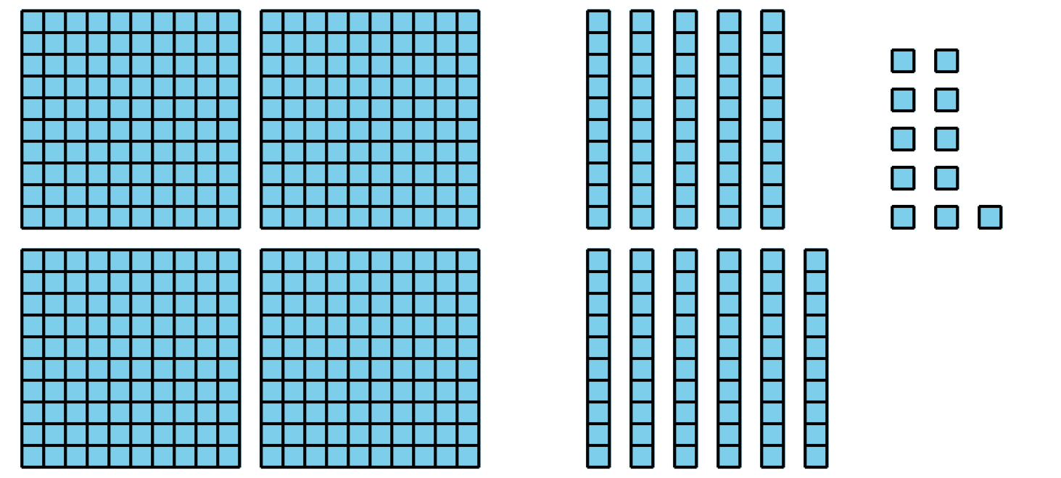
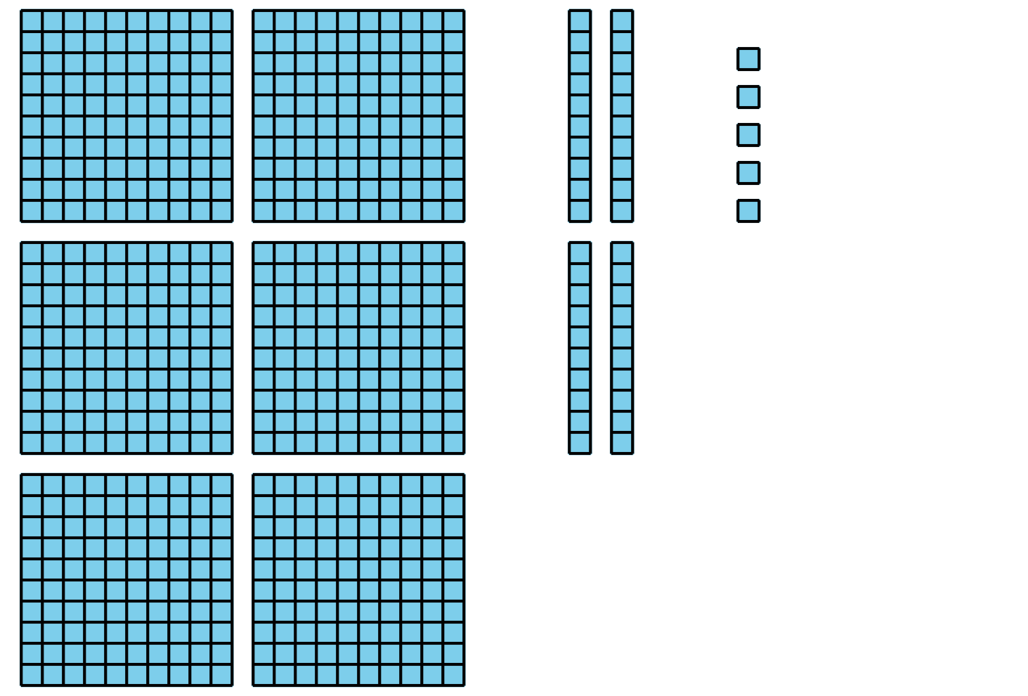

2 Let Me Count the Ways

Student Task Statement
- Represent 356 in at least 3 different ways. Show your thinking using diagrams, symbols, or other representations.
- Create a poster with your group to show 356 in different ways.
© CC BY 2021 Illustrative Mathematics®

