Lesson 14: Half of the Clock

Standards Alignments
Addressing | 1.MD.B.3, 1.NBT.C.4

Teacher-facing Learning Goals
- Relate halves of circles to half hours.
- Tell time in hours and half hours.

Student-facing Learning Goals
- Let’s learn more about time to the half hour.

Lesson Purpose
The purpose of this lesson is for students to learn about the position of the hands on an analog clock at half past the hour.
In a previous lesson, students learned how to tell and write time in hours. In a previous section, students partitioned shapes into two equal pieces and identified each piece as “a half of” the shape.
The purpose of this lesson is for students to learn about the position of the hands on an analog clock at half past the hour. They analyze how the hands on the clock move as time goes from one hour to the next. They see that half past the hour is when the hour hand is half way between two numbers and the minute hand is halfway around the clock. They create new clock cards that show half past and add the minute hand to the clocks.

Access for:

Students with Disabilities
- Representation (Activity 2)

English Learners
- MLR2 (Activity 2)

Instructional Routines
Number Talk (Warm-up)

Materials to Gather
- Colored pencils, crayons, or markers: Activity 2
- Materials from a previous activity: Activity 3
- Materials from a previous lesson: Activity 1
- Scissors: Activity 1

Materials to Copy
- Clock Cards Half Past (groups of 1): Activity 1

Required Preparation

Lesson Timeline
Warm-up | 10 min
Activity 1 | 15 min
Activity 2 | 10 min
Activity 3 | 10 min
Lesson Synthesis | 10 min
Cool-down | 5 min

Teacher Reflection Question
With which math ideas from today’s lesson did students grapple most? Did this surprise you or was this what you expected?

Cool-down
(to be completed at the end of the lesson) 5min
Find 2:30

Standards Alignments
Addressing | 1.MD.B.3

Student-facing Task Statement
Circle the clock that shows 2:30.
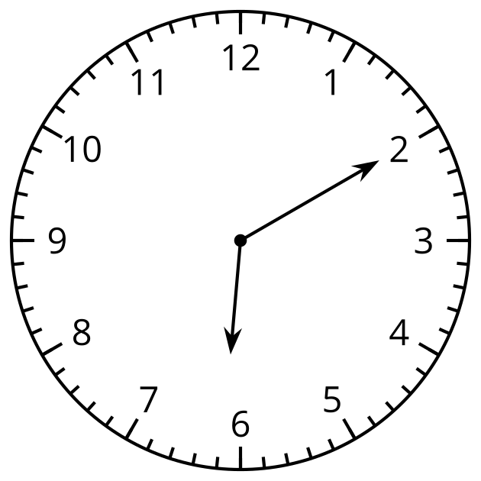
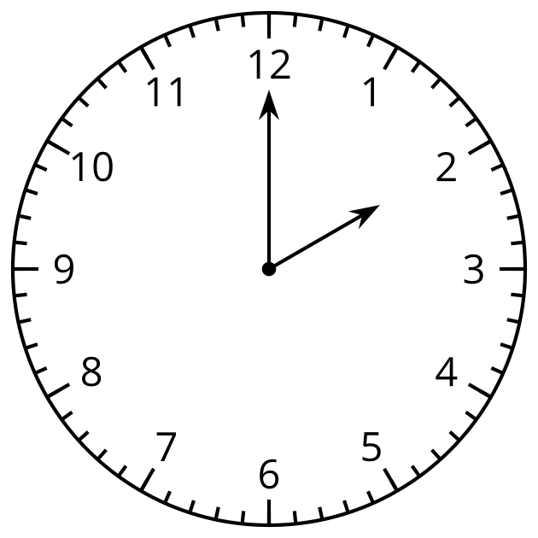
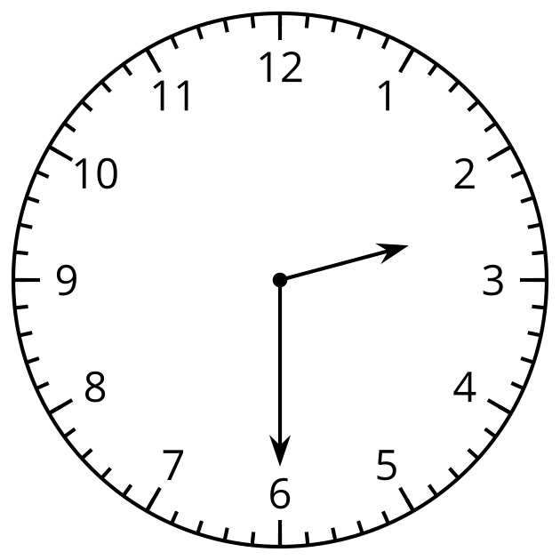

Student Responses
Circle the last clock.

