Lesson 2 Practice Problems
- How many small squares are in Step 10?
- 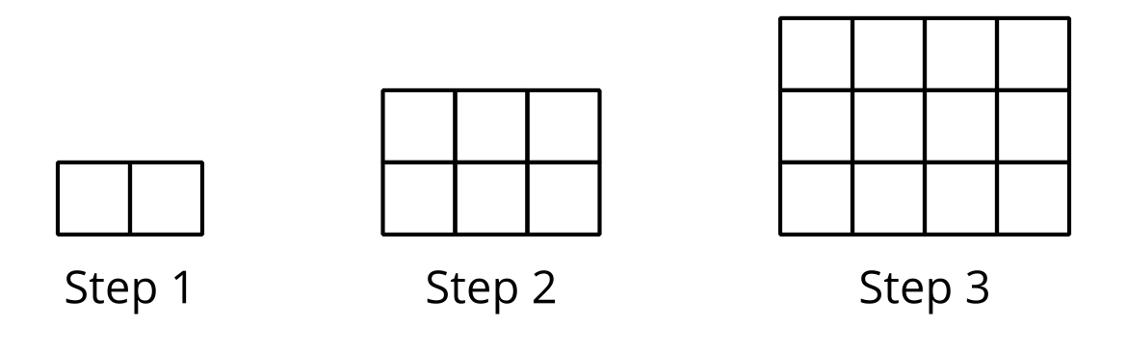
  - 10
  - 11
  - 90
  - 110
- Here are 2 patterns of dots.

- Pattern A

- Pattern B
- 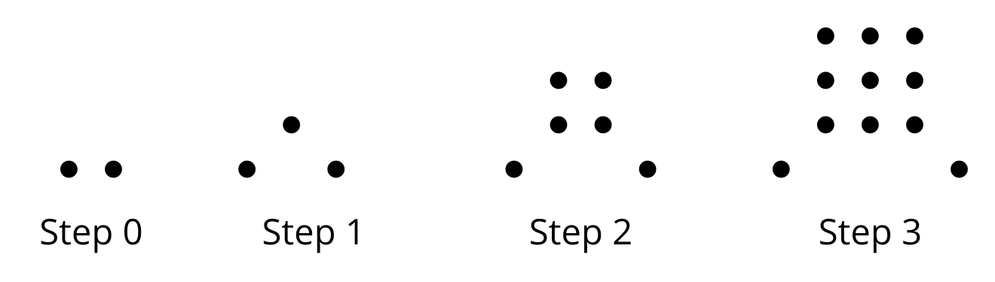
  - How many dots will there be in Step 4 of each pattern?
  - Which pattern shows a quadratic relationship between the step number and the number of dots? Explain how you know.
- Here are descriptions for how two dot patterns are growing.
  - Pattern A: Step 2 has 10 dots. It grows by 3 dots at each additional step.
  - Pattern B: The total number of dots can be expressed by $2n^{2}+1$, where $n$ is the step number.
- For each pattern, draw a diagram of Step 0 to Step 3.
- Each expression represents the total number of dots in a pattern where $n$ represents the step number.
- Select all the expressions that represent a quadratic relationship between the step number and the total number of dots. (If you get stuck, consider sketching the first few steps of each pattern as described by the expression.)
  - $n^{2}$
  - $2n$
  - $n⋅n$
  - $n+n$
  - $n+2$
  - $n÷2$
- The function $C$ gives the percentage of homes using only cell phone service $x$ years after 2004. Explain the meaning of each statement.
  - $C\left(10\right)=35$
  - $C\left(x\right)=10$
  - How is $C\left(10\right)$ different from $C\left(x\right)=10$?
- (From Unit 4, Lesson 3.)
- Here are some lengths, widths, and areas of a garden whose perimeter is 40 feet.
  - Complete the table with the missing measurements.
  - What lengths and widths do you think will produce the largest possible area? Explain how you know.
- length  (ft) | - width  (ft) | - area  (sq ft)
- 4 | - 16 | - 64
- 8 | - 12
- 10
- 12 |  | - 96
- 14
- 16 |  | - 64
- (From Unit 6, Lesson 1.)
- A bacteria population is 10,000 when it is first measured and then doubles each day.
  - Use this information to complete the table.
  - Which is the first day, after the population was originally measured, that the bacteria population is more than 1,000,000?
  - Write an equation relating $p$, the bacteria population, to $d$, the number of days since it was first measured.
- $d$, time  (days) | - $p$, population  (thousands)
- 0
- 1
- 2
- 5
- 10
- $d$
- (From Unit 5, Lesson 3.)
- Graph the solutions to the inequality $7x−3y≥21$.

- 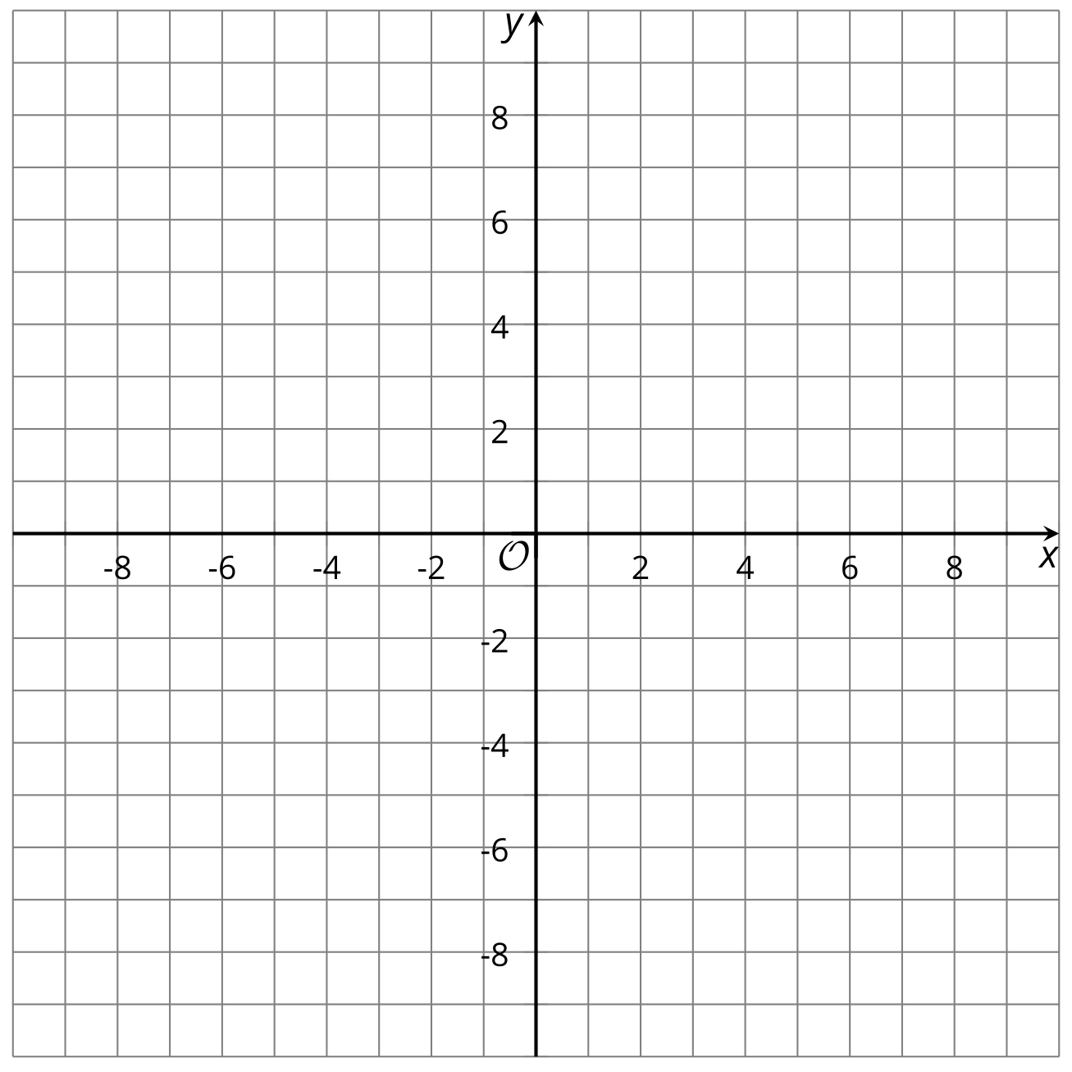

- (From Unit 2, Lesson 21.)
© CC BY 2019 by Illustrative Mathematics®

