Lesson 2: Meanings of Division
Let’s explore ways to think about division.

2.1: A Division Expression
Here is an expression: $20÷4$.
What are some ways to think about this expression? Describe at least two meanings you think it could have.

2.2: Bags of Almonds
A baker has 12 pounds of almonds. She puts them in bags, so that each bag has the same weight.
Clare and Tyler drew diagrams and wrote equations to show how they were thinking about $12÷6$.
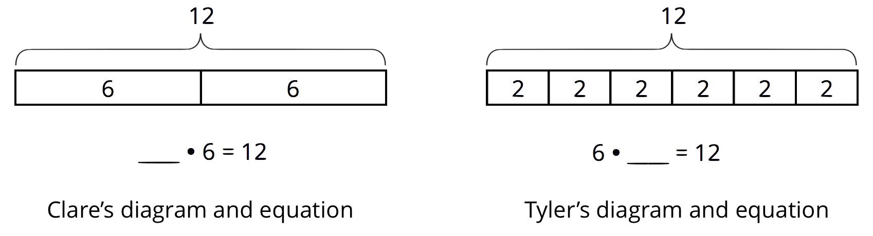
- How do you think Clare and Tyler thought about $12÷6$? Explain what each diagram and the parts of each equation could mean about the situation with the bags of almonds. Make sure to include the meaning of the missing number.
- Pause here for a class discussion.
- Explain what each division expression could mean about the situation with the bags of almonds. Then draw a diagram and write a multiplication equation to show how you are thinking about the expression.
  - $12÷4$
  - $12÷2$
  - $12÷\frac{1}{2}$

Are you ready for more?
A loaf of bread is cut into slices.
- If each slice is $\frac{1}{2}$ of a loaf, how many slices are there?
- If each slice is $\frac{1}{5}$ of a loaf, how many slices are there?
- What happens to the number of slices as each slice gets smaller?
- What would dividing by 0 mean in this situation about slicing bread?

2.3: Homemade Jams
Draw a diagram, and write a multiplication equation to represent each situation. Then answer the question.
- Mai had 4 jars. In each jar, she put $2\frac{1}{4}$ cups of homemade blueberry jam. Altogether, how many cups of jam are in the jars?
- Priya filled 5 jars, using a total of $7\frac{1}{2}$ cups of strawberry jam. How many cups of jam are in each jar?
- Han had some jars. He put $\frac{3}{4}$ cup of grape jam in each jar, using a total of $6\frac{3}{4}$ cups. How many jars did he fill?

Lesson 2 Summary
Suppose 24 bagels are being distributed into boxes. The expression $24÷3$ could be understood in two ways:
- 24 bagels are distributed equally into 3 boxes, as represented by this diagram:
- 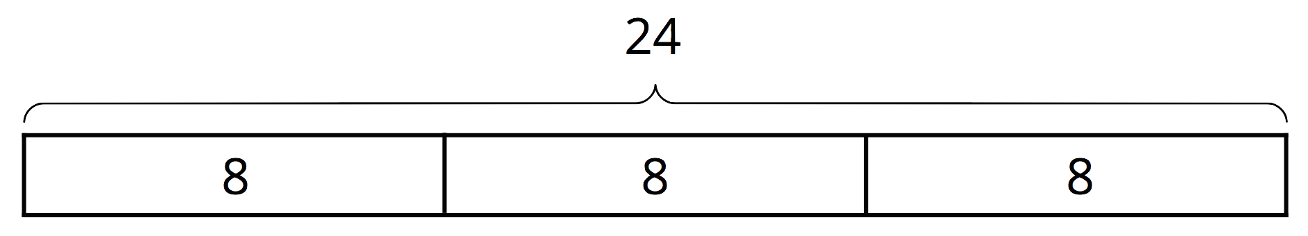
- 24 bagels are distributed into boxes, 3 bagels in each box, as represented by this diagram:
- 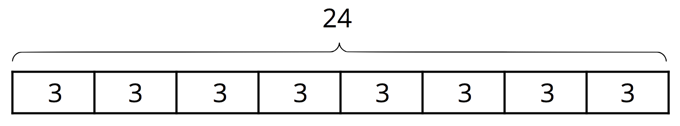
In both interpretations, the quotient is the same ($24÷3=8$), but it has different meanings in each case. In the first case, the 8 represents the number of bagels in each of the 3 boxes. In the second, it represents the number of boxes that were formed with 3 bagels in each box.
These two ways of seeing division are related to how 3, 8, and 24 are related in a multiplication. Both $3⋅8$ and $8⋅3$ equal 24.
- $3⋅8=24$ can be read as “3 groups of 8 make 24.”
- $8⋅3=24$ can be read as “8 groups of 3 make 24.”
If 3 and 24 are the only numbers given, the multiplication equations would be: $3⋅?=24$ $?⋅3=24$
In both cases, the division $24÷3$ can be used to find the value of the “?” But now we see that it can be interpreted in more than one way, because the “?” can refer to the size of a group (as in “3 groups of what number make 24?”), or to the number of groups (as in “How many groups of 3 make 24?”).
- Next, suppose we have 20 ounces of water to fill 6 equal-sized bottles, and the amount in each bottle is not given. Here we have 6 groups, an unknown amount in each, and a total of 20. We can represent it like this:
- 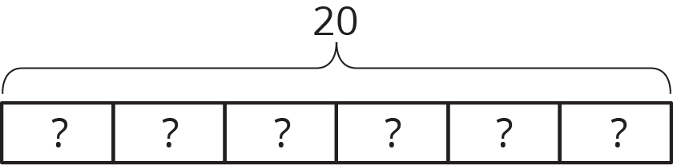
- This situation can also be expressed using multiplication, but the unknown is a factor, rather than the product: $6 ⋅?=20$
- To find the unknown, we cannot simply multiply, but we can think of it as a division problem: $20÷6= ?$
- Now, suppose we have 40 ounces of water to pour into bottles, 12 ounces in each bottle, but the number of bottles is not given. Here we have an unknown number of groups, 12 in each group, and a total of 40.
- 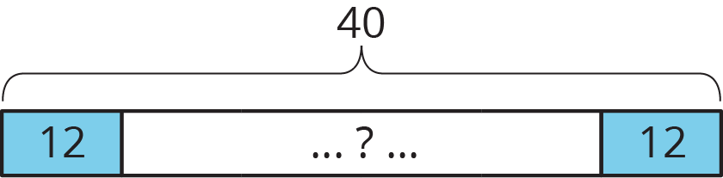
- Again, we can think of this in terms of multiplication, with a different factor being the unknown: $?⋅12=40$
- Likewise, we can use division to find the unknown: $40÷12= ?$
Whenever we have a multiplication situation, one factor tells us how many groups there are, and the other factor tells us how much is in each group.
Sometimes we want to find the total. Sometimes we want to find how many groups there are. Sometimes we want to find how much is in each group. Anytime we want to find out how many groups there are or how much is in each group, we can represent the situation using division.
© CC BY Open Up Resources. Adaptations CC BY IM.

