Unit 9 Lesson 4: Measure and Plot

WU Notice and Wonder: Line Plots (Warm up)

Student Task Statement
What do you notice? What do you wonder?
patient | foot length (cm)
A | 12
B | 18
C | 20
D | 18
E | 18
F | 20
G | 17
H | 21
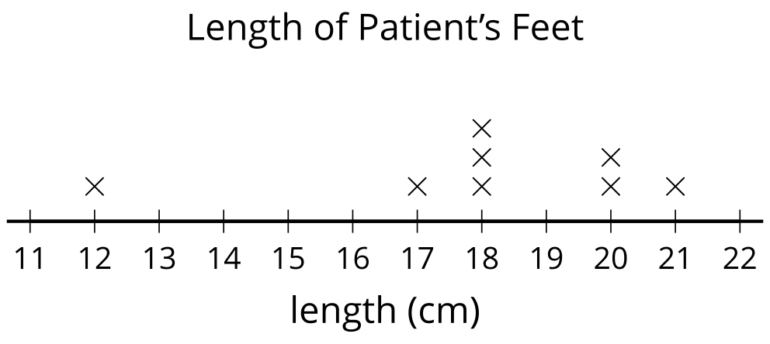

1 May I Sharpen My Pencil?

Student Task Statement
group | length of pencils in cm |  |  |  | total length
A | 8 | 13 | 12 | 7
B | 9 | 15 | 7 | 10
C | 12 | 13 | 8 | 6
D | 9 | 9 | 11 | 13
E
- Measure the length of your pencil. _______ cm
- Write the lengths of your group’s pencils in the table.
- Find the total length of each group’s pencils.

2 A Plot Twist

Student Task Statement
- Use the pencil measurements to create a line plot.
- What is the most common pencil length? _______
- What is the least common pencil length? _______
- How many students had a pencil longer than 10 cm? _______
- What is the difference between the longest pencil and the shortest pencil? Write an equation to represent the difference.
- What is the difference between the shortest pencil and the length of an unsharpened pencil? Write an equation to represent the difference.
© CC BY 2021 Illustrative Mathematics®

