Unit 9 Lesson 3: Measure on a Map

WU Notice and Wonder: From Sea to Shining Sea (Warm up)

Student Task Statement
What do you notice? What do you wonder?
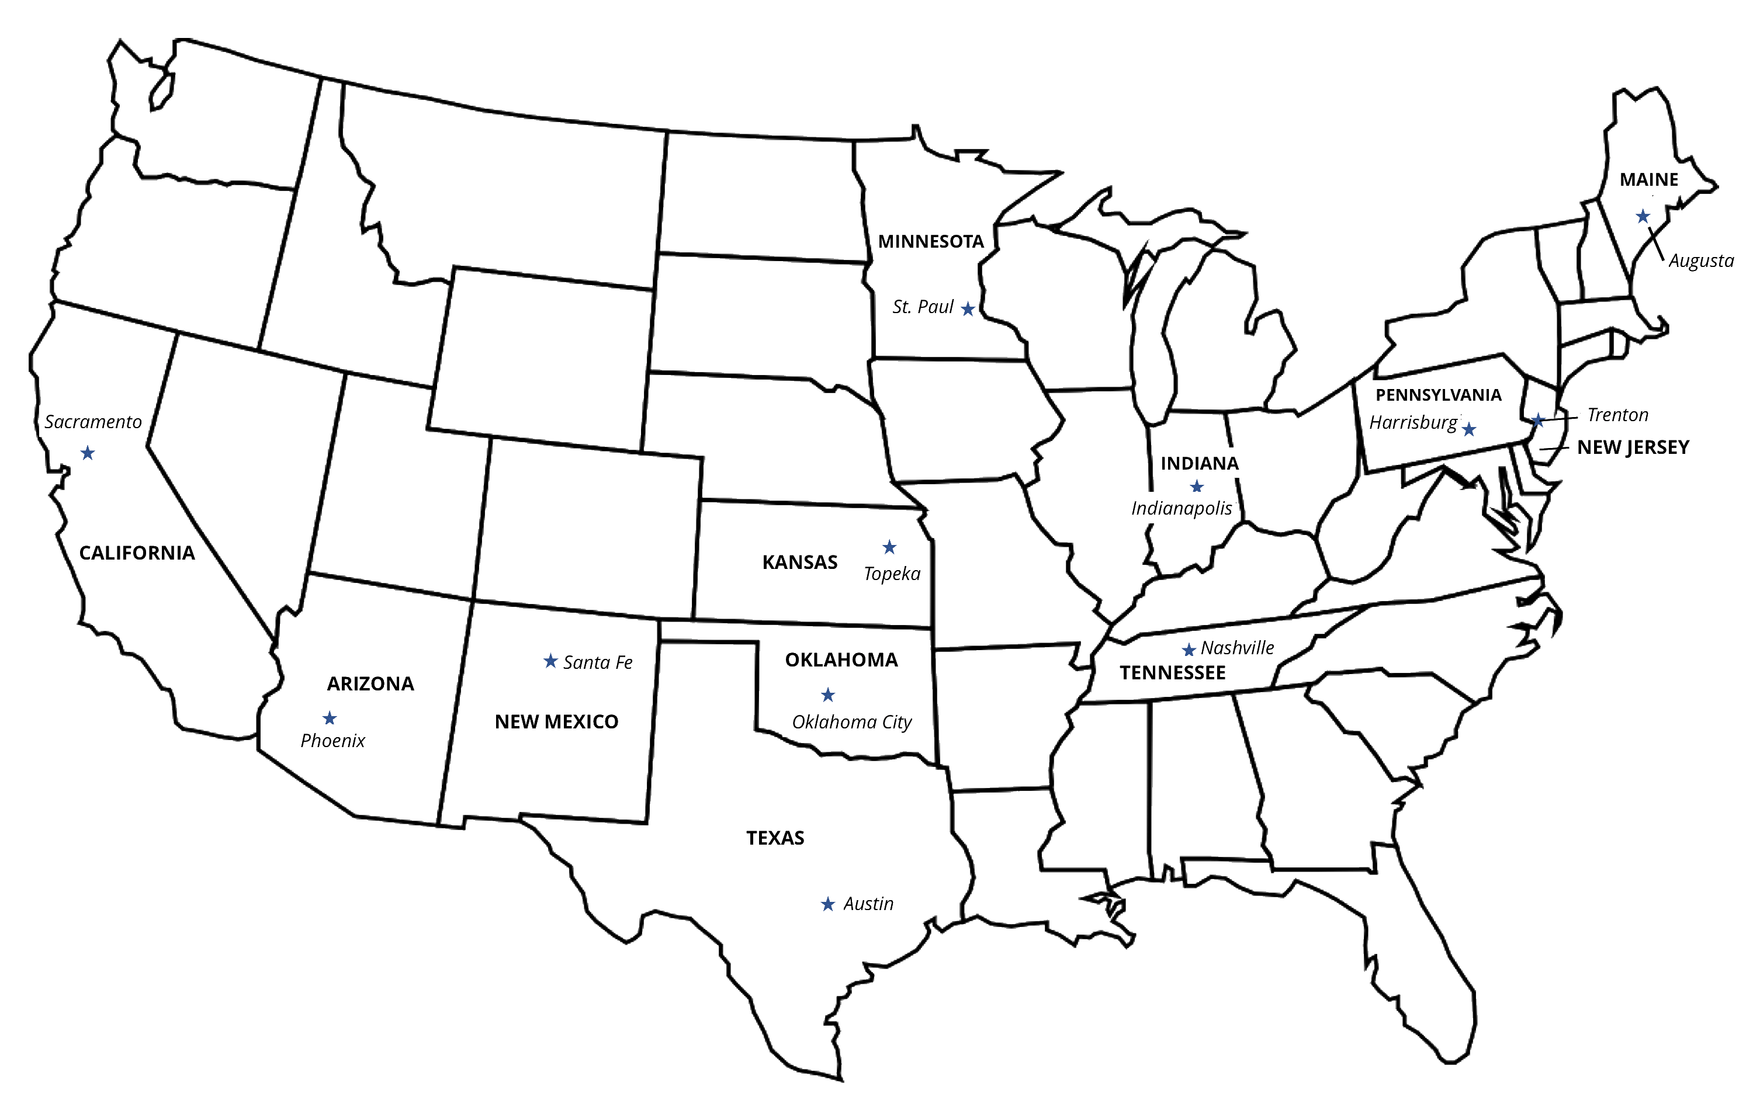

1 Measure on the Map

Student Task Statement
Draw a line to represent the distance between cities on the map. Then measure the length in centimeters.
- Noah started in Trenton, New Jersey.
  - First, he traveled to Harrisburg, Pennsylvania. _____ cm
  - Next, he traveled from Harrisburg to Indianapolis, Indiana. _____ cm
  - Last, he traveled from Indianapolis to St. Paul, Minnesota. _____ cm
- Diego started in Sacramento, California.
  - First, he traveled to Phoenix, Arizona. _____ cm
  - Next, he traveled from Phoenix to Santa Fe, New Mexico. _____ cm
  - Last, he traveled from Santa Fe to Topeka, Kansas. _____ cm
- Lin started in Austin, Texas.
  - First, she traveled to Oklahoma City, Oklahoma. _____ cm
  - Next, she traveled from Oklahoma City to Nashville, Tennessee. _____ cm
  - Last, she traveled from Nashville to Augusta, Maine. _____ cm
- Find the total length of each student’s trip. Represent the total with an equation.
  - Lin’s total
  - Diego’s total
  - Noah’s total

2 How Much Longer?

Student Task Statement
Use your map and the stories from the previous activity to answer the questions. Represent each story with an equation with a symbol for the unknown length.
- How much shorter is the total length of Diego’s trip than the total length of Lin’s trip?
- How much longer is the total length of Diego’s trip than the total length of Noah’s trip?
- How much shorter is the total length of Noah’s trip than the total length of Lin’s trip?
© CC BY 2021 Illustrative Mathematics®

