Lesson 4 Practice Problems
- Which statement is true about these 2 distributions?

- set A
- 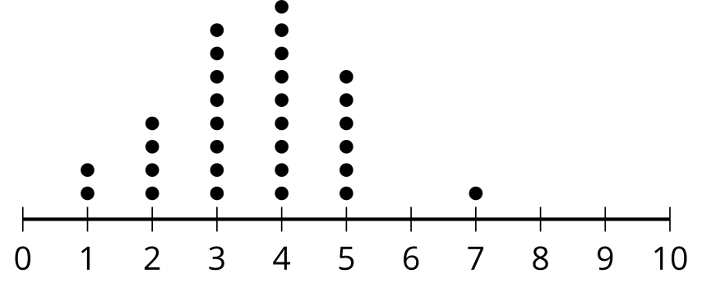

- set B
- 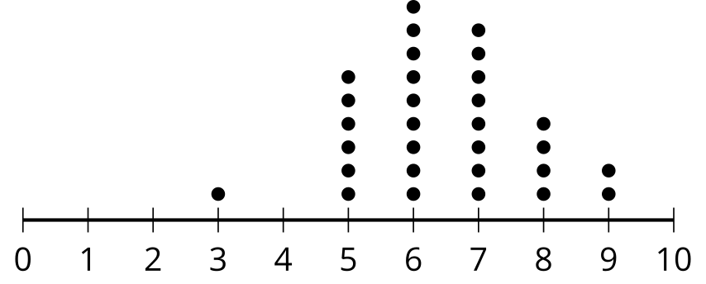
  - The mean of set A is less than the mean of set B, and their standard deviations are the same.
  - The mean of set A is greater than the mean of set B, and their standard deviations are the same.
  - The standard deviation of set A is less than the standard deviation of set B, and their means are the same.
  - The standard deviation of set A is greater than the standard deviation of set B, and their means are the same.
- Mai collects information about 37 classmates. She believes her data set is perfectly symmetrical with a mean and median of 20. She then realizes that the number she has recorded as 32 was actually supposed to be 42. What is true about the mean and median of her corrected data set?
  - The mean and median of the corrected set are both still 20.
  - The mean of the corrected data set is still 20, but the median is greater than 20.
  - The median of the corrected data set is still 20, but the mean is greater than 20.
  - The mean and median of the corrected set are both greater than 20.
- Select all distributions which are approximately symmetric.

- set A
- 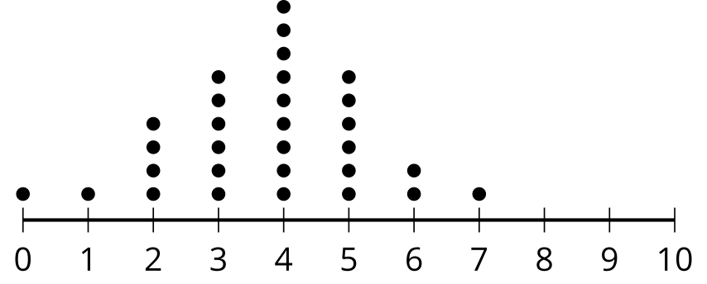

- set B
- 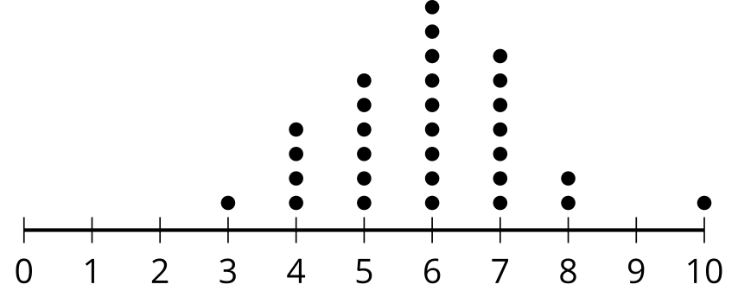

- set C
- 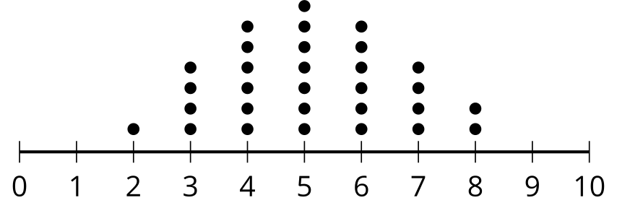

- set D
- 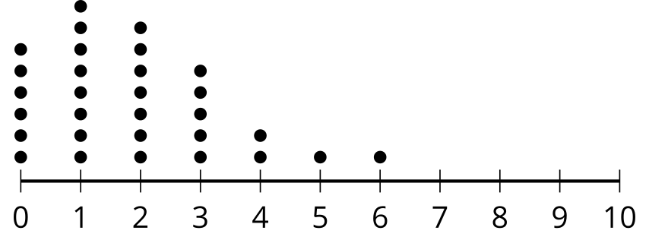

- set E
- 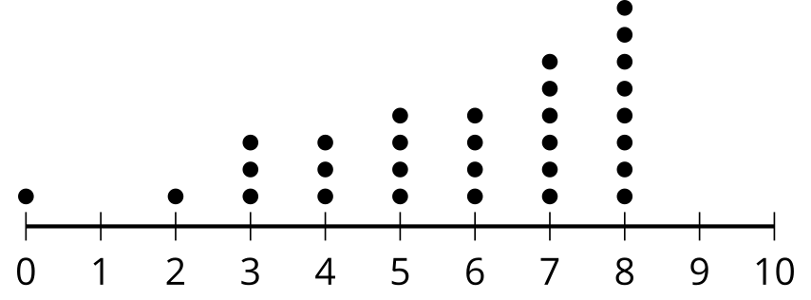

- set F
- 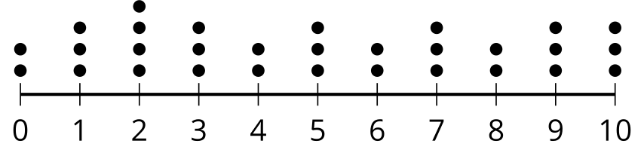
  - set A
  - set B
  - set C
  - set D
  - set E
  - set F
- In an experimental study, it was noticed that people who eat more leafy, green vegetables tend to get better sleep than the general population. Researchers wonder whether the improved sleep might be caused by the minerals potassium and magnesium found in leafy, green vegetables. How could the researchers design an experiment to determine the effects of potassium and magnesium on sleep?
- (From Unit 7, Lesson 2.)
- Elena is conducting an experiment to determine if high school students are more relaxed when the lights are off or when music is played during an exam. She selects 10 of her friends to take an exam with the lights off and another 10 of her friends to take an exam with music playing. What is problematic about the way that Elena selected her groups?
- (From Unit 7, Lesson 3.)
- An environmental education club has 318 members. Select all methods that would select a sample of 20 members at random from the entire environmental education club.
  - Ask for 20 members to volunteer to take the survey.
  - Place the names of all 318 members on individual slips of paper placed into a bowl. Thoroughly mix up the slips and then select 20 of them.
  - Number the members from 1 to 318. Use a random number generator to make a list of 20 random integers between 1 and 318 inclusive.
  - Select 10 of the younger members at random and 10 of the older members at random.
  - Send a survey to all 318 members and record the results of the first 20 responses.
- (From Unit 7, Lesson 3.)
© CC BY 2019 by Illustrative Mathematics®

