Lesson 1: Understanding Proportional Relationships
Let’s study some graphs.

1.1: Notice and Wonder: Two Graphs
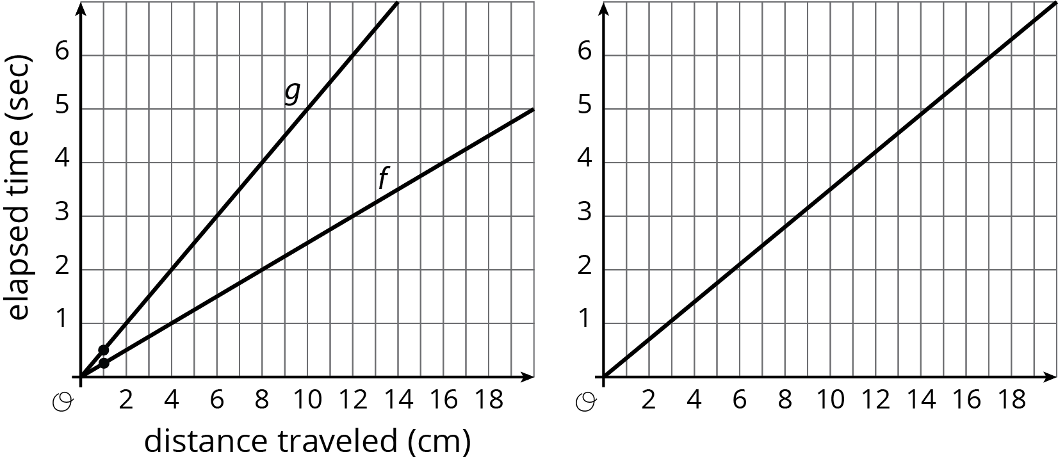
What do you notice? What do you wonder?

1.2: Moving Through Representations
A ladybug and ant move at constant speeds. The diagrams with tick marks show their positions at different times. Each tick mark represents 1 centimeter.
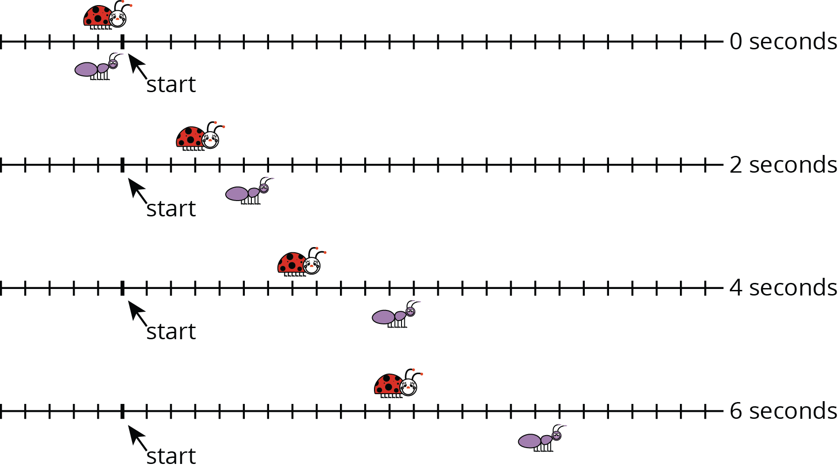
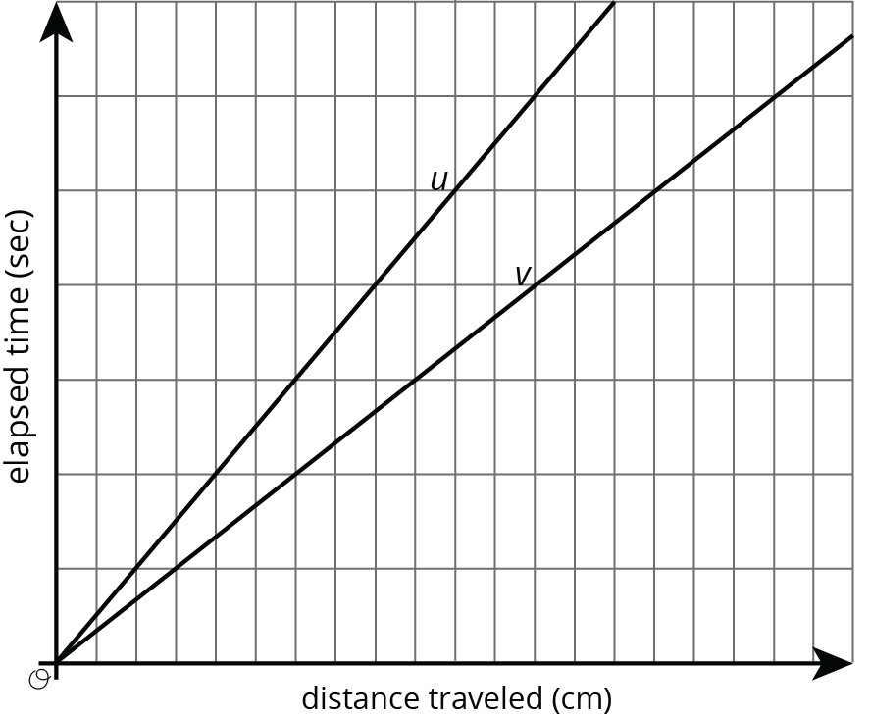
- Lines $u$ and $v$ also show the positions of the two bugs. Which line shows the ladybug’s movement? Which line shows the ant’s movement? Explain your reasoning.
- How long does it take the ladybug to travel 12 cm? The ant?
- Scale the vertical and horizontal axes by labeling each grid line with a number. You will need to use the time and distance information shown in the tick-mark diagrams.
- Mark and label the point on line $u$ and the point on line $v$ that represent the time and position of each bug after traveling 1 cm.

Are you ready for more?
- How fast is each bug traveling?
- Will there ever be a time when the ant is twice as far away from the start as the ladybug? Explain or show your reasoning.

1.3: Moving Twice as Fast
Refer to the tick-mark diagrams and graph in the earlier activity when needed.
- Imagine a bug that is moving twice as fast as the ladybug. On each tick-mark diagram, mark the position of this bug.
- Plot this bug’s positions on the coordinate axes with lines $u$ and $v$, and connect them with a line.
- Write an equation for each of the three lines.

Lesson 1 Summary
Graphing is a way to help us make sense of relationships. But the graph of a line on a coordinate axes without scale or labels isn’t very helpful. For example, let’s say we know that on longer bike rides Kiran can ride 4 miles every 16 minutes and Mai can ride 4 miles every 12 minutes. Here are the graphs of these relationships:
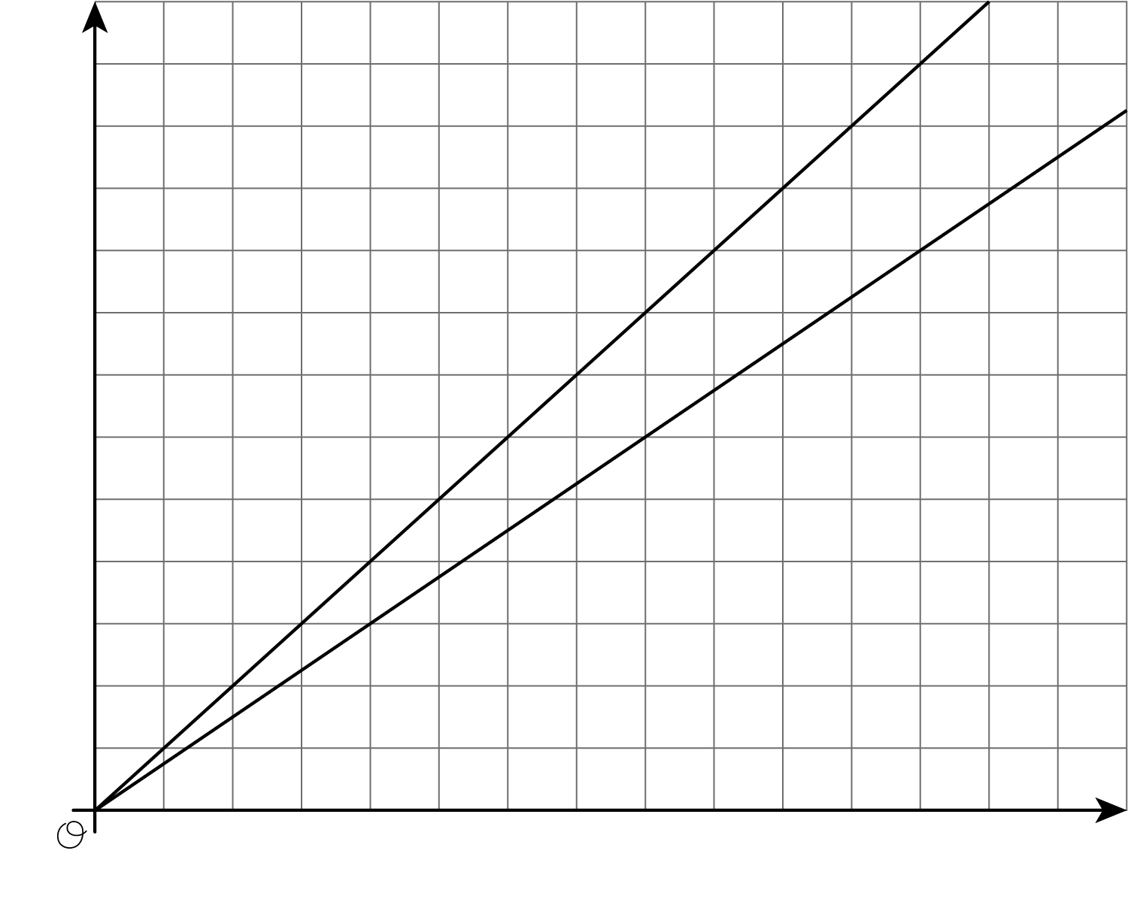
Without labels we can’t even tell which line is Kiran and which is Mai! Without labels and a scale on the axes, we can’t use these graphs to answer questions like:
- Which graph goes with which rider?
- Who rides faster?
- If Kiran and Mai start a bike trip at the same time, how far are they after 24 minutes?
- How long will it take each of them to reach the end of the 12 mile bike path?
Here are the same graphs, but now with labels and scale:
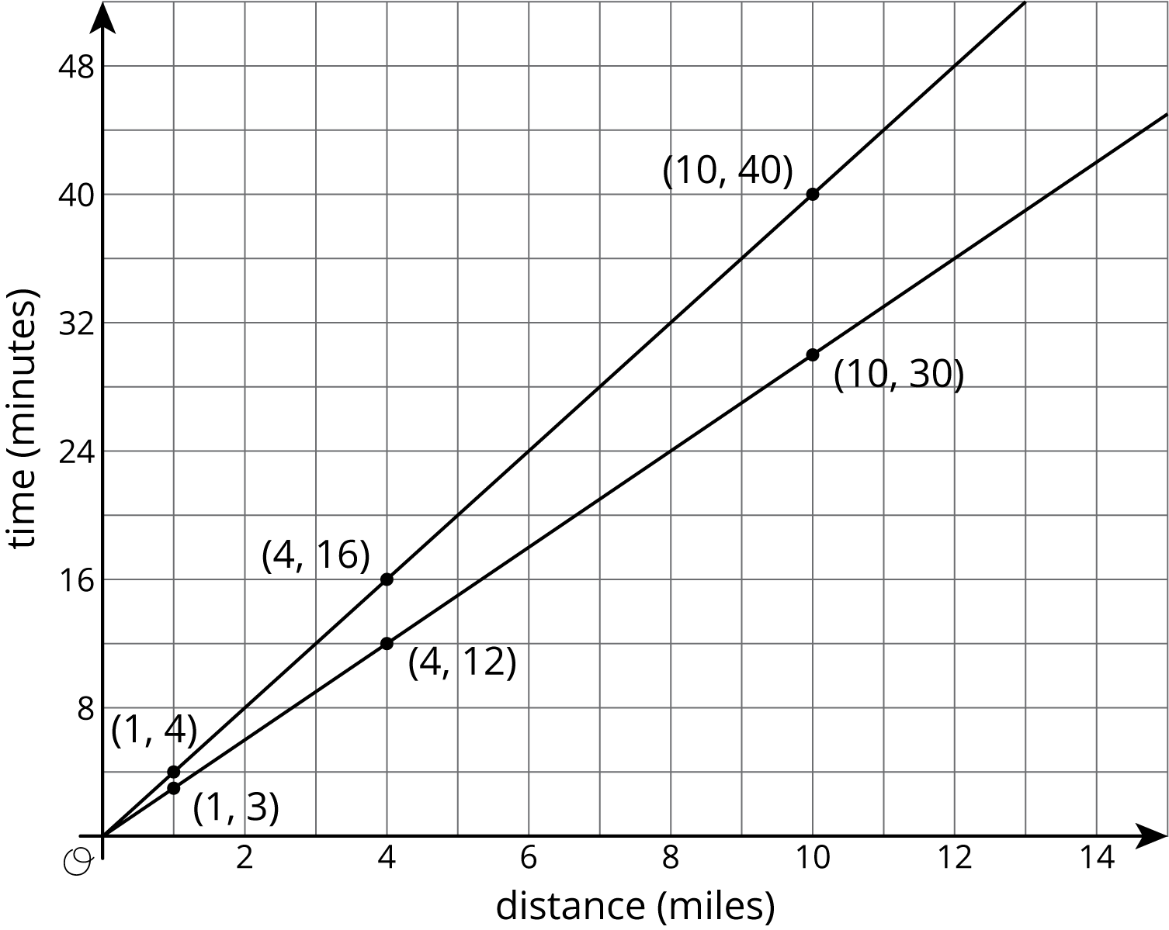
Revisiting the questions from earlier:
- Which graph goes with each rider? If Kiran rides 4 miles in 16 minutes, then the point $\left(4,16\right)$ is on his graph. If he rides for 1 mile, it will take 4 minutes. 10 miles will take 40 minutes. So the upper graph represents Kiran’s ride. Mai’s points for the same distances are $\left(1,3\right)$, $\left(4,12\right)$, and $\left(10,30\right)$, so hers is the lower graph. (A letter next to each line would help us remember which is which!)
- Who rides faster? Mai rides faster because she can ride the same distance as Kiran in a shorter time.
- If Kiran and Mai start a bike trip at the same time, how far are they after 20 minutes? The points on the graphs at height 20 are 5 miles for Kiran and a little less than 7 miles for Mai.
- How long will it take each of them to reach the end of the 12 mile bike path? The points on the graphs at a horizontal distance of 12 are 36 minutes for Mai and 48 minutes for Kiran. (Kiran’s time after 12 miles is almost off the grid!)
© CC BY Open Up Resources. Adaptations CC BY IM.

