Unit 7 Lesson 7 Cumulative Practice Problems
- In the diagram, the length of segment $AB$ is 10 units and the radius of the circle centered at $A$ is 4 units. Use this to create two unique triangles, each with a side of length 10 and a side of length 4. Label the sides that have length 10 and 4.
- 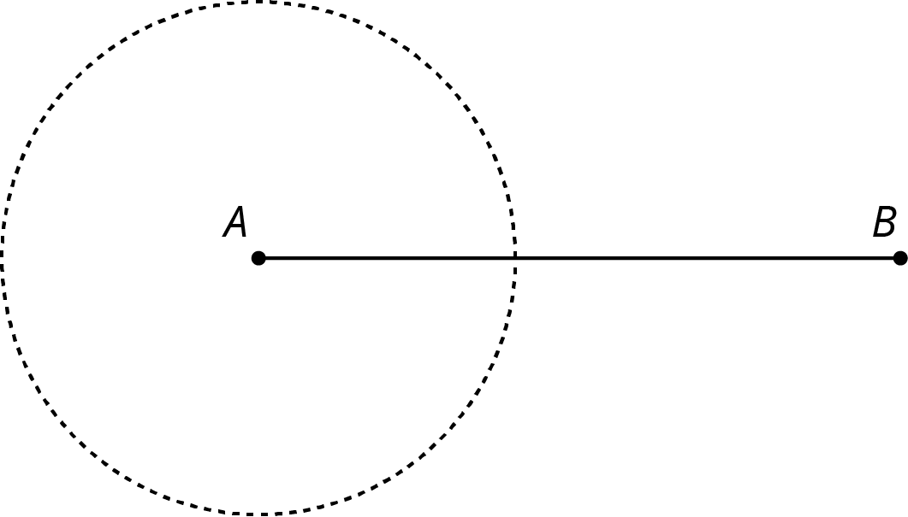
- Select all the sets of three side lengths that will make a triangle.
  - 3, 4, 8
  - 7, 6, 12
  - 5, 11, 13
  - 4, 6, 12
  - 4, 6, 10
- Based on signal strength, a person knows their lost phone is exactly 47 feet from the nearest cell tower. The person is currently standing 23 feet from the same cell tower. What is the closest the phone could be to the person? What is the furthest their phone could be from them?
- Each row contains the degree measures of two complementary angles. Complete the table.
- measure of an angle | - measure of its complement
- ${80}^{∘}$
- ${25}^{∘}$
- ${54}^{∘}$
- $x$
- (From Unit 7, Lesson 2.)
- Here are two patterns made using identical rhombuses. Without using a protractor, determine the value of $a$ and $b$. Explain or show your reasoning.
- 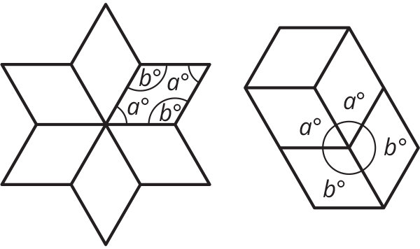

- (From Unit 7, Lesson 1.)
- Mai’s family is traveling in a car at a constant speed of 65 miles per hour.
  - At that speed, how long will it take them to travel 200 miles?
  - How far do they travel in 25 minutes?
- (From Unit 4, Lesson 3.)
© CC BY Open Up Resources. Adaptations CC BY IM.

