Lesson 1 Practice Problems
- Here are a few pairs of positive numbers whose sum is 50.
  - Find the product of each pair of numbers.
  - Find a pair of numbers that have a sum of 50 and will produce the largest possible product.
  - Explain how you determined which pair of numbers have the largest product.
- first number | - second number | - product
- 1 | - 49
- 2 | - 48
- 10 | - 40
- Here are some lengths and widths of a rectangle whose perimeter is 20 meters.
  - Complete the table. What do you notice about the areas?
- length  (meters) | - width  (meters) | - area  (square meters)
- 1 | - 9
- 3 | - 7
  - 5
  - 7
  - 9
  - Without calculating, predict whether the area of the rectangle will be greater or less than 25 square meters if the length is 5.25 meters.
  - On the coordinate plane, plot the points for length and area from your table.
  - Do the values change in a linear way? Do they change in an exponential way?
  - 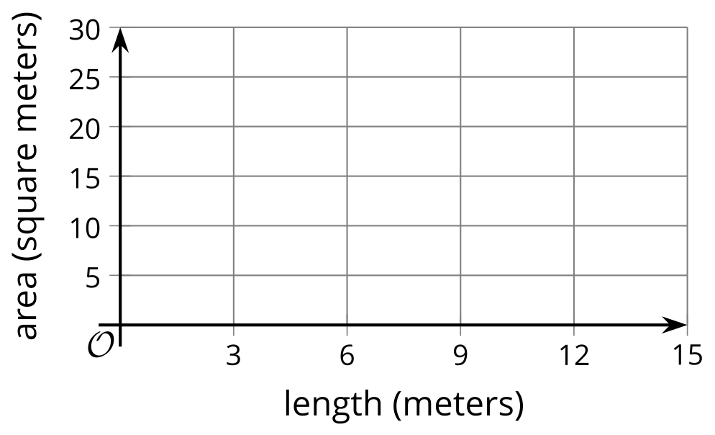
- The table shows the relationship between $x$ and $y$, the side lengths of a rectangle, and the area of the rectangle.
  - Explain why the relationship between the side lengths is linear.
  - Explain why the relationship between $x$ and the area is neither linear nor exponential.
- $x$ (cm) | - $y$ (cm) | - area  (sq cm)
- 2 | - 4 | - 8
- 4 | - 8 | - 32
- 6 | - 12 | - 72
- 8 | - 16 | - 128
- Which statement best describes the relationship between a rectangle's side length and area as represented by the graph?
- 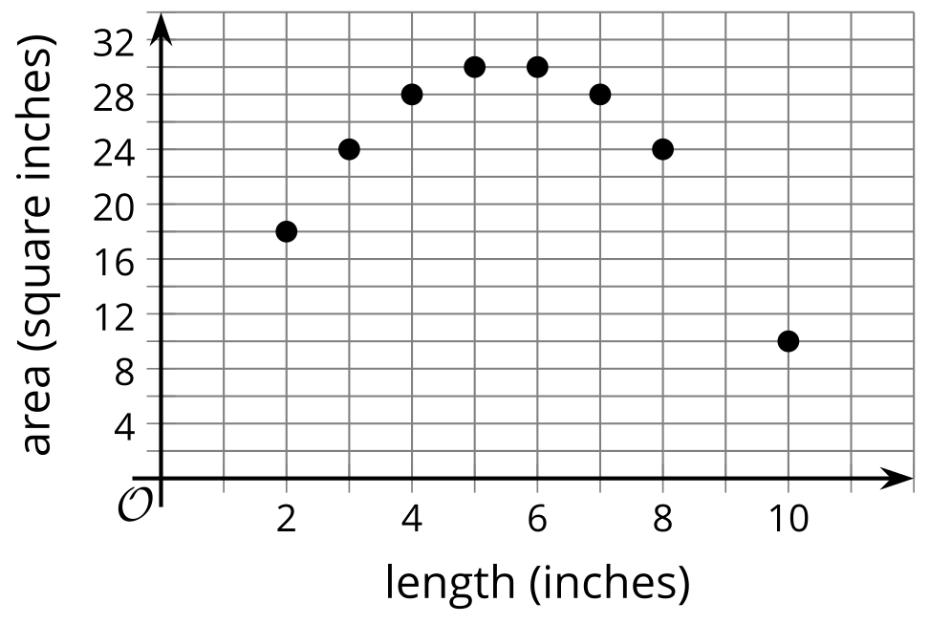
  - As the side length increases by 1, the area increases and then decreases by an equal amount.
  - As the side length increases by 1, the area increases and then decreases by an equal factor.
  - As the side length increases by 1, the area does not increase or decrease by an equal amount.
  - As the side length increases by 1, the area does not change.
- Copies of a book are arranged in a stack. Each copy of a book is 2.1 cm thick.
  - Complete the table.
  - What do you notice about the differences in the height of the stack of books when a new copy of the book is added?
  - What do you notice about the factor by which the height of the stack of books changes when a new copy is added?
  - How high is a stack of $b$ books?
- copies of book | - stack height in cm
- 0
- 1
- 2
- 3
- 4
- (From Unit 5, Lesson 2.)
- The value of a phone when it was purchased was $500. It loses $\frac{1}{5}$ of its value a year.
  - What is the value of the phone after 1 year? What about after 2 years? 3 years?
  - Tyler says that the value of the phone decreases by $100 each year since $\frac{1}{5}$ of 500 is 100. Do you agree with Tyler? Explain your reasoning.
- (From Unit 5, Lesson 4.)
- Technology required. The data in the table represents the price of one gallon of milk in different years.
- Use graphing technology to create a scatter plot of the data.
  - Does a linear model seem appropriate for this data? Why or why not?
  - If it seems appropriate for the data, create the line of best fit. Round to two decimal places.
  - What is the slope of the line of best fit, and what does it mean in this context? Is it realistic?
  - What is the $y$-intercept of the line of best fit, and what does it mean in this context? Is it realistic?
- $x$, time (years) | - price per gallon  of milk (dollars)
- 1930 | - 0.26
- 1935 | - 0.47
- 1940 | - 0.52
- 1940 | - 0.50
- 1945 | - 0.63
- 1950 | - 0.83
- 1955 | - 0.93
- 1960 | - 1.00
- 1965 | - 1.05
- 1970 | - 1.32
- 1970 | - 1.25
- 1975 | - 1.57
- 1985 | - 2.20
- 1995 | - 2.50
- 2005 | - 3.20
- 2018 | - 2.90
- 2018 | - 3.25
- (From Unit 3, Lesson 5.)
- Give a value for $r$ that indicates that a line of best fit has a negative slope and models the data well.
- (From Unit 3, Lesson 7.)
© CC BY 2019 by Illustrative Mathematics®

