Lesson 3: Ordering Rational Numbers
Let’s order rational numbers.

3.1: How Do They Compare?
Use the symbols >, <, or = to compare each pair of numbers. Be prepared to explain your reasoning.
- 12 _____ 19
- 212 _____ 190
- 15 _____ 1.5
- 9.02 _____ 9.2
- 6.050 _____ 6.05
- 0.4 _____ $\frac{9}{40}$
- $\frac{19}{24}$ _____ $\frac{19}{21}$
- $\frac{16}{17}$ _____ $\frac{11}{12}$

3.2: Ordering Rational Number Cards
Your teacher will give you a set of number cards. Order them from least to greatest.
Your teacher will give you a second set of number cards. Add these to the correct places in the ordered set.

3.3: Comparing Points on A Line

- Use each of the following terms at least once to describe or compare the values of points $M$, $N$, $P$, $R$.
  - greater than
  - less than
  - opposite of (or opposites)
  - negative number
- Tell what the value of each point would be if:
  - $P$ is $2\frac{1}{2}$
  - $N$ is -0.4
  - $R$ is 200
  - $M$ is -15

Are you ready for more?
The list of fractions between 0 and 1 with denominators between 1 and 3 looks like this:
$\frac{0}{1}, \frac{1}{1}, \frac{1}{2}, \frac{1}{3}, \frac{2}{3}$
We can put them in order like this: $\frac{0}{1}<\frac{1}{3}<\frac{1}{2}<\frac{2}{3}<\frac{1}{1}$
Now let’s expand the list to include fractions with denominators of 4. We won’t include $\frac{2}{4}$, because $\frac{1}{2}$ is already on the list.
$\frac{0}{1}<\frac{1}{4}<\frac{1}{3}<\frac{1}{2}<\frac{2}{3}<\frac{3}{4}<\frac{1}{1}$
- Expand the list again to include fractions that have denominators of 5.
- Expand the list you made to include fractions have have denominators of 6.
- When you add a new fraction to the list, you put it in between two “neighbors.” Go back and look at your work. Do you see a relationship between a new fraction and its two neighbors?

3.4: Drinks for Sale
A vending machine in an office building sells bottled beverages. The machine keeps track of all changes in the number of bottles from sales and from machine refills and maintenance. This record shows the changes for every 5-minute period over one hour.
- What might a positive number mean in this context? What about a negative number?
- What would a “0” in the second column mean in this context?
- Which numbers—positive or negative—result in fewer bottles in the machine?
- At what time was there the greatest change to the number of bottles in the machine? How did that change affect the number of remaining bottles in the machine?
- At which time period, 8:05–8:09 or 8:25–8:29, was there a greater change to the number of bottles in the machine? Explain your reasoning.
- The machine must be emptied to be serviced. If there are 40 bottles in the machine when it is to be serviced, what number will go in the second column in the table?
time | number of bottles
8:00–8:04 | -1
8:05–8:09 | +12
8:10–8:14 | -4
8:15–8:19 | -1
8:20–8:24 | -5
8:25–8:29 | -12
8:30–8:34 | -2
8:35–8:39 | 0
8:40–8:44 | 0
8:45–8:49 | -6
8:50–8:54 | +24
8:55–8:59 | 0
service

Are you ready for more?
Priya, Mai, and Lin went to a cafe on a weekend. Their shared bill came to $25. Each student gave the server a $10 bill. The server took this $30 and brought back five $1 bills in change. Each student took $1 back, leaving the rest, $2, as a tip for the server.
As she walked away from the cafe, Lin thought, “Wait—this doesn’t make sense. Since I put in $10 and got $1 back, I wound up paying $9. So did Mai and Priya. Together, we paid $27. Then we left a $2 tip. That makes $29 total. And yet we originally gave the waiter $30. Where did the extra dollar go?”
Think about the situation and about Lin’s question. Do you agree that the numbers didn’t add up properly? Explain your reasoning.

Lesson 3 Summary
To order rational numbers from least to greatest, we list them in the order they appear on the number line from left to right. For example, we can see that the numbers
-2.7, -1.3, 0.8
are listed from least to greatest because of the order they appear on the number line.
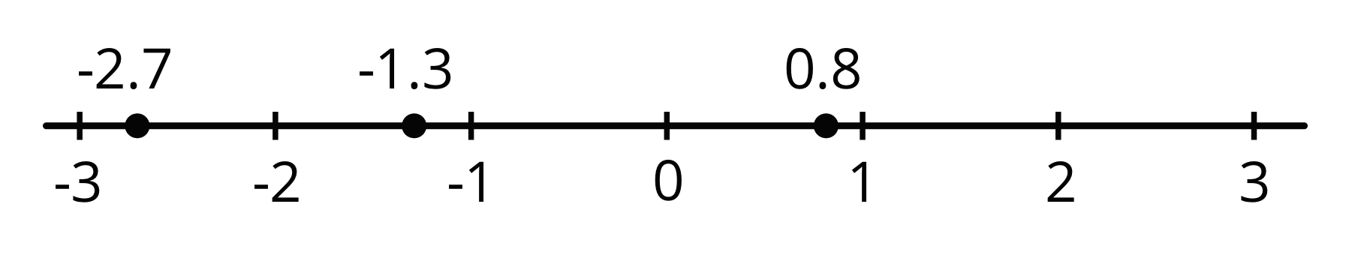
© CC BY Open Up Resources. Adaptations CC BY IM.

