Unit 1 Lesson 10: Situations and Sequence Types

1 Describing Growth (Warm up)

Student Task Statement
- Here is a geometric sequence. What is the growth factor? 16, 24, 36, 54, 81
- One way to describe its growth is to say it’s growing by $\underset{_}{​}$% each time. What number goes in the blank for the sequence 16, 24, 36, 54, 81? Be prepared to explain your reasoning.

2 Finding Population Patterns

Student Task Statement
The table shows two animal populations growing over time.
years since 1990 | Population $A$ | Population $B$
0 | 23,000 | 3,125
1 | 29,000 | 3,750
2 | 35,000 | 4,500
3 | 41,000 | 5,400
4 | 47,000 | 6,480
- Are the sequences represented by Population $A$ and Population $B$ arithmetic or geometric? Explain how you know.
- Write an equation to define Population $A$.
- Write an equation to define Population $B$.
- Does Population $B$ ever overtake Population $A$? If so, when? Explain how you know.

3 Finding Square Patterns

Student Task Statement
Define the sequence $W$ so that $W\left(n\right)$ is the number of white squares in Step $n$, and define the sequence $B$ so that $B\left(n\right)$ is the number of black squares in Step $n$.
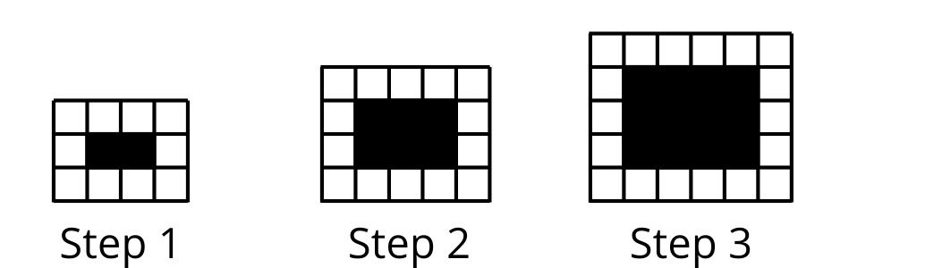
- Are the sequences $W$ and $B$ arithmetic, geometric, or neither? Explain how you know.
- Write an equation for sequence $W$.
- Write an equation for sequence $B$.
- Is the number of black squares ever larger than the number of white squares? Explain how you know.
© CC BY 2019 by Illustrative Mathematics®

