Unit 1 Lesson 9: What’s the Equation?

1 Math Talk: Multiplying Fractions (Warm up)

Student Task Statement
For the function $f\left(x\right)=32⋅{\left(\frac{3}{4}\right)}^{x}$, evaluate mentally:
$f\left(0\right)$
$f\left(1\right)$
$f\left(2\right)$
$f\left(3\right)$

2 Take the Cake!

Student Task Statement
A large cake is in a room. The first person who comes in takes $\frac{1}{3}$ of the cake. Then a second person takes $\frac{1}{3}$ of what is left. Then a third person takes $\frac{1}{3}$ of what is left. And so on.
- Complete the table for $C\left(n\right)$, the fraction of the original cake left after $n$ people take some.
- Write two definitions for $C$: one recursive and one non-recursive.
- What is a reasonable domain for this function? Be prepared to explain your reasoning.
$n$ | $C\left(n\right)$
0
1 | $\frac{2}{3}$
2
3
4

3 Fibonacci Squares

Student Task Statement
- On graph paper, draw a square of side length 1. Draw another square of side length 1 that shares a side with the first square. Next, add a 2-by-2 square, with one side along the sides of both of the first two squares. Next, add a square with one side that goes along the sides of the previous two squares you created. Next, do it again.
Pause here for your teacher to check your work.
- Write a sequence that lists the side lengths of the squares you drew.
- Predict the next two terms in the sequence and draw the corresponding squares to check your predictions.
- Describe how each square’s side length depends on previous side lengths.
- Let $F\left(n\right)$ be the side length of the $n$^{th} square. So $F\left(1\right)=1$ and $F\left(2\right)=1$. Write a recursive definition for $F$.

Images for Activity Synthesis
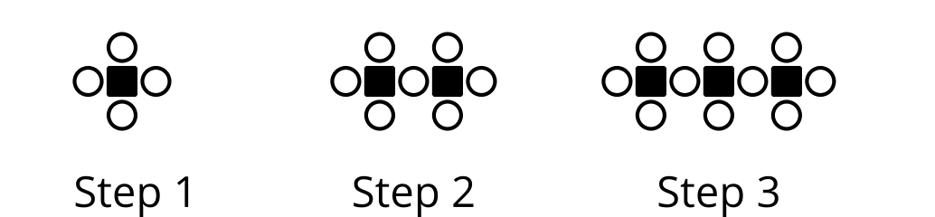
© CC BY 2019 by Illustrative Mathematics®

