Unit 2 Lesson 4: Congruent Triangles, Part 2

1 Make That Triangle (Warm up)

Student Task Statement
Draw triangle $ABC$ with these measurements:
- Angle $A$ is 40 degrees.
- Angle $B$ is 20 degrees.
- Angle $C$ is 120 degrees.
- Segment $AB$ is 5 centimeters.
- Segment $AC$ is 2 centimeters.
- Segment $BC$ is 3.7 centimeters.
Highlight each piece of given information that you used. Check your triangle to make sure the remaining measurements match.

2 Info Gap: Too Much Information

Images for Launch
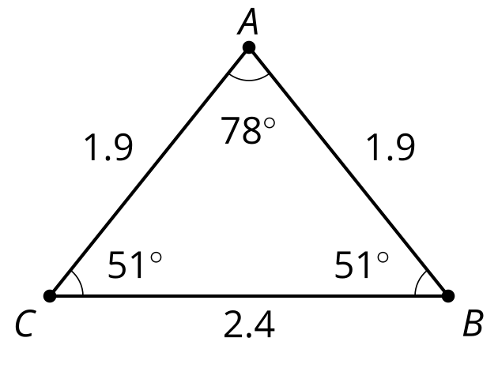

Student Task Statement
Your teacher will give you either a problem card or a data card. Do not show or read your card to your partner.
If your teacher gives you the data card:
- Silently read the information on your card.
- Ask your partner “What specific information do you need?” and wait for your partner to ask for information. Only give information that is on your card. (Do not figure out anything for your partner!)
- Before telling your partner the information, ask “Why do you need to know (that piece of information)?”
- Read the problem card, and solve the problem independently.
- Share the data card, and discuss your reasoning.
If your teacher gives you the problem card:
- Silently read your card and think about what information you need to answer the question.
- Ask your partner for the specific information that you need.
- Explain to your partner how you are using the information to solve the problem.
- When you have enough information, share the problem card with your partner, and solve the problem independently.
- Read the data card, and discuss your reasoning.

3 Too Little Information?

Student Task Statement
Jada and Tyler were playing the Info Gap, using Card 3.
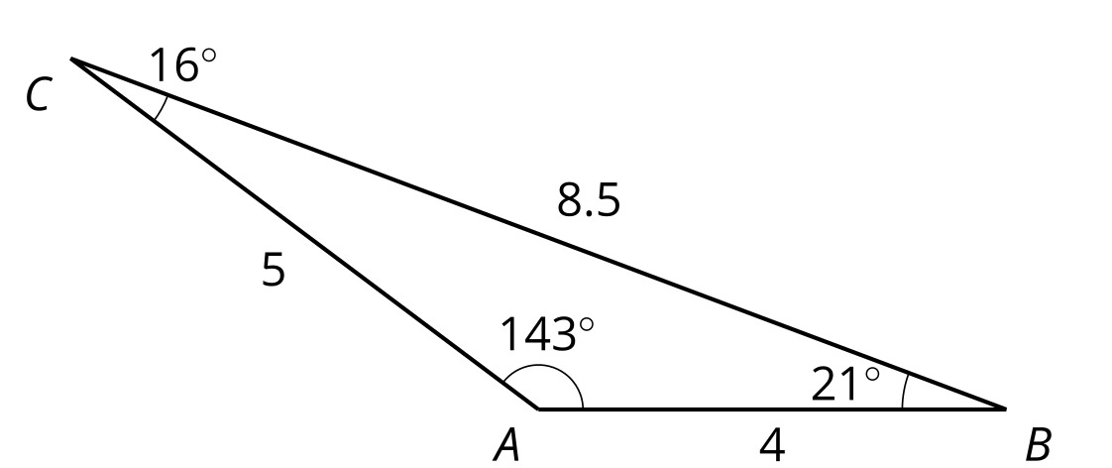
Tyler asked, “Can I have 2 sides and an angle?”
Jada told Tyler that one angle was ${16}^{∘}$, one side was 5 cm, and one side was 4 cm. Here is the triangle Tyler made:
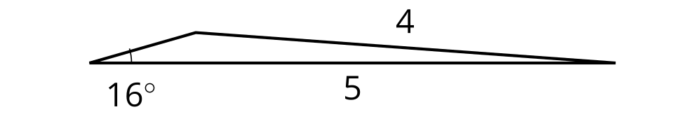
- Is Tyler’s triangle congruent to the triangle on the Data Card?
- Did Tyler do anything that didn’t match Jada’s instructions?
- How could Tyler have made a more specific request for 2 sides and an angle so that his triangle was guaranteed to match Jada’s?

Activity Synthesis
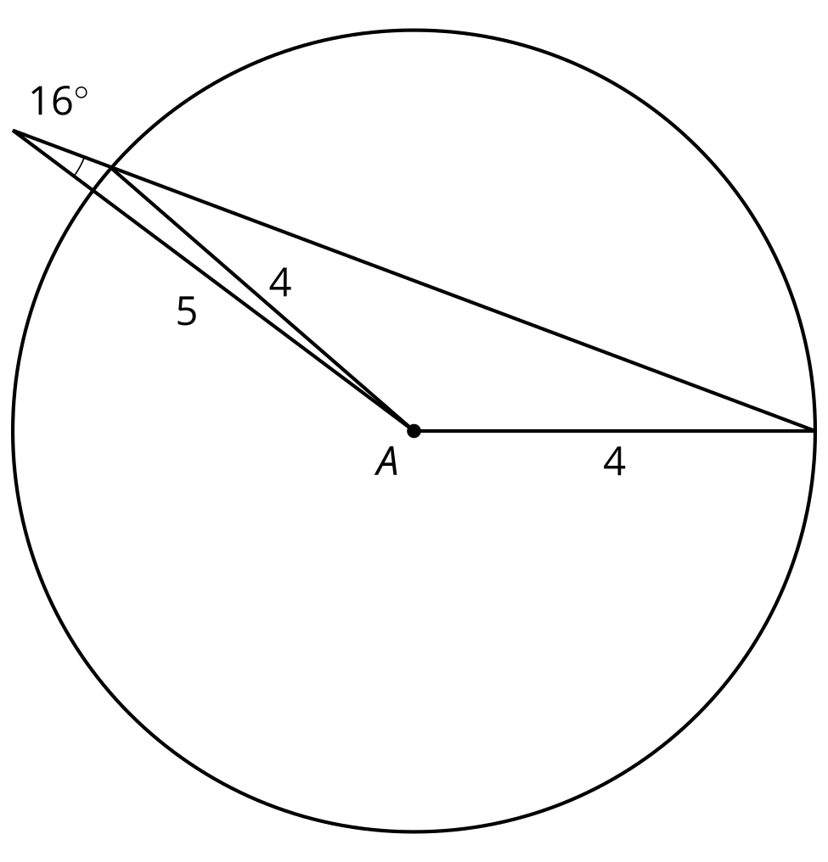
© CC BY 2019 by Illustrative Mathematics®

