Lesson 5 Practice Problems
- Select all the points that are on the graph of the equation $4y−6x=12$.
  - $\left(\text{-}4,\text{-}3\right)$
  - $\left(\text{-}1,1.5\right)$
  - $\left(0,\text{-}2\right)$
  - $\left(0,3\right)$
  - $\left(3,\text{-}4\right)$
  - $\left(6,4\right)$
- Here is a graph of the equation $x+3y=6$.
- Select all coordinate pairs that represent a solution to the equation.
- 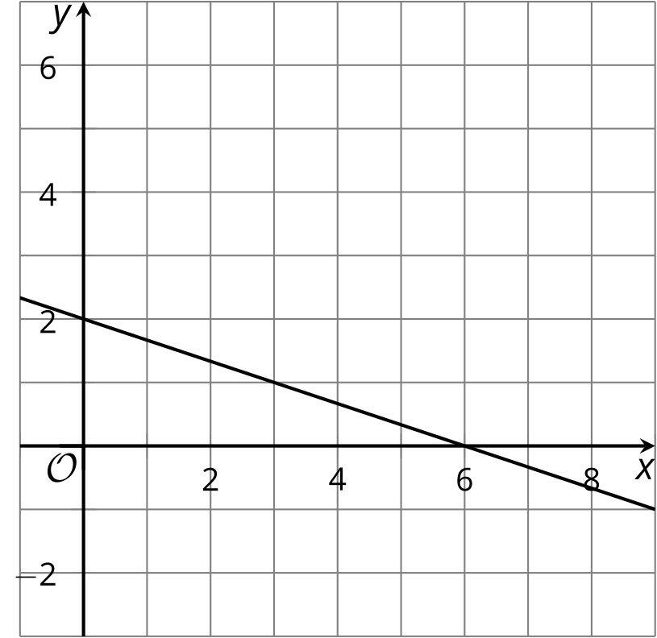
  - $\left(0,2\right)$
  - $\left(0,6\right)$
  - $\left(2,6\right)$
  - $\left(3,1\right)$
  - $\left(4,1\right)$
  - $\left(6,2\right)$
- A theater is selling tickets to a play. Adult tickets cost $8 each and children’s tickets cost $5 each. They collect $275 after selling $x$ adult tickets and $y$ children’s tickets.
- 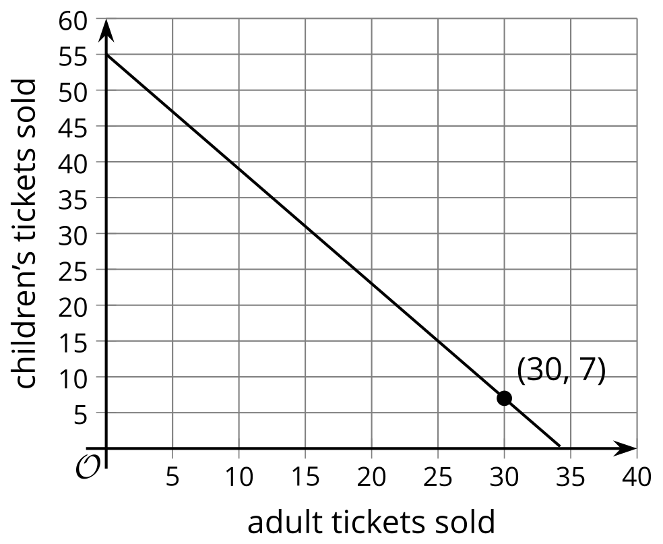
- What does the point $\left(30,7\right)$ mean in this situation?
- Technology required. Priya starts with $50 in her bank account. She then deposits $20 each week for 12 weeks.
  - Write an equation that represents the relationship between the dollar amount in her bank account and the number of weeks of saving.
  - Graph your equation using graphing technology. Mark the point on the graph that represents the amount after 3 weeks.
  - How many weeks does it take her to have $250 in her bank account? Mark this point on the graph.
- During the month of August, the mean of the daily rainfall in one city was 0.04 inches with a standard deviation of 0.15 inches. In another city, the mean of the daily rainfall was 0.01 inches with a standard deviation of 0.05 inches.
- Han says that both cities had a similar pattern of precipitation in the month of August. Do you agree with Han? Explain your reasoning.
- (From Unit 1, Lesson 13.)
- In a video game, players form teams and work together to earn as many points as possible for their team. Each team can have between 2 and 4 players. Each player can score up to 20 points in each round of the game. Han and three of his friends decided to form a team and play a round.
- Write an expression, an equation, or an inequality for each quantity described here. If you use a variable, specify what it represents.
  - the allowable number of players on a team
  - the number of points Han's team earns in one round if every player earns a perfect score
  - the number of points Han's team earns in one round if no players earn a perfect score
  - the number of players in a game with six teams of different sizes: two teams have 4 players each and the rest have 3 players each
  - the possible number of players in a game with eight teams
- (From Unit 2, Lesson 1.)
- A student on the cross-country team runs 30 minutes a day as a part of her training.
- Write an equation to describe the relationship between the distance she runs in miles, $D$, and her running speed, in miles per hour, when she runs:
  - at a constant speed of 4 miles per hour for the entire 30 minutes
  - at a constant speed of 5 miles per hour the first 20 minutes, and then at 4 miles per hour the last 10 minutes
  - at a constant speed of 6 miles per hour the first 15 minutes, and then at 5.5 miles per hour for the remaining 15 minutes
  - at a constant speed of $a$ miles per hour the first 6 minutes, and then at 6.5 miles per hour for the remaining 24 minutes
  - at a constant speed of 5.4 miles per hour for $m$ minutes, and then at $b$ miles per hour for $n$ minutes
- (From Unit 2, Lesson 2.)
- In the 21st century, people measure length in feet and meters. At various points in history, people measured length in hands, cubits, and paces. There are 9 hands in 2 cubits. There are 5 cubits in 3 paces.
  - Write an equation to express the relationship between hands, $h$, and cubits, $c$.
  - Write an equation to express the relationship between hands, $h$, and paces, $p$.
- (From Unit 2, Lesson 3.)
- The table shows the amount of money, $A$, in a savings account after $m$ months.
- Select all the equations that represent the relationship between the amount of money, $A$, and the number of months, $m$.
- number of months | - dollar amount
- 5 | - 1,200
- 6 | - 1,300
- 7 | - 1,400
- 8 | - 1,500
  - $A=100m$
  - $A=100\left(m−5\right)$
  - $A−700=100m$
  - $A−1,​200=100m$
  - $A=700+100m$
  - $A=1200+100m$
  - $A=1,​200+100\left(m−5\right)$
- (From Unit 2, Lesson 3.)
© CC BY 2019 by Illustrative Mathematics®

