Unit 8 Lesson 8: Keeping Track of All Possible Outcomes

1 How Many Different Meals? (Warm up)

Student Task Statement
How many different meals are possible if each meal includes one main course, one side dish, and one drink?
main courses | side dishes | drinks
grilled chicken | salad | milk
turkey sandwich | applesauce | juice
pasta salad | — | water

2 Lists, Tables, and Trees

Student Task Statement
Consider the experiment: Flip a coin, and then roll a number cube.
Elena, Kiran, and Priya each use a different method for finding the sample space of this experiment.
- Elena carefully writes a list of all the options: Heads 1, Heads 2, Heads 3, Heads 4, Heads 5, Heads 6, Tails 1, Tails 2, Tails 3, Tails 4, Tails 5, Tails 6.
- Kiran makes a table:
 | 1 | 2 | 3 | 4 | 5 | 6
H | H1 | H2 | H3 | H4 | H5 | H6
T | T1 | T2 | T3 | T4 | T5 | T6
- Priya draws a tree with branches in which each pathway represents a different outcome:
- 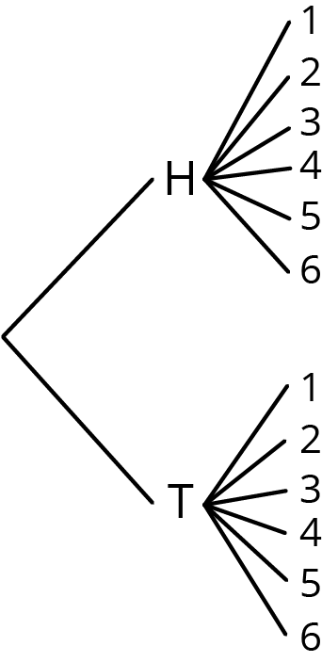
- Compare the three methods. What is the same about each method? What is different? Be prepared to explain why each method produces all the different outcomes without repeating any.
- Which method do you prefer for this situation?
- Pause here so your teacher can review your work.
- Find the sample space for each of these experiments using any method. Make sure you list every possible outcome without repeating any.
  - Flip a dime, then flip a nickel, and then flip a penny. Record whether each lands heads or tails up.
  - Han’s closet has: a blue shirt, a gray shirt, a white shirt, blue pants, khaki pants, and black pants. He must select one shirt and one pair of pants to wear for the day.
  - Spin a color, and then spin a number.
  - 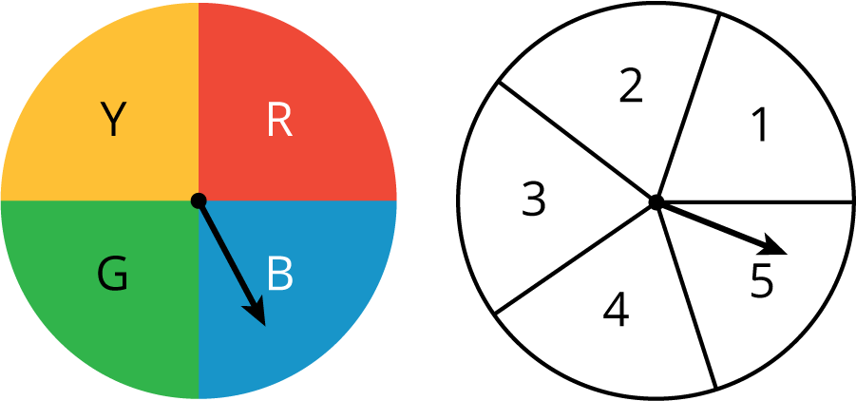
  - Spin the hour hand on an analog clock, and then choose a.m. or p.m.

3 How Many Sandwiches?

Student Task Statement
- A submarine sandwich shop makes sandwiches with one kind of bread, one protein, one choice of cheese, and two vegetables. How many different sandwiches are possible? Explain your reasoning. You do not need to write out the sample space.
  - Breads: Italian, white, wheat
  - Proteins: Tuna, ham, turkey, beans
  - Cheese: Provolone, Swiss, American, none
  - Vegetables: Lettuce, tomatoes, peppers, onions, pickles
- 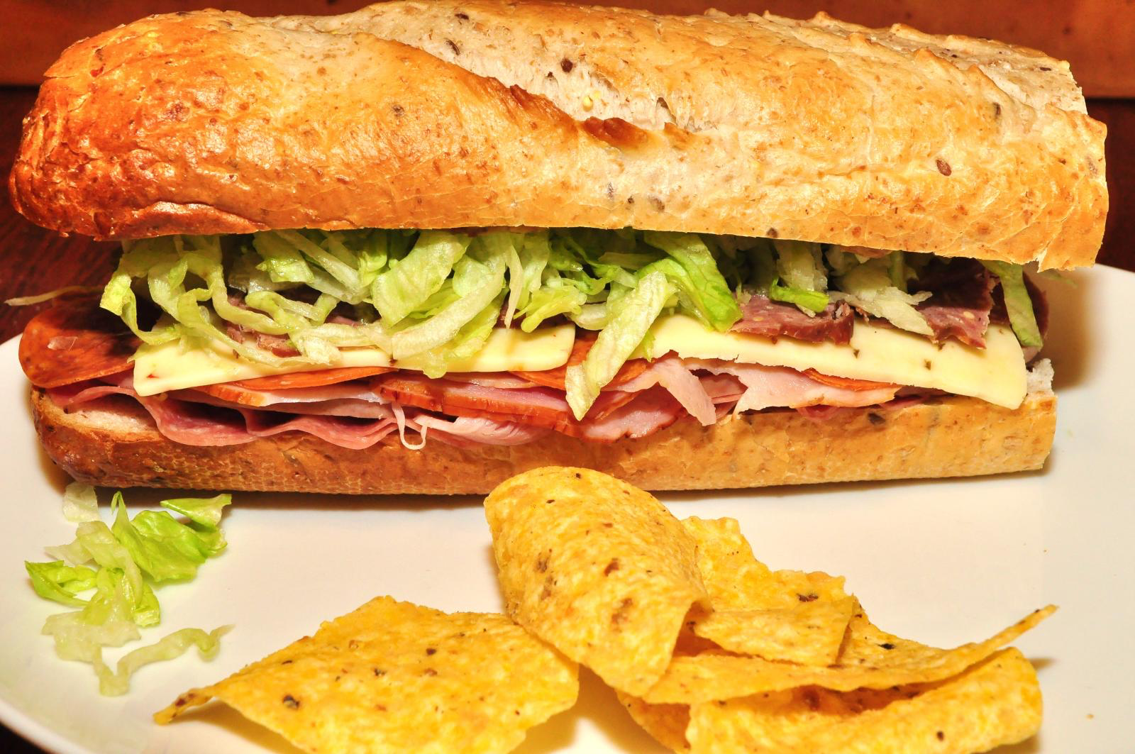
- Andre knows he wants a sandwich that has ham, lettuce, and tomatoes on it. He doesn’t care about the type of bread or cheese. How many of the different sandwiches would make Andre happy?
- If a sandwich is made by randomly choosing each of the options, what is the probability it will be a sandwich that Andre would be happy with?
© CC BY Open Up Resources. Adaptations CC BY IM.

