Lesson 7 Practice Problems
- Match each equation with an equivalent equation. Some of the answer choices are not used.
  - $3x+6=4x+7$
  - $3\left(x+6\right)=4x+7$
  - $4x+3x=7−6$
  - $9x=4x+7$
  - $3x+18=4x+7$
  - $3x=4x+7$
  - $3x−1=4x$
  - $7x=1$
- Mai says that equations A and B have the same solution.
  - Equation A: $\text{-}3\left(x+7\right)=24$
  - Equation B: $x+7=\text{-}8$
- Which statement explains why this is true?
  - Adding 3 to both sides of Equation A gives $x+7=\text{-}8$.
  - Applying the distributive property to Equation A gives $x+7=\text{-}8$.
  - Subtracting 3 from both sides of Equation A gives $x+7=\text{-}8$.
  - Dividing both sides of Equation A by -3 gives $x+7=\text{-}8$.
- Is 0 a solution to $2x+10=4x+10$? Explain or show your reasoning.
- Kiran says that a solution to the equation $x+4=20$ must also be a solution to the equation $5\left(x+4\right)=100$.
- Write a convincing explanation as to why this is true.
- The entrepreneurship club is ordering potted plants for all 36 of its sponsors. One store charges $8.50 for each plant plus a delivery fee of $20. The equation $320=x+7.50\left(36\right)$ represents the cost of ordering potted plants at a second store.
- What does the $x$ represent in this situation?
  - The cost for each potted plant at the second store
  - The delivery fee at the second store
  - The total cost of ordering potted plants at the second store
  - The number of sponsors of the entrepreneurship club
- (From Unit 2, Lesson 4.)
- Which equation is equivalent to the equation $5x+30=45$?
  - $35x=45$
  - $5x=75$
  - $5\left(x+30\right)=45$
  - $5\left(x+6\right)=45$
- (From Unit 2, Lesson 6.)
- The environmental science club is printing T-shirts for its 15 members. The printing company charges a certain amount for each shirt plus a setup fee of $20.
- If the T-shirt order costs a total of $162.50, how much does the company charge for each shirt?
- (From Unit 2, Lesson 4.)
- The graph shows the relationship between temperature in degrees Celsius and temperature in degrees Fahrenheit.
- 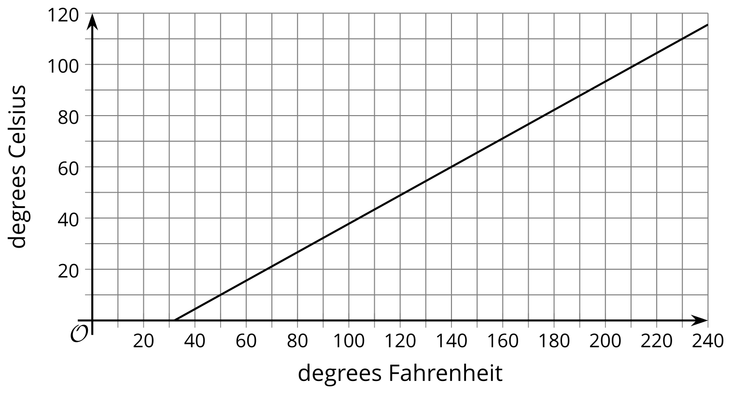
  - Mark the point on the graph that shows the temperature in Celsius when it is 60 degrees Fahrenheit.
  - Mark the point on the graph that shows the temperature in Fahrenheit when it is 60 degrees Celsius.
  - Water boils at 100 degrees Celsius. Use the graph to approximate the boiling temperature in Fahrenheit, or to confirm it, if you knew what it is.
  - The equation that converts Fahrenheit to Celsius is $C=\frac{5}{9}\left(F−32\right)$. Use it to calculate the temperature in Celsius when it is 60 degrees Fahrenheit. (This answer will be more exact than the point you found in the first part.)
- (From Unit 2, Lesson 5.)
- Select all the equations that have the same solution as $2x−5=15$.
  - $2x=10$
  - $2x=20$
  - $2\left(x−5\right)=15$
  - $2x−20=0$
  - $4x−10=30$
  - $15=5−2x$
- Diego’s age $d$ is 5 more than 2 times his sister’s age $s$. This situation is represented by the equation $d=2s+5$. Which equation is equivalent to the equation $d=2s+5$?
  - $d=2\left(s+5\right)$
  - $d−5=2s$
  - $d−2=s+5$
  - $\frac{d}{2}=s+5$
- (From Unit 2, Lesson 6.)
© CC BY 2019 by Illustrative Mathematics®

