Unit 1 Lesson 5: Bases and Heights of Parallelograms

1 A Parallelogram and Its Rectangles (Warm up)

Student Task Statement
Elena and Tyler were finding the area of this parallelogram:
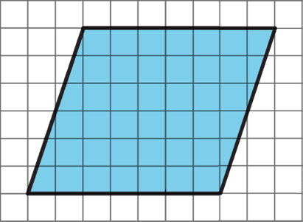
Here is how Elena did it:
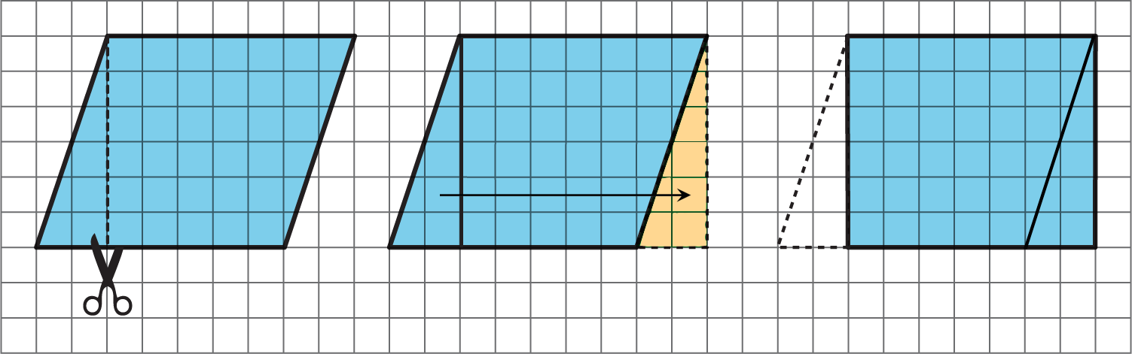
Here is how Tyler did it:
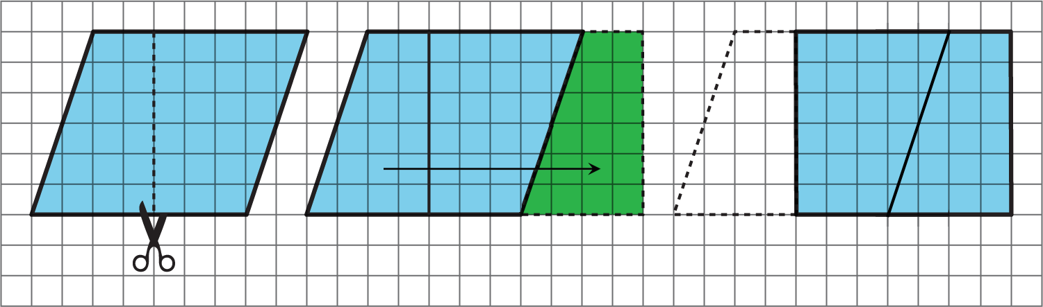
How are the two strategies for finding the area of a parallelogram the same? How they are different?

Activity Synthesis
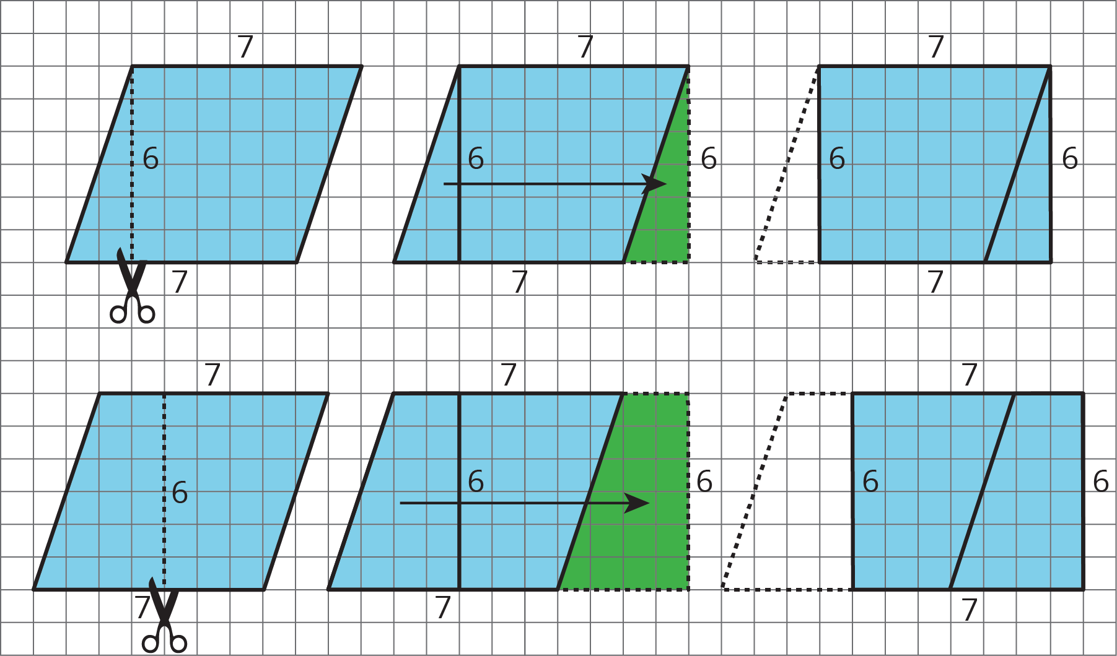

2 The Right Height?

Student Task Statement
Study the examples and non-examples of bases and heights of parallelograms.
- Examples: The dashed segments in these drawings represent the corresponding height for the given base.
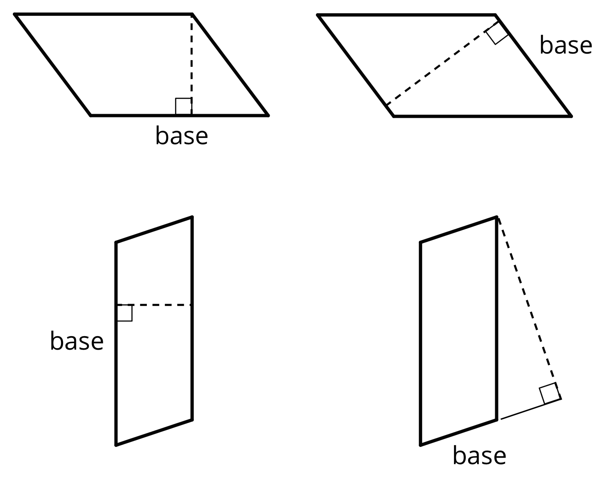
- Non-examples: The dashed segments in these drawings do not represent the corresponding height for the given base.
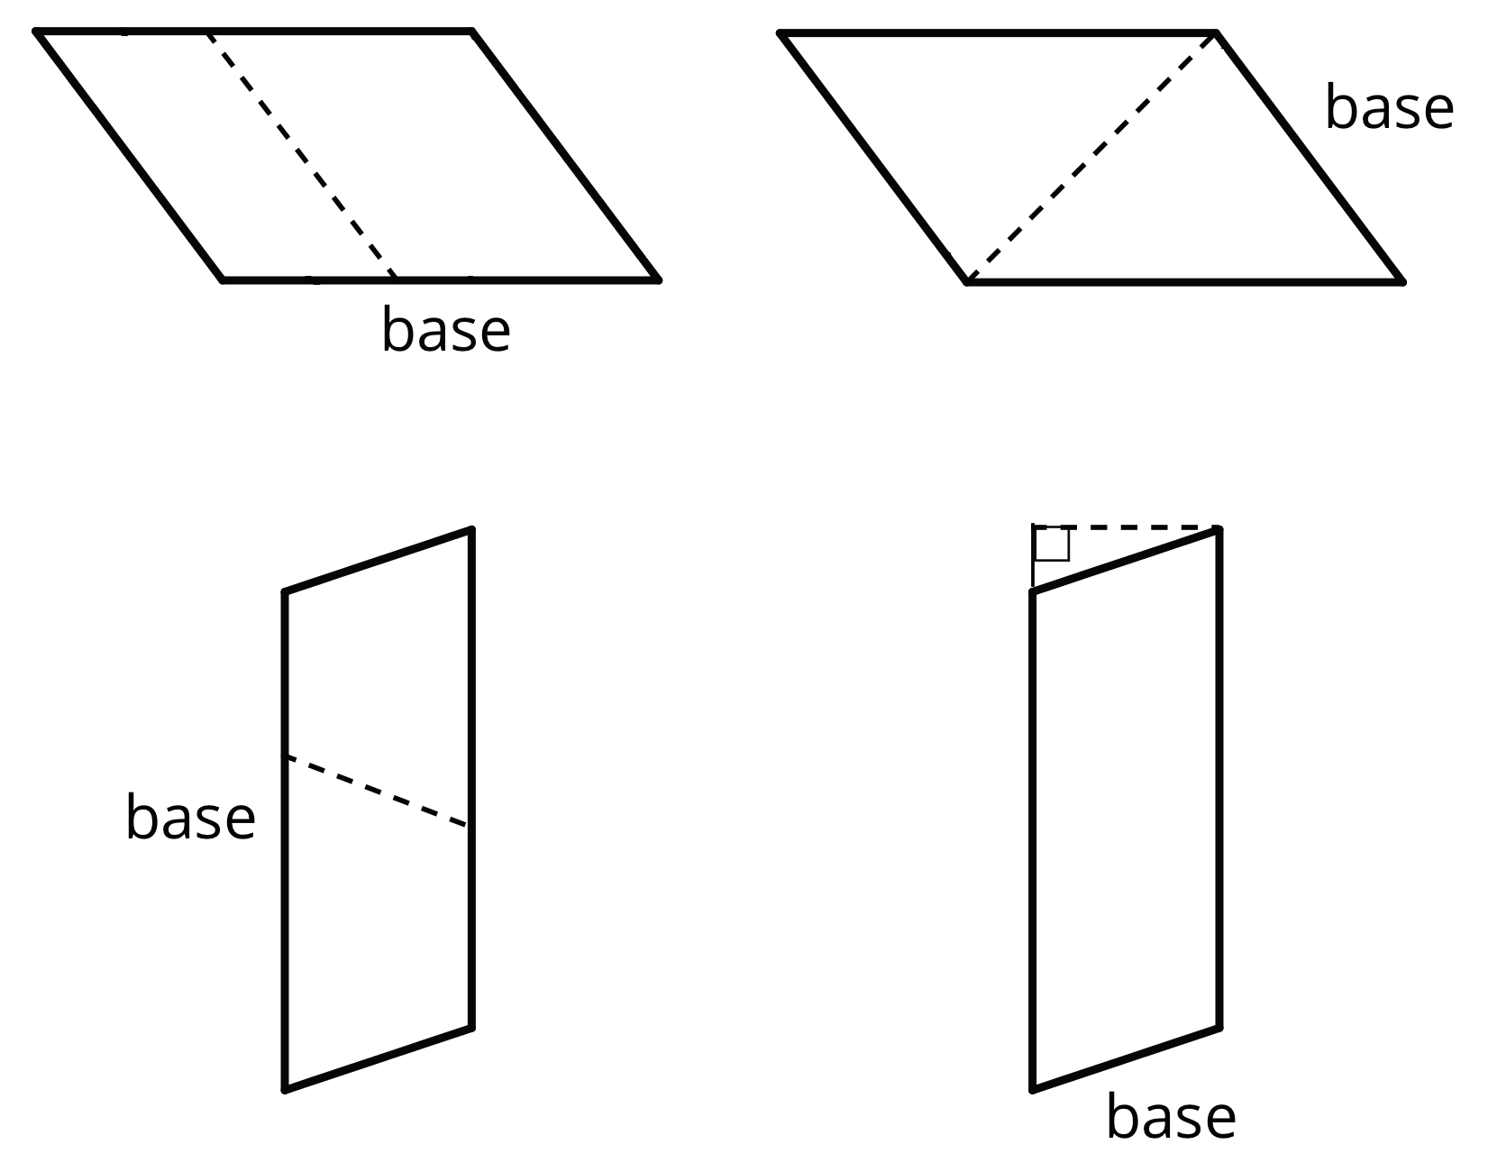
- Select all the statements that are true about bases and heights in a parallelogram.
  - Only a horizontal side of a parallelogram can be a base.
  - Any side of a parallelogram can be a base.
  - A height can be drawn at any angle to the side chosen as the base.
  - A base and its corresponding height must be perpendicular to each other.
  - A height can only be drawn inside a parallelogram.
  - A height can be drawn outside of the parallelogram, as long as it is drawn at a 90-degree angle to the base.
  - A base cannot be extended to meet a height.
- Five students labeled a base $b$ and a corresponding height $h$ for each of these parallelograms. Are all drawings correctly labeled? Explain how you know.
- 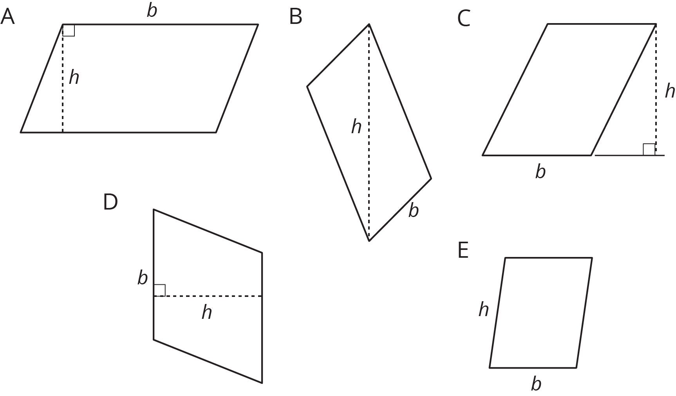

3 Finding the Formula for Area of Parallelograms

Student Task Statement
For each parallelogram:
- Identify a base and a corresponding height, and record their lengths in the table.
- Find the area of the parallelogram and record it in the last column of the table.
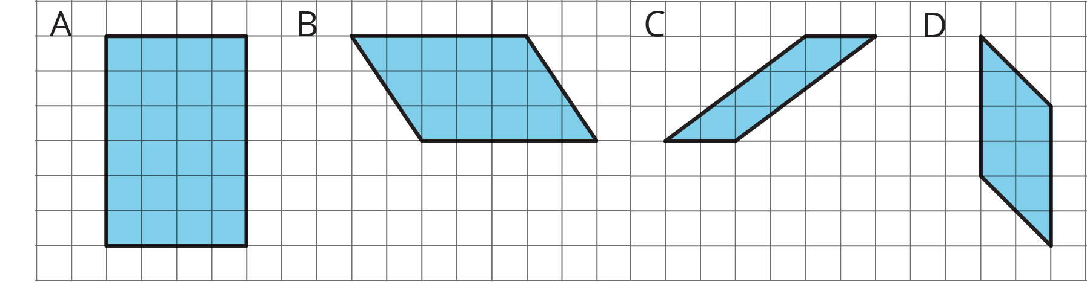
parallelogram | base (units) | height (units) | area (sq units)
A
B
C
D
any parallelogram | $b$ | $h$
In the last row, write an expression for the area of any parallelogram, using $b$ and $h$ .
© CC BY Open Up Resources. Adaptations CC BY IM.

