Unit 2 Lesson 21: Rational Equations (Part 2)

1 Math Talk: Adding Rationals (Warm up)

Student Task Statement
Solve each equation mentally:
$\frac{x}{2}=\frac{3}{4}$
$\frac{3}{x}=\frac{1}{6}$
$\frac{1}{4}=\frac{1}{x^{2}}$
$\frac{2}{x}=\frac{x}{8}$

2 A Rational River

Student Task Statement
Noah likes to go for boat rides along a river with his family. In still water, the boat travels about 8 kilometers per hour. In the river, it takes them the same amount of time $t$ to go upstream 5 kilometers as it does to travel downstream 10 kilometers.
- If the speed of the river is $r$, write an expression for the time it takes to travel 5 kilometers upstream and an expression for the time it takes to travel 10 kilometers downstream.
- Use your expressions to calculate the speed of the river. Explain or show your reasoning.

3 Rational Resistance

Images for Launch
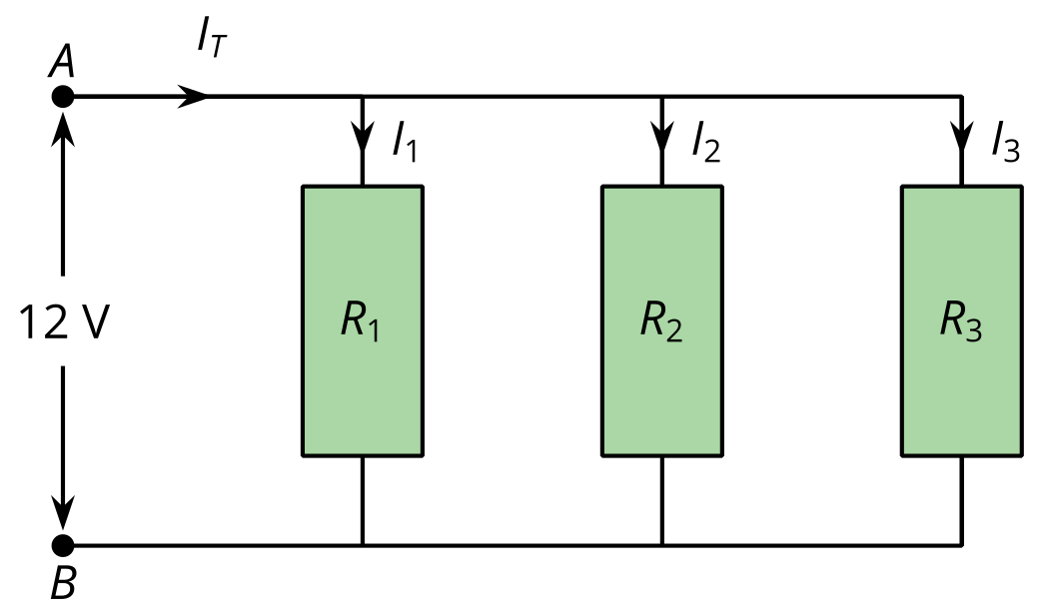

Student Task Statement
Circuits in parallel follow this law: The inverse of the total resistance is the sum of the inverses of each individual resistance. We can write this as: $\frac{1}{R_{T}}=\frac{1}{R_{1}}+\frac{1}{R_{2}}+...+\frac{1}{R_{n}}$ where there are $n$ parallel circuits and $R_{T}$ is the total resistance. Resistance is measured in ohms.
- Two circuits are placed in parallel. The first circuit has a resistance of 40 ohms and the second circuit has a resistance of 60 ohms. What is the total resistance of the two circuits?
- Two circuits are placed in parallel. The second circuit has a resistance of 150 ohms more than the first. Write an equation for this situation showing the relationships between $R_{T}$ and the resistance $R$ of the first circuit.
- For this circuit, Clare wants to use graphs to estimate the resistance of the first circuit $R$ if $R_{T}$ is 85 ohms. Describe how she could use a graph to determine the value of $R$ and then follow your instructions to find $R$.
© CC BY 2019 by Illustrative Mathematics®

