Lesson 7 Practice Problems
- Technology required. Mai is visiting Paris to see the Eiffel Tower. She is 80 feet away when she spots it. To see the top, she has to look up at an angle of 85.7 degrees. How tall is the Eiffel Tower?
- Technology required. Find the missing measurements of the right triangle.
- 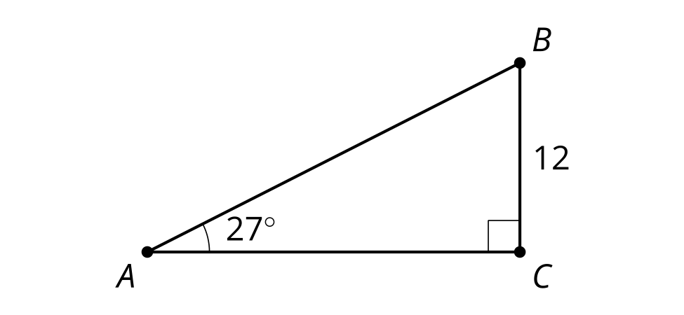
- Technology required. Gateway Arch in St. Louis, Missouri, is 630 feet tall. Priya can look up at a 50 degree angle to see the top of the arch. How far away from the base of the arch is she standing?
- Based on the figure, which equation is true?
- 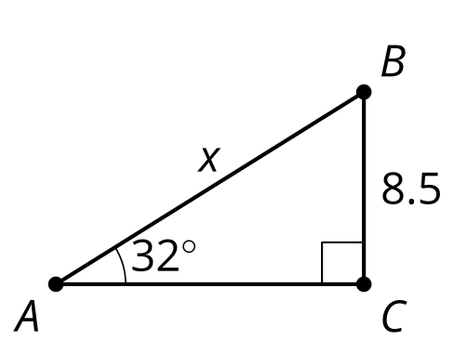
  - $sin\left(32\right)=\frac{8.5}{x}$
  - $sin\left(32\right)=\frac{x}{8.5}$
  - $cos\left(32\right)=\frac{8.5}{x}$
  - $cos\left(32\right)=\frac{x}{8.5}$
- (From Unit 4, Lesson 6.)
- Kiran is flying a kite. He gets tired, so he stakes the kite into the ground. The kite is on a string that is 12 feet long and makes a 45 degree angle with the ground. How high is the kite?
- 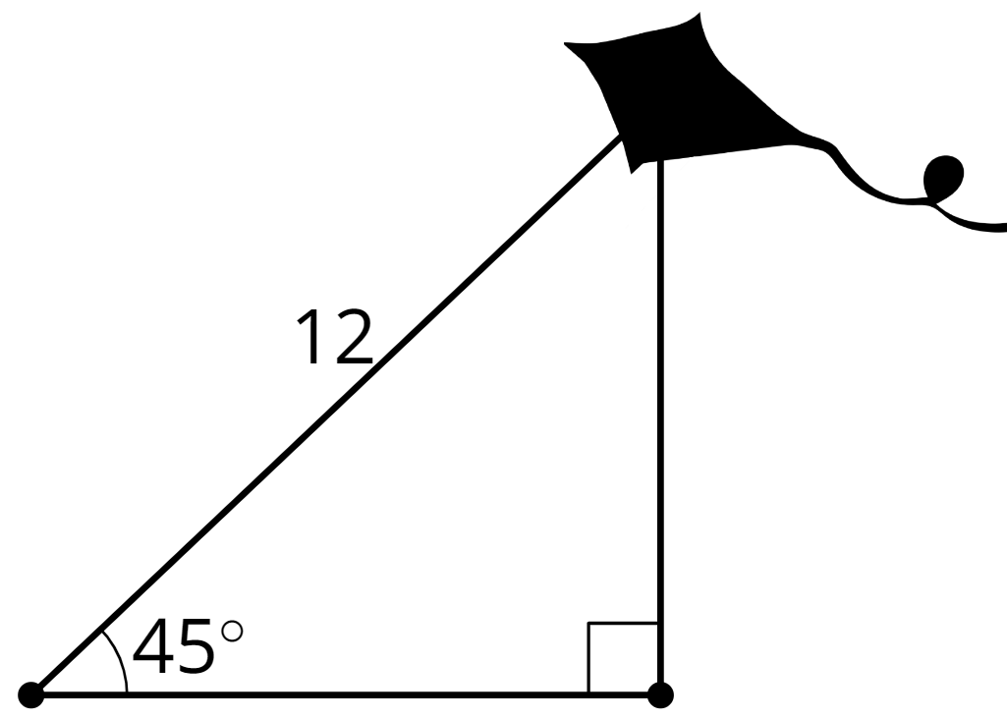
  - 12 ft
  - $\frac{12}{\sqrt{2}}$ ft
  - $12\sqrt{2}$ ft
  - 24 ft
- (From Unit 4, Lesson 5.)
- Match the ratio of side lengths to its corresponding angle measure.
  - adjacent leg $÷$ hypotenuse = 0.139
  - opposite leg $÷$ adjacent leg = 0.249
  - opposite leg $÷$ hypotenuse = 0.469
  - adjacent leg $÷$ hypotenuse = 0.682
  - opposite leg $÷$ hypotenuse = 0.848
  - ${14}^{∘}$
  - ${28}^{∘}$
  - ${47}^{∘}$
  - ${58}^{∘}$
  - ${82}^{∘}$
- (From Unit 4, Lesson 4.)
- In the right triangles shown, the measure of angle $ABC$ is the same as the measure of angle $EBD$.​​ What is the length of side $BE$?
- 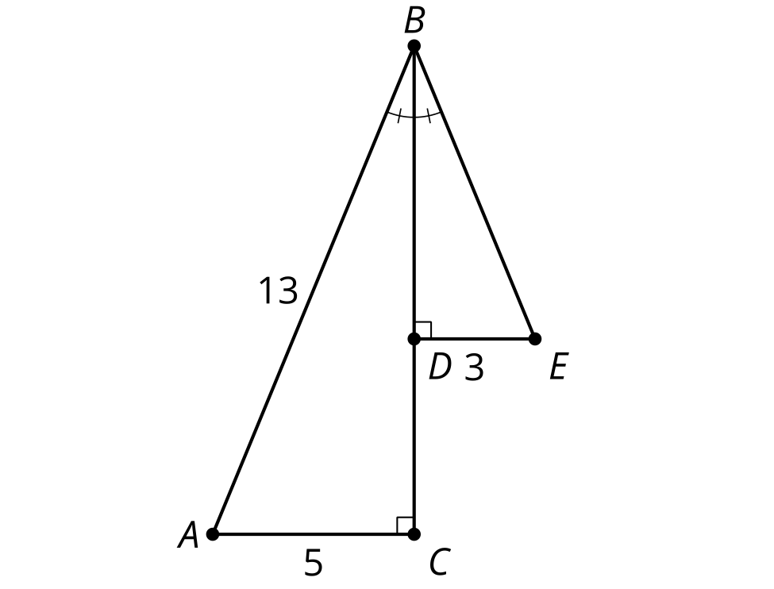
- (From Unit 3, Lesson 15.)
© CC BY 2019 by Illustrative Mathematics®

