Unit 7 Lesson 3 Cumulative Practice Problems
- Two lines intersect. Find the value of $b$ and $c$.
- 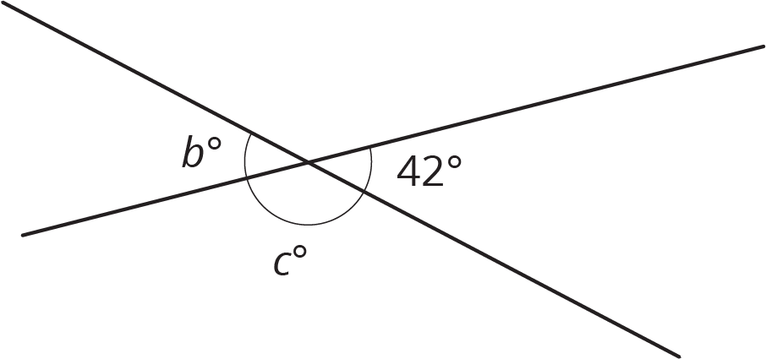
- In this figure, angles $R$ and $S$ are complementary. Find the measure of angle $S$.
- 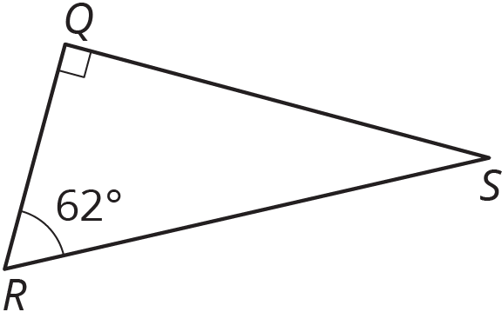
- If two angles are both vertical and supplementary, can we determine the angles? Is it possible to be both vertical and complementary? If so, can you determine the angles? Explain how you know.
- Match each expression in the first list with an equivalent expression from the second list.
  - $5(x+1)−2x+11$
  - $2x+2+x+5$
  - $\frac{\text{-}3}{8}x−9+\frac{5}{8}x+1$
  - $2.06x−5.53+4.98−9.02$
  - $99x+44$
  - $\frac{1}{4}x−8$
  - $\frac{1}{2}(6x+14)$
  - $11(9x+4)$
  - $3x+16$
  - $2.06x+(\text{-}5.53)+4.98+(\text{-}9.02)$
- (From Unit 6, Lesson 22.)
- Factor each expression.
  - $15a−13a$
  - $\text{-}6x−18y$
  - $36abc+54ad$
- (From Unit 6, Lesson 19.)
- The directors of a dance show expect many students to participate but don’t yet know how many students will come. The directors need 7 students to work on the technical crew. The rest of the students work on dance routines in groups of 9. For the show to work, they need at least 6 full groups working on dance routines.
  - Write and solve an inequality to represent this situation, and graph the solution on a number line.
  - Write a sentence to the directors about the number of students they need.
- (From Unit 6, Lesson 17.)
- A small dog gets fed $\frac{3}{4}$ cup of dog food twice a day. Using $d$ for the number of days and $f$ for the amount of food in cups, write an equation relating the variables. Use the equation to find how many days a large bag of dog food will last if it contains 210 cups of food.
- (From Unit 2, Lesson 5.)
© CC BY Open Up Resources. Adaptations CC BY IM.

