Lesson 2: Anchoring Units of Measurement
Let’s see how big different things are.

2.1: Estimating Volume
Estimate the volume of the tiny salt shaker.
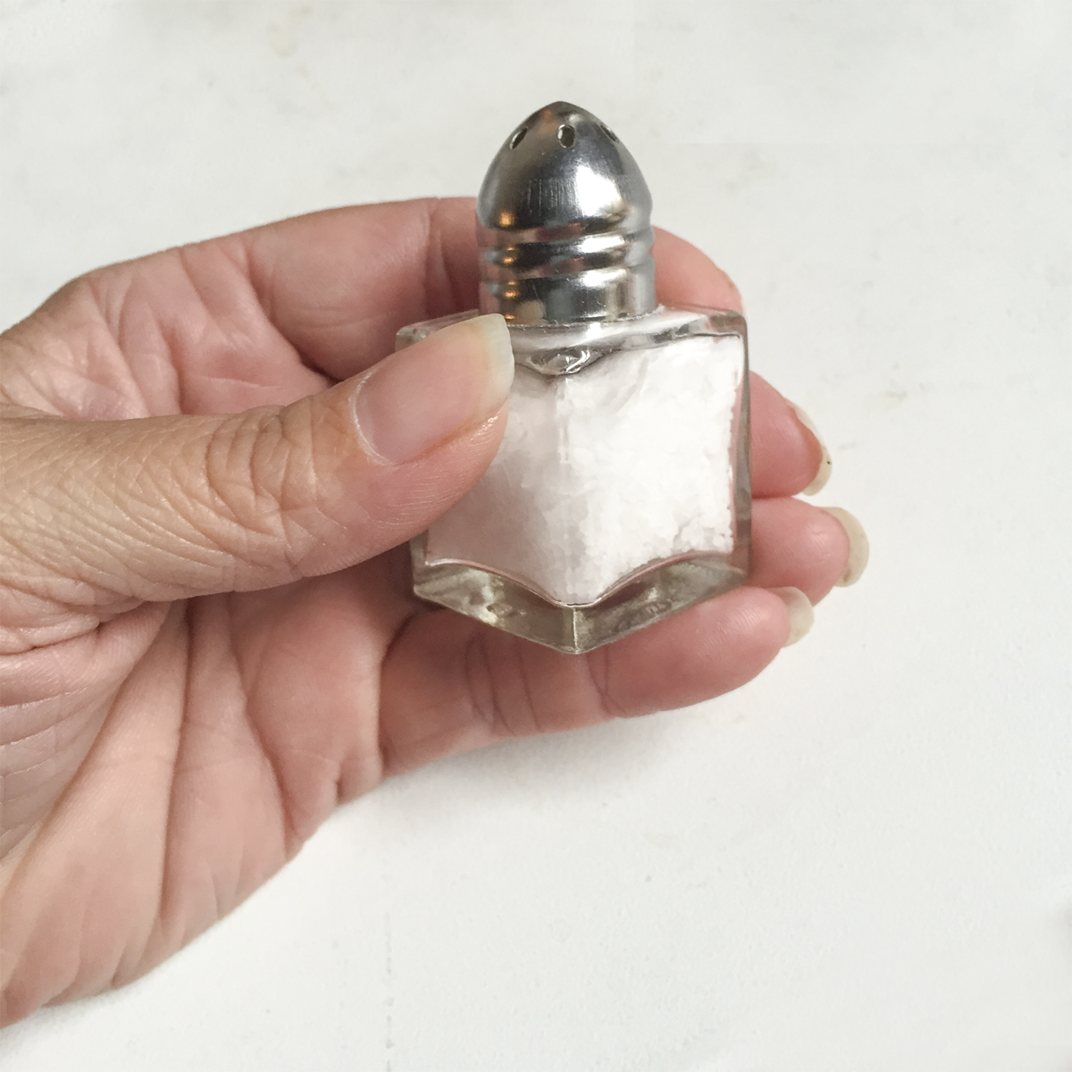

2.2: Cutting String
Your teacher will assign you one of the following lengths:
1 centimeter, 1 foot, 1 inch, 1 meter, or 1 yard.
Estimate and cut a piece of string as close to your assigned length as you can without using a measurement tool.

2.3: Card Sort: Measurements
Your teacher will give you some cards with the names of different units of measurement and other cards with pictures of objects.
- Sort the units of measurement into groups based on the attribute they measure. Pause here so your teacher can review your groups.
- Match each picture card that has “L” in the top right corner with the closest unit to the length of the object.
- Match each picture card that has “V” in the top right corner with the closest unit to the volume of the object.
- Match each picture card that has “WM” in the top right corner with the closest unit to the weight or mass of the object.
Your teacher will assign you a new group to discuss how you matched the objects. If you disagree, work to reach an agreement.

Lesson 2 Summary
We can use everyday objects to estimate standard units of measurement.
For units of length:
- 1 millimeter is about the thickness of a dime.
- 1 centimeter is about the width of a pinky finger.
- 1 inch is about the length from the tip of your thumb to the first knuckle.
- 1 foot is the length of a football.
- 1 yard is about the length of a baseball bat.
- 1 meter is about the length of a baseball bat and ball.
- 1 kilometer is about the distance someone walks in ten minutes.
- 1 mile is about the distance someone runs in ten minutes.
For units of volume:
- 1 milliliter is about the volume of a raindrop.
- 1 cup is about the volume of a school milk carton.
- 1 quart is about the volume of a large sports drink bottle.
- 1 liter is about the volume of a reusable water bottle.
- 1 gallon is about the volume of a large milk jug.
For units of weight and mass:
- 1 gram is about the mass of a raisin.
- 1 ounce is about the weight of a slice of bread.
- 1 pound is about the weight of a loaf of bread.
- 1 kilogram is about the mass of a textbook.
- 1 ton is about the weight of a small car.
© CC BY Open Up Resources. Adaptations CC BY IM.

