Lesson 5 Practice Problems
- A triangle has sides with lengths 8, 15, and 17.
  - Verify this is a Pythagorean triple.
  - Approximate the acute angles in this triangle.
- Kiran is flying a kite. He gets tired, so he stakes the kite into the ground. The kite is on a string that is 18 feet long and makes a 30 degree angle with the ground. How high is the kite?
- 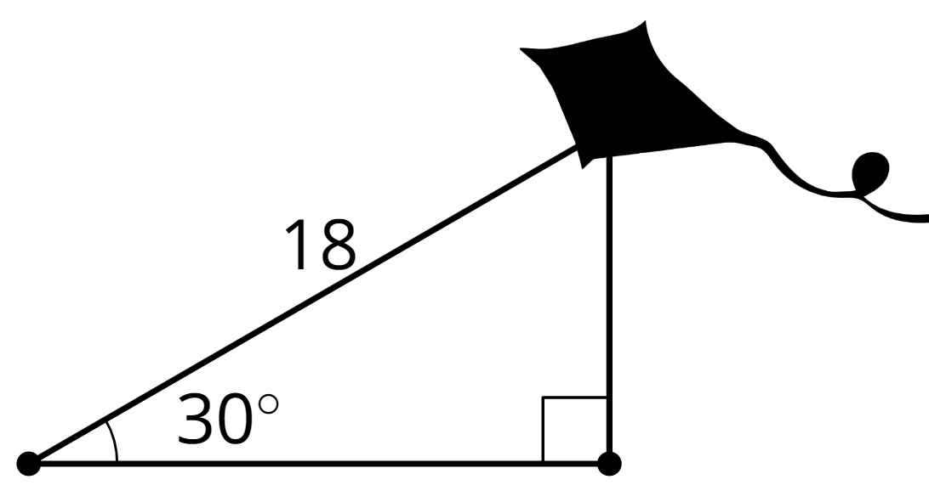
- Triangle $ABC$ has a right angle at $C$. Select all measurements which would mean it has a hypotenuse with a length of 10 units.
- 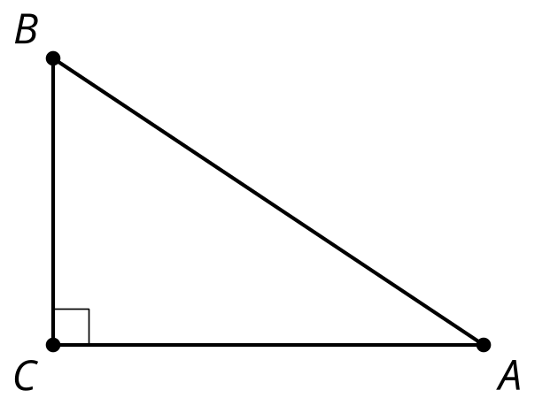
  - Angle $A$ is 20 degrees, $BC$ is 2 units
  - $AC$ is 7 units, $BC$ is 3 units
  - Angle $B$ is 50 degrees, $BC$ is 4 units
  - Angle $A$ is 30 degrees, $BC$ is 5 units
  - $AC$ is 8 units, $BC$ is 6 units
- What is a reasonable approximation for angle $B$ if the ratio of the adjacent leg divided by the hypotenuse is 0.45?
  - 27 degrees
  - 30 degrees
  - 60 degrees
  - 63 degrees
- (From Unit 4, Lesson 4.)
- Estimate the values to complete the table.
- 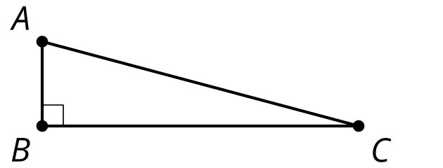
- angle | - adjacent leg $÷$ hypotenuse | - opposite leg $÷$ hypotenuse | - opposite leg $÷$ adjacent leg
- $A$ | - 0.31 | - 0.95 | - 3.1
- $C$
- (From Unit 4, Lesson 4.)
- What is the length of side $AB$?
- 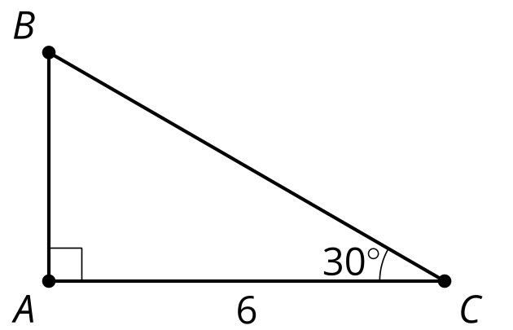
- (From Unit 4, Lesson 3.)
- What is the length of the square’s side?
- 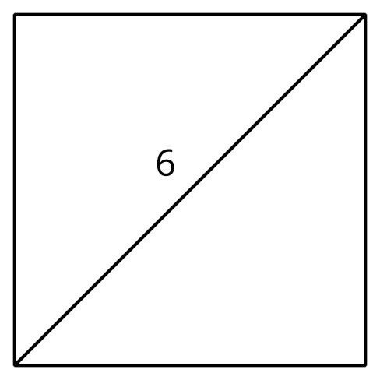
  - 3 units
  - $\frac{6}{\sqrt{2}}$ units
  - $6\sqrt{2}$ units
  - 12 units
- Find the lengths of segments $AD$ and $BD$. Then check your answers using a different method.
- 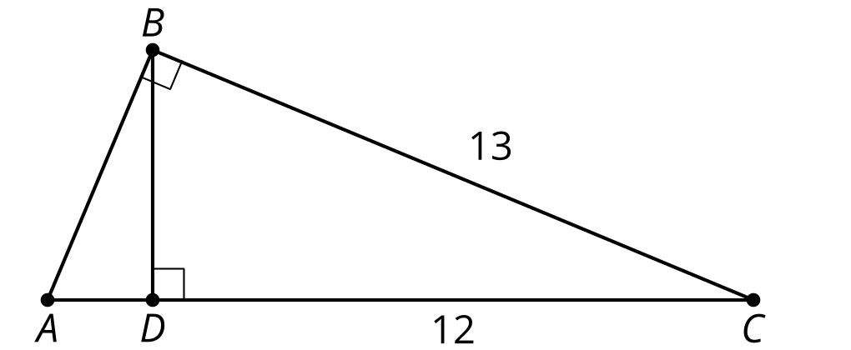
- (From Unit 3, Lesson 13.)
© CC BY 2019 by Illustrative Mathematics®

