Lesson 4 Practice Problems
- A restaurant offers delivery for their pizzas. The total cost is a delivery fee added to the price of the pizzas. One customer pays $25 to have 2 pizzas delivered. Another customer pays $58 for 5 pizzas. How many pizzas are delivered to a customer who pays $80?
- To paint a house, a painting company charges a flat rate of $500 for supplies, plus $50 for each hour of labor.
  - How much would the painting company charge to paint a house that needs 20 hours of labor? A house that needs 50 hours?
  - Draw a line representing the relationship between $x$, the number of hours it takes the painting company to finish the house, and $y$, the total cost of painting the house. Label the two points from the earlier question on your graph.
  - 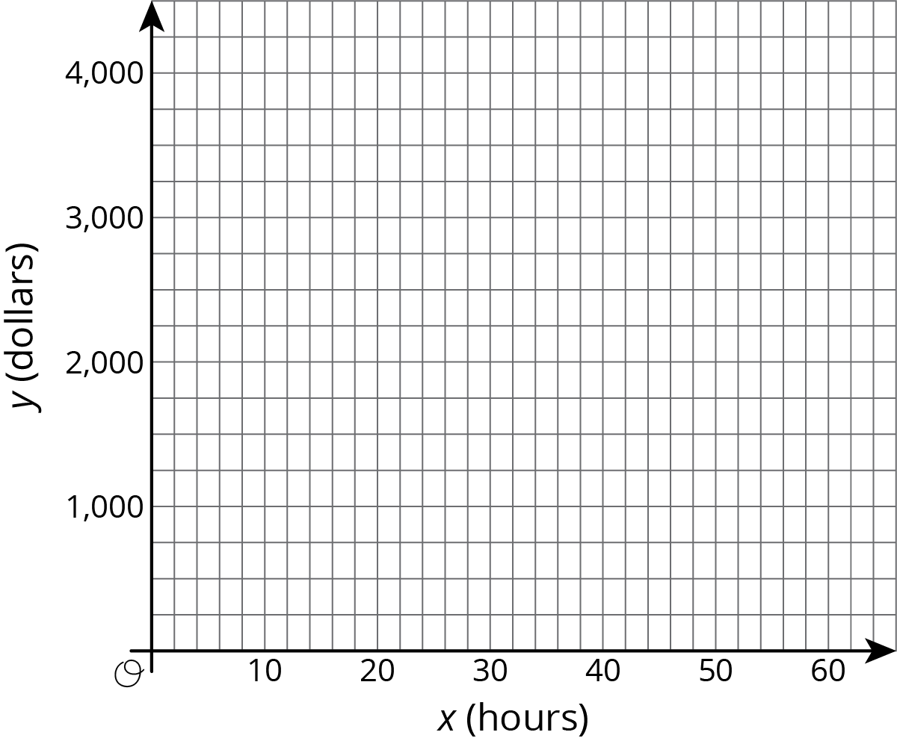
  - Find the slope of the line. What is the meaning of the slope in this context?
- Tyler and Elena are on the cross country team.
- Tyler's distances and times for a training run are shown on the graph.
- 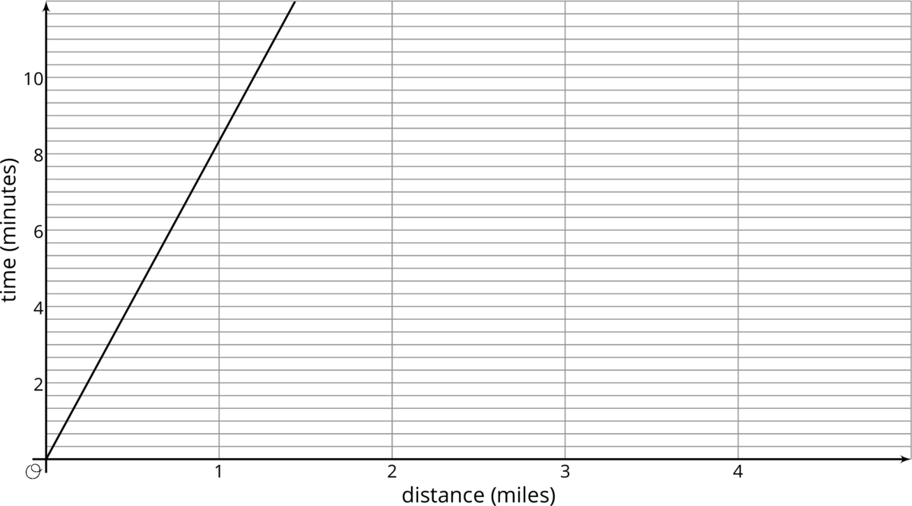
- Elena’s distances and times for a training run are given by the equation $y=8.5x$, where $x$ represents distance in miles and $y$ represents time in minutes.
  - Who ran farther in 10 minutes? How much farther? Explain how you know.
  - Calculate each runner's pace in minutes per mile.
  - Who ran faster during the training run? Explain or show your reasoning.
- (From Unit 5, Lesson 3.)
- Write an equation for the line that passes through $\left(2,5\right)$ and $\left(6,7\right)$.
- (From Unit 2, Lesson 17.)
© CC BY Open Up Resources. Adaptations CC BY IM.

