Lesson 3 Practice Problems
- A contractor must haul a large amount of dirt to a work site. She collected information from two hauling companies.
- EZ Excavation gives its prices in a table.
- dirt  (cubic yards) | - cost  (dollars)
- 8 | - 196
- 20 | - 490
- 26 | - 637
- Happy Hauling Service gives its prices in a graph.
- 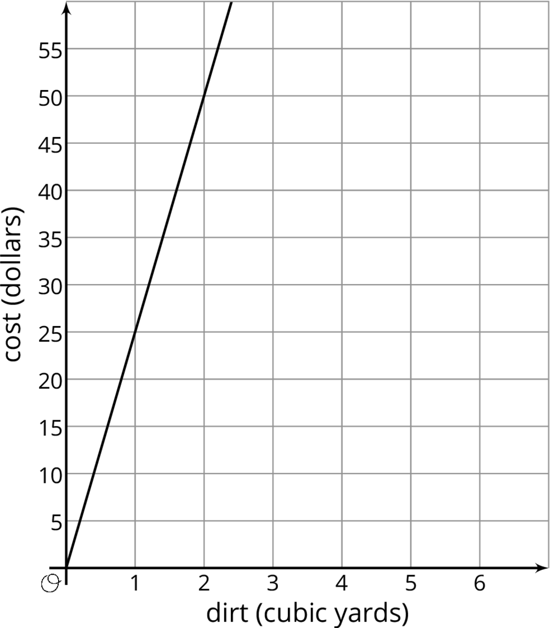
  - How much would each hauling company charge to haul 40 cubic yards of dirt? Explain or show your reasoning.
  - Calculate the rate of change for each relationship. What do they mean for each company?
  - If the contractor has 40 cubic yards of dirt to haul and a budget of $1000, which hauling company should she hire? Explain or show your reasoning.
- Andre and Priya are tracking the number of steps they walk. Andre records that he can walk 6000 steps in 50 minutes. Priya writes the equation $y=118x$, where $y$ is the number of steps and $x$ is the number of minutes she walks, to describe her step rate. This week, Andre and Priya each walk for a total of 5 hours. Who walks more steps? How many more?
- Find the coordinates of point $D$ in each diagram:
- 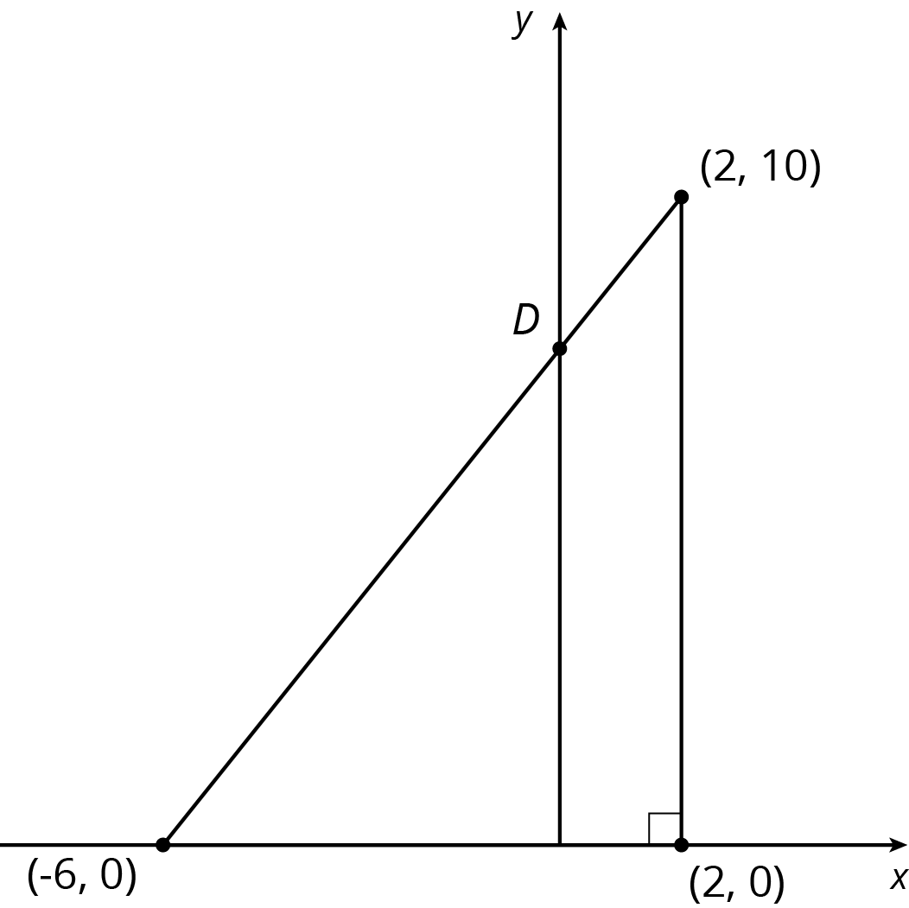
- 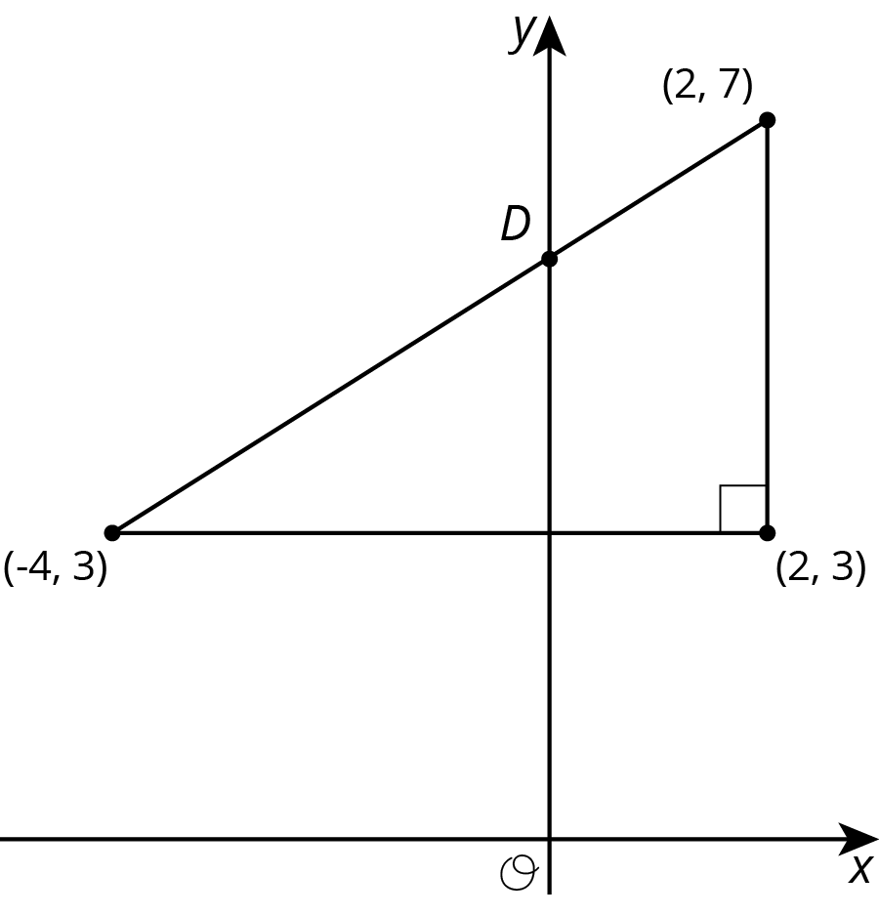
- (From Unit 2, Lesson 16.)
- Solve each equation.
- $\frac{1}{7}a+\frac{3}{4}=\frac{9}{8}$
- $\frac{2}{3}+\frac{1}{5}b=\frac{5}{6}$
- $\frac{3}{2}=\frac{4}{3}c+\frac{2}{3}$
- $0.3d+7.9=9.1$
- $11.03=8.78+0.02e$
- (From Unit 3, Lesson 7.)
© CC BY Open Up Resources. Adaptations CC BY IM.

