Lesson 3 Practice Problems
- Select all statements that are true about equilateral triangle $ABC$.
- 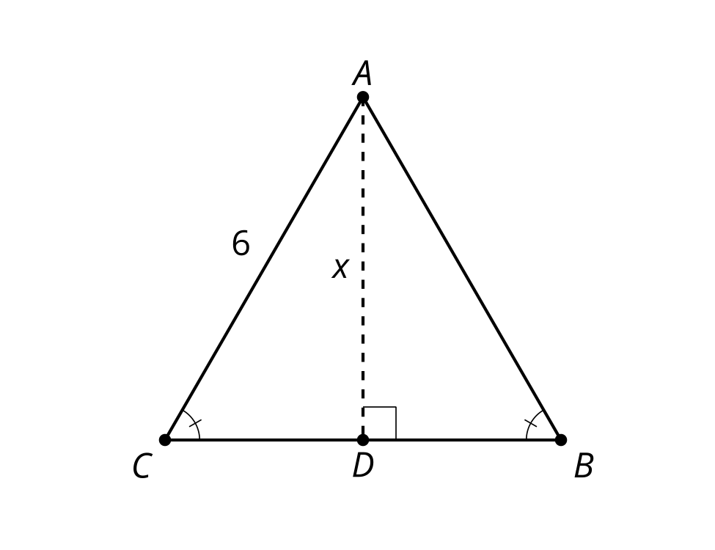
  - Angles $B$ and $C$ are 60 degrees.
  - $x=3\sqrt{3}$
  - $x=6\sqrt{3}$
  - Triangle $ABD$ is congruent to triangle $ACD$.
  - $BD$ and $CD$ are both 3 units long.
- Find the length of each leg.
- 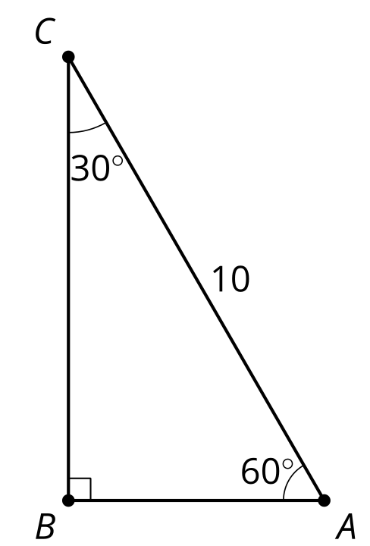
- An equilateral triangle has a side length of 10 units. What is its area?
- Find the lengths of the legs.
- 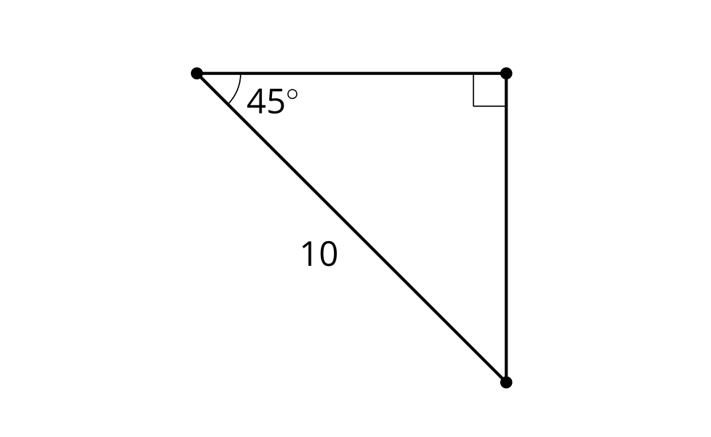
- (From Unit 4, Lesson 2.)
- A square has side length 3 units. What is the length of the diagonal?
  - 3 units
  - $\frac{3}{\sqrt{2}}$ units
  - $3\sqrt{2}$ units
  - 6 units
- (From Unit 4, Lesson 2.)
- A step has a height of 5 inches. A ramp starts 4 feet away from the base of the step, making a ${5.9}^{∘}$ angle with the ground. What can you say about the angle the ramp would make with the ground if the ramp starts farther away from the step?
  - The angle would decrease.
  - The angle would remain the same.
  - The angle would increase.
  - We cannot determine anything about the angle.
- (From Unit 4, Lesson 1.)
- Segment $A^{′}B^{′}$ is parallel to segment $AB$.
  - What is the length of segment $A^{′}B^{′}$?
  - What is the length of segment $B^{′}B$?
- 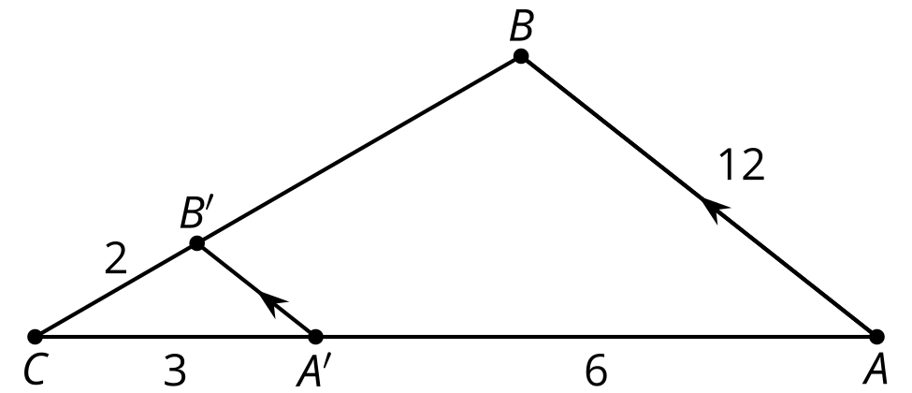
- (From Unit 3, Lesson 11.)
- Here is triangle $POG$. Match the description of the rotation with the image of $POG$ under that rotation.
- 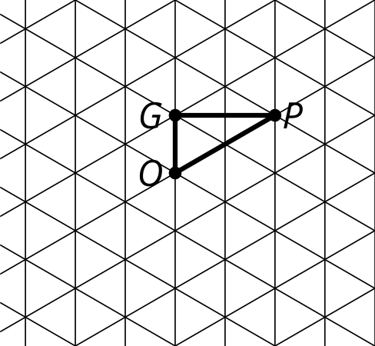

- Image 1
- 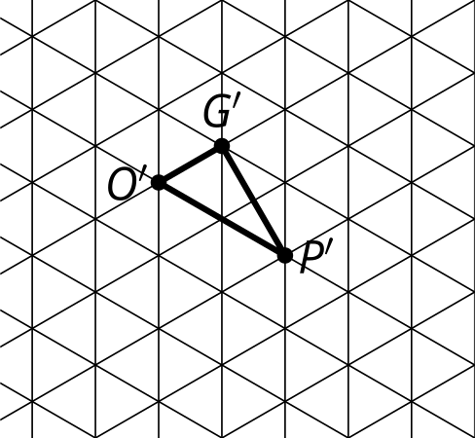

- Image 2
- 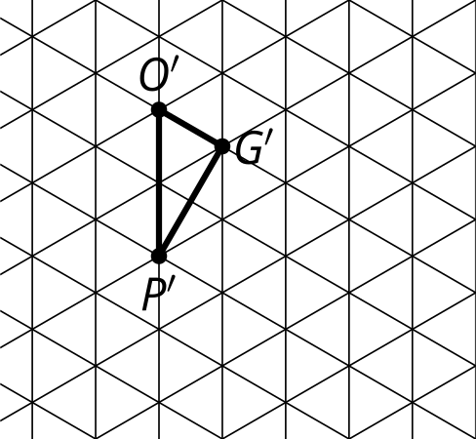

- Image 3
- 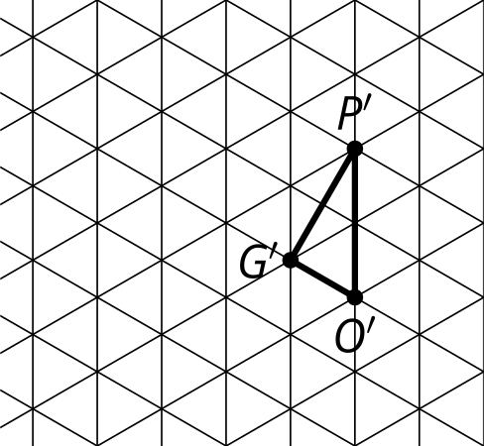

- Image 4
- 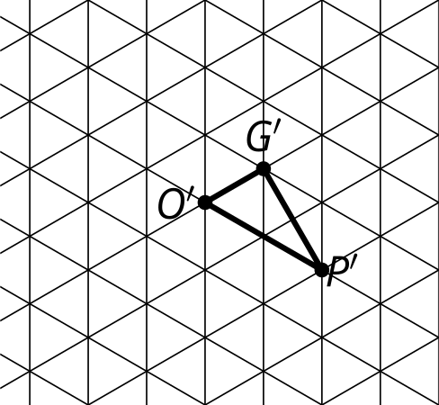
  - Rotate 60 degrees counterclockwise around $P$.
  - Rotate 60 degrees clockwise around $O$.
  - Rotate 120 degrees clockwise around $G$.
  - Rotate 60 degrees clockwise around $G$.
  - Image 1
  - Image 2
  - Image 3
  - Image 4
- (From Unit 1, Lesson 13.)
© CC BY 2019 by Illustrative Mathematics®

