Lesson 20 Practice Problems
- Priya: I bet if the alternate interior angles are congruent, then the lines will have to be parallel.
- Han: Really? We know if the lines are parallel then the alternate interior angles are congruent, but I didn't know that it works both ways.
- Priya: Well, I think so. What if angle $ABC$ and angle $BCJ$ are both 40 degrees? If I draw a line perpendicular to line $AI$ through point $B$, I get this triangle. Angle $CBX$ would be 50 degrees because $40+50=90$. And because the angles of a triangle sum to 180 degrees, angle $CXB$ is 90 degrees. It's also a right angle!
- Han: Oh! Then line $AI$ and line $GJ$ are both perpendicular to the same line. That's how we constructed parallel lines, by making them both perpendicular to the same line. So lines $AI$ and $GJ$ must be parallel.
- 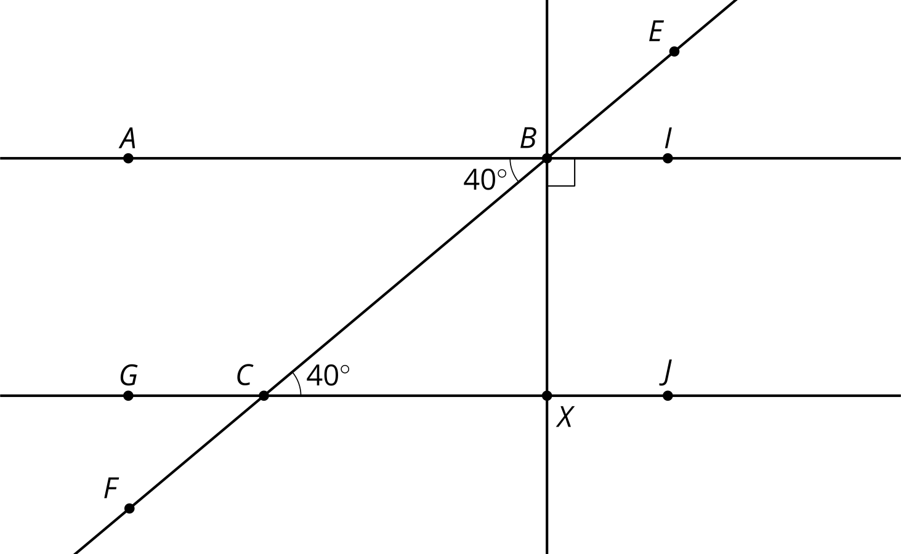
  - Label the diagram based on Priya and Han's conversation.
  - Is there something special about 40 degrees? Will any 2 lines cut by a transversal with congruent alternate interior angles, be parallel?
- Prove lines $AI$ and $GJ$ are parallel.
- 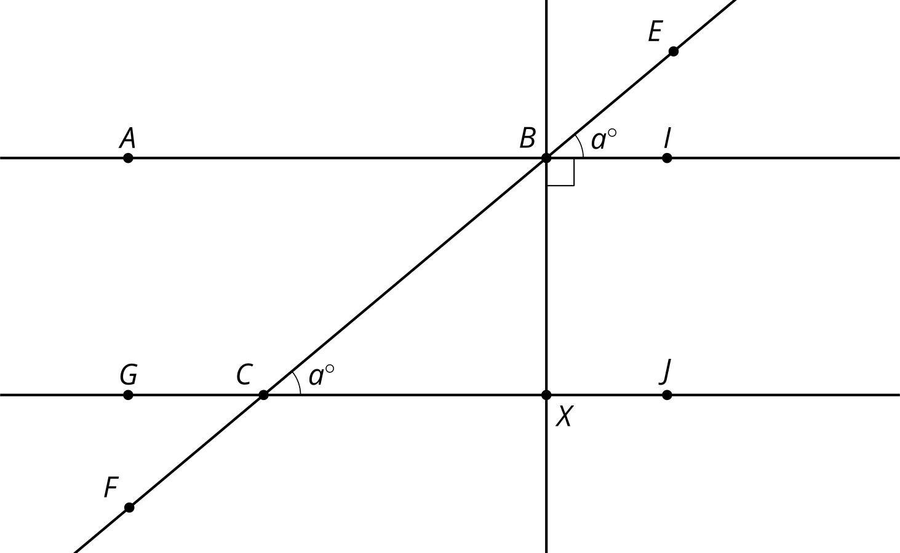

- What is the measure of angle $ABE$?
- 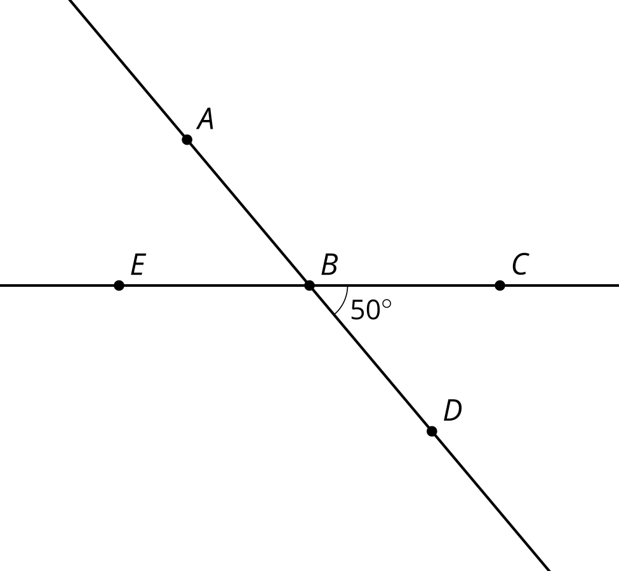
- (From Unit 1, Lesson 19.)
- Lines $AB$ and $BC$ are perpendicular. The dashed rays bisect angles $ABD$ and $CBD$. Explain why the measure of angle $EBF$ is 45 degrees.
- 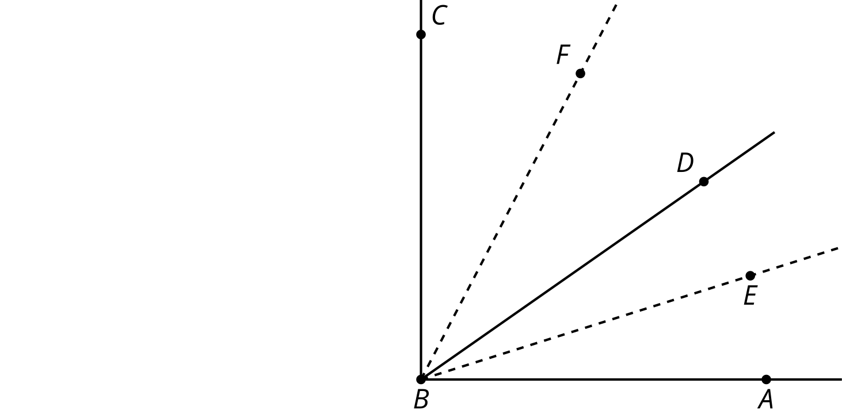

- (From Unit 1, Lesson 19.)
- Identify a figure that is not the image of quadrilateral $ABCD$ after a sequence of transformations. Explain how you know.
- 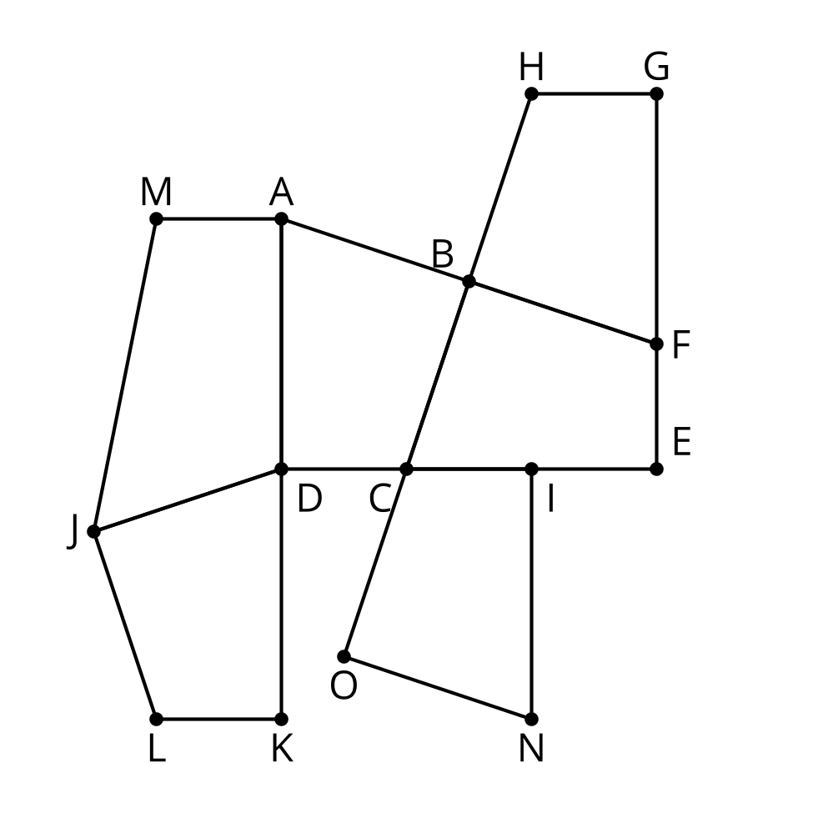
- (From Unit 1, Lesson 18.)
- Quadrilateral $ABCD$ is congruent to quadrilateral $A^{′}B^{′}C^{′}D^{′}$. Describe a sequence of rigid motions that takes $A$ to $A^{′}$, $B$ to $B^{′}$, $C$ to $C^{′}$, and $D$ to $D^{′}$.
- 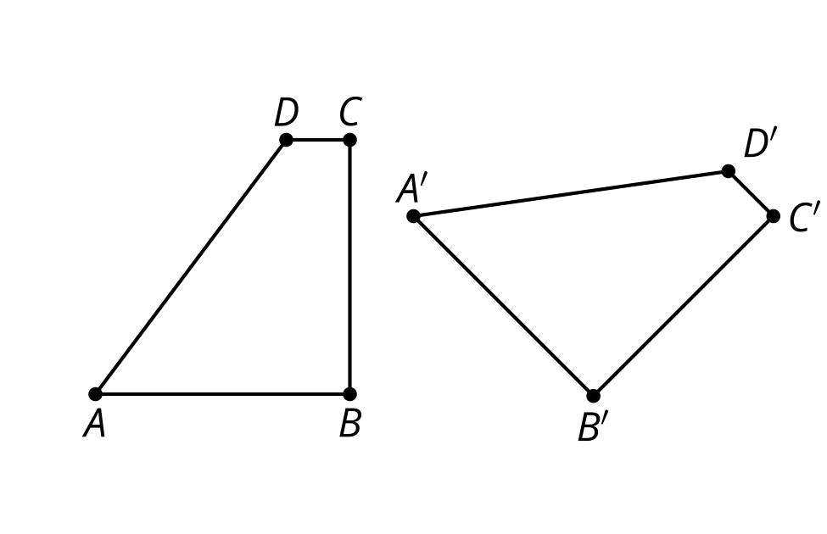
- (From Unit 1, Lesson 17.)
- Triangle $ABC$ is congruent to triangle $A^{′}B^{′}C^{′}$. Describe a sequence of rigid motions that takes $A$ to $A^{′}$, $B$ to $B^{′}$, and $C$ to $C^{′}$.
- 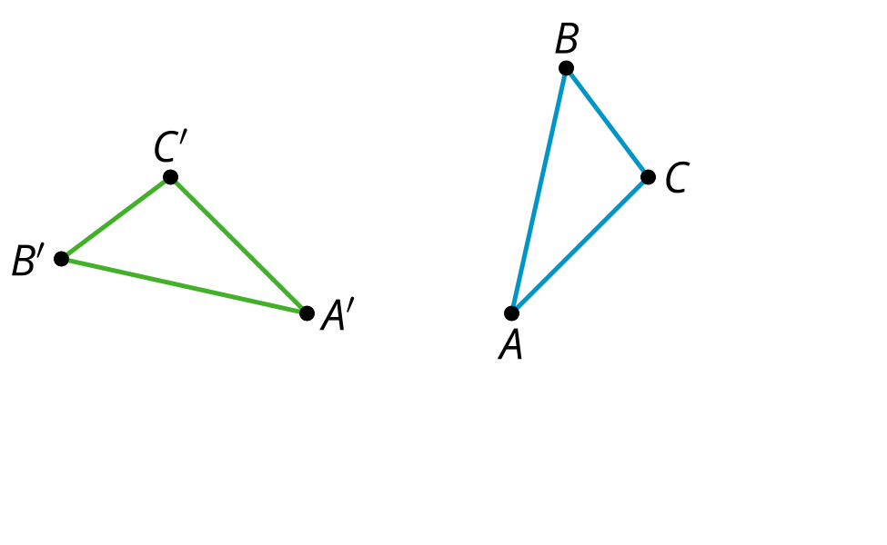
- (From Unit 1, Lesson 17.)
- Identify any angles of rotation that create symmetry.
- 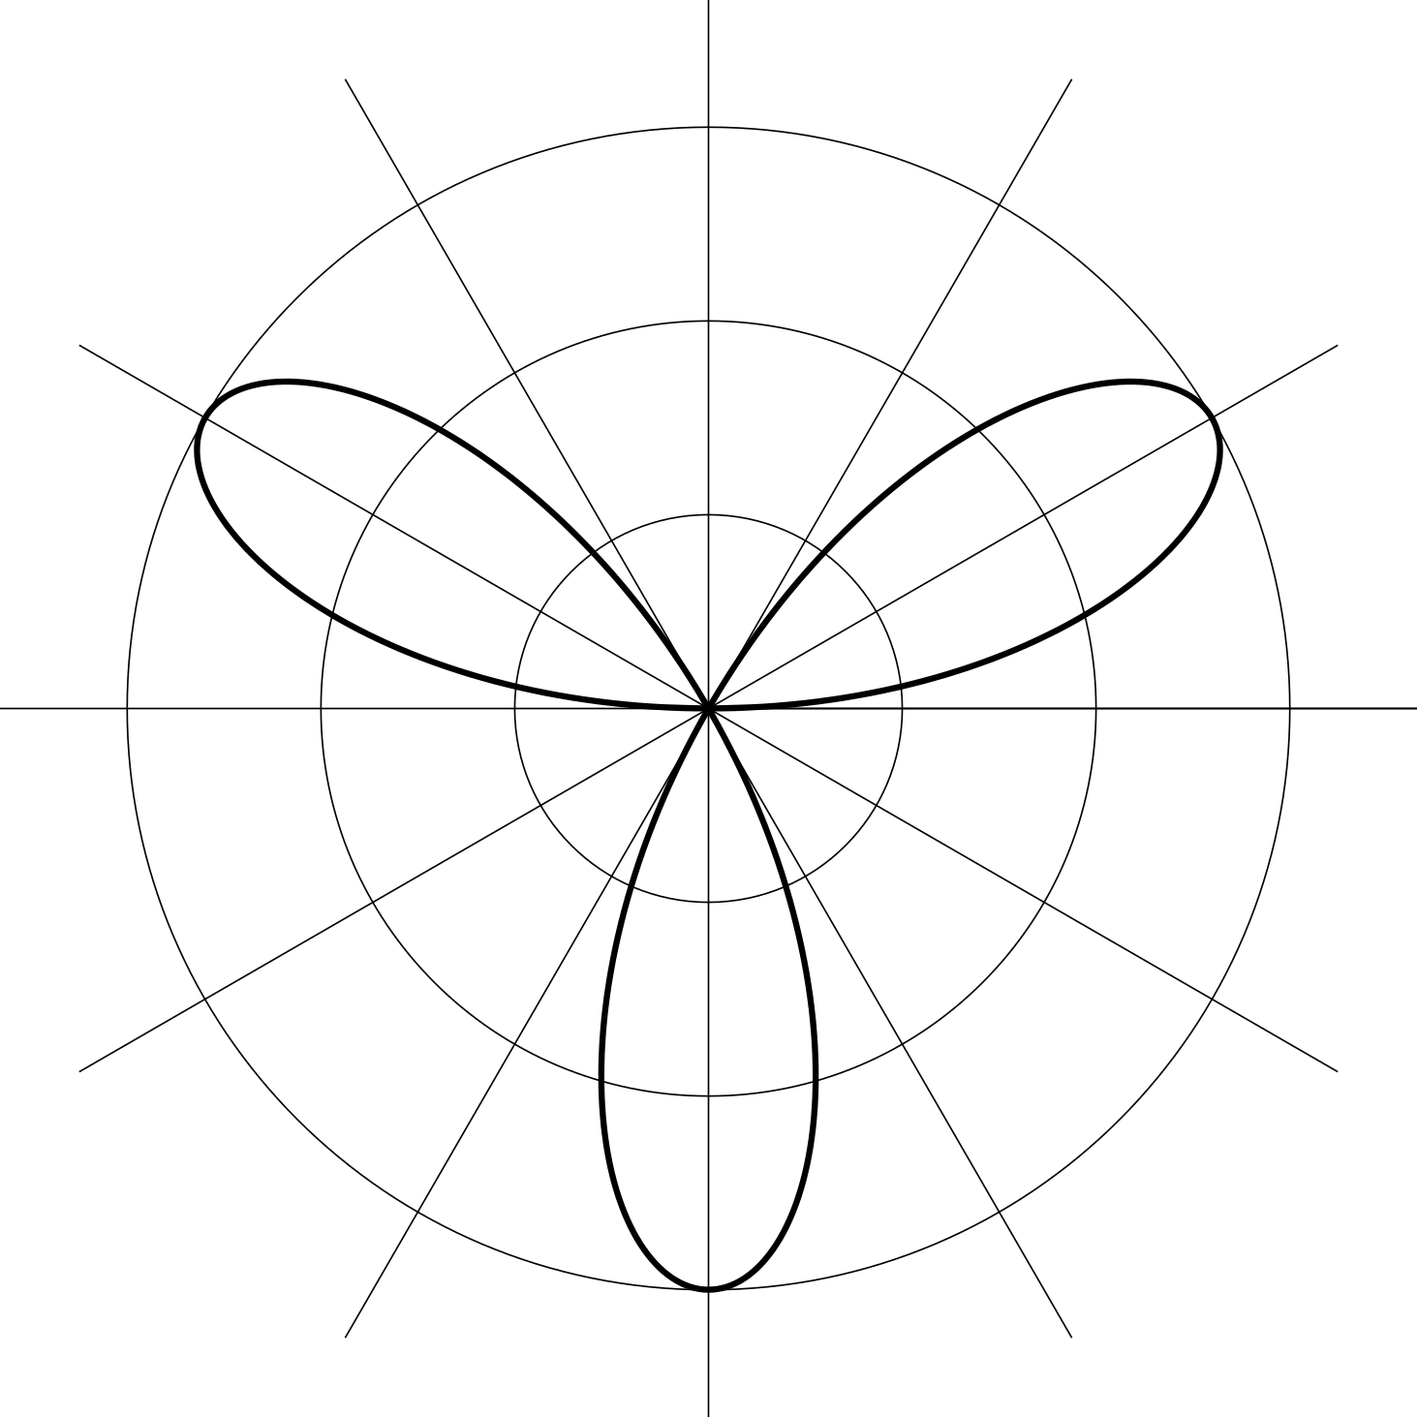
- (From Unit 1, Lesson 16.)
- Select all the angles of rotation that produce symmetry for this flower.
- 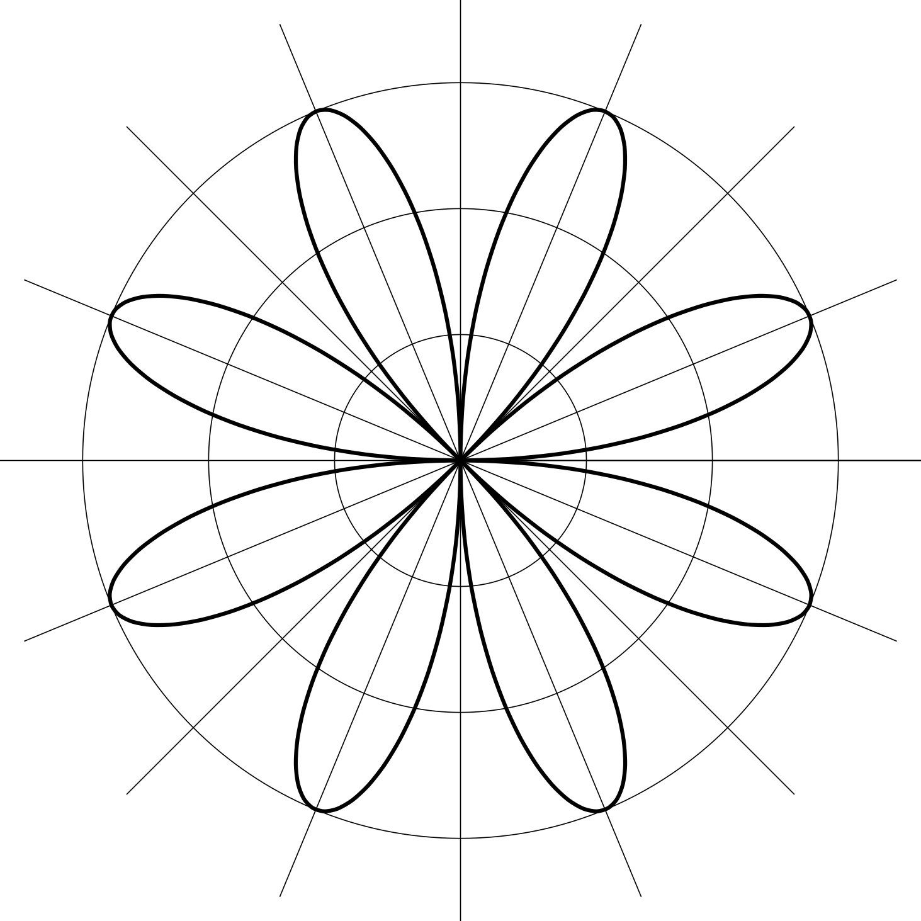
  - 45
  - 60
  - 90
  - 120
  - 135
  - 150
  - 180
- (From Unit 1, Lesson 16.)
- Three line segments form the letter N. Rotate the letter N clockwise around the midpoint of segment $BC$ by 180 degrees. Describe the result.
- 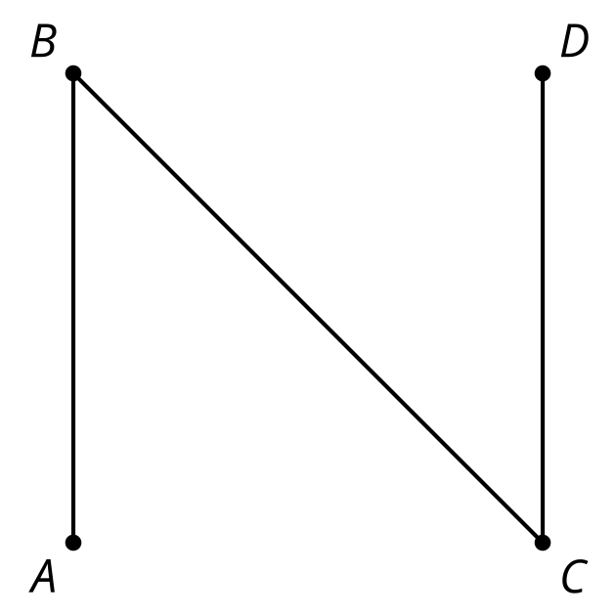
- (From Unit 1, Lesson 14.)
© CC BY 2019 by Illustrative Mathematics®

