Lesson 13: Exponential Functions with Base $e$
- Let’s look at situations that can be modeled using exponential functions with base $e$.

13.1: $e$ on a Calculator
The other day, you learned that $e$ is a mathematical constant whose value is approximately 2.718. When working on problems that involve $e$, we often rely on calculators to estimate values.
- Find the $e$ button on your calculator. Experiment with it to understand how it works. (For example, see how the value of $2e$ or $e^{2}$ can be calculated.)
- Evaluate each expression. Make sure your calculator gives the indicated value. If it doesn’t, check in with your partner to compare how you entered the expression.
  - $10⋅e^{\left(1.1\right)}$ should give approximately 30.04166
  - $5⋅e^{\left(1.1\right)\left(7\right)}$ should give approximately 11,041.73996
  - $e^{\frac{9}{23}}+7$ should give approximately 8.47891

13.2: Same Situation, Different Equations
The population of a colony of insects is 9 thousand when it was first being studied. Here are two functions that could be used to model the growth of the colony $t$ months after the study began.
$P\left(t\right)=9⋅{\left(1.02\right)}^{t}$
$Q\left(t\right)=9⋅e^{\left(0.02t\right)}$
- Use technology to find the population of the colony at different times after the beginning of the study and complete the table.
- $t$ (time in months) | - $P\left(t\right)$ (population in thousands) | - $Q\left(t\right)$ (population in thousands)
- 6
- 12
- 24
- 48
- 100
- What do you notice about the populations in the two models?
- Here are pairs of equations representing the populations, in thousands, of four other insect colonies in a research lab. The initial population of each colony is 10 thousand and they are growing exponentially. $t$ is time, in months, since the study began.
- $\text{Colony 1}f\left(t\right)=10⋅{\left(1.05\right)}^{t}g\left(t\right)=10⋅e^{\left(0.05t\right)}$
- $\text{Colony 2}k\left(t\right)=10⋅{\left(1.03\right)}^{t}l\left(t\right)=10⋅e^{\left(0.03t\right)}$
- $\text{Colony 3}p\left(t\right)=10⋅{\left(1.01\right)}^{t}q\left(t\right)=10⋅e^{\left(0.01t\right)}$
- $\text{Colony 4}v\left(t\right)=10⋅{\left(1.005\right)}^{t}w\left(t\right)=10⋅e^{\left(0.005t\right)}$
  - Graph each pair of functions on the same coordinate plane. Adjust the graphing window to the following boundaries to start: $0<x<50$ and $0<y<80$.
  - What do you notice about the graph of the equation written using $e$ and the counterpart written without $e$? Make a couple of observations.

13.3: $e$ in Exponential Models
Exponential models that use $e$ often use the format shown in this example:
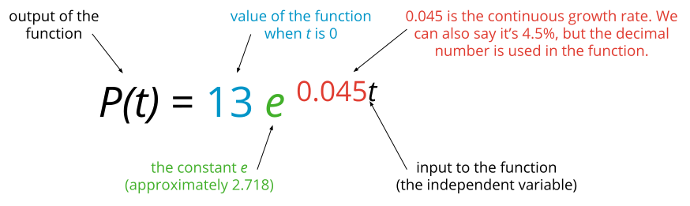
Here are some situations in which a percent change is considered to be happening continuously. For each function, identify the missing information and the missing growth rate (expressed as a percentage).
- At time $t=0$, measured in hours, a scientist puts 50 bacteria into a gel on a dish. The bacteria are growing and the population is expected to show exponential growth.
  - function: $b\left(t\right)=50⋅e^{\left(0.25t\right)}$
  - continuous growth rate per hour:
- In 1964, the population of the United States was growing at a rate of 1.4% annually. That year, the population was approximately 192 million. The model predicts the population, in millions, $t$ years after 1964.
  - function: $p\left(t\right)=\underset{_}{}⋅e^{\underset{_}{​}t}$
  - continuous growth rate per year: 1.4%
- In 1955, the world population was about 2.5 billion and growing. The model predicts the population, in billions, $t$ years after 1955.
  - function: ​​$q\left(t\right)=\underset{_}{}⋅e^{\left(0.0168t\right)}$
  - continuous growth rate per year:

13.4: Graphing Exponential Functions with Base $e$
- Use graphing technology to graph the function defined by $f\left(t\right)=50⋅e^{\left(0.25t\right)}$. Adjust the graphing window as needed to answer these questions:
  - The function $f$ models the population of bacteria in $t$ hours after it was initially measured. About how many bacteria were in the dish 10 hours after the scientist put the initial 50 bacteria in the dish?
  - About how many hours did it take for the number of bacteria in the dish to double? Explain or show your reasoning.
- Use graphing technology to graph the function defined by $p\left(t\right)=192⋅e^{\left(0.014t\right)}$. Adjust the graphing window as needed to answer these questions:
  - The equation models the population, in millions, in the U.S. $t$ years after 1964. What does the model predict for the population of the U.S. in 1974?
  - In which year does the model predict the population will reach 300 million?

Are you ready for more?
Research what the population of the U.S. was in the year the model predicted 300 million people. How far off was the model? What factors do you think account for the actual population in that year being different from the prediction of the model? In what year did the U.S. actually reach 300 million people?

Lesson 13 Summary
Suppose 24 square feet of a pond is covered with algae and the area is growing at a rate of 8% each day.
We learned earlier that the area, in square feet, can be modeled with a function such as $a\left(d\right)=24⋅{\left(1+0.08\right)}^{d}$ or $a\left(d\right)=24⋅{\left(1.08\right)}^{d}$, where $d$ is the number of days since the area was 24 square feet. This model assumes that the growth rate of 0.08 happens once each day.
In this lesson, we looked at a different type of exponential function, using the base $e$. For the algae growth, this might look like $A\left(d\right)=24⋅e^{\left(0.08d\right)}$. This model is different because the 8% growth is not just applied at the end of each day: it is successively divided up and applied at every moment. Because the growth is applied at every moment or "continuously," the functions $a$ and $A$ are not the same, but the smaller the growth rate the closer they are to each other.
Many functions that express real-life exponential growth or decay are expressed in the form that uses $e$. For the algae model $A$, 0.08 is called the continuous growth rate while $e^{0.08}$ is the growth factor for 1 day. In general, when we express an exponential function in the form $P⋅e^{rt}$, we are assuming the growth rate (or decay rate) $r$ is being applied continuously and $e^{r}$ is the growth (or decay) factor. When $r$ is small, $e^{rt}$ is close to ${\left(1+r\right)}^{t}$.
© CC BY 2019 by Illustrative Mathematics®

