Lesson 19 Practice Problems
- What is the measure of angle $ABE$?
- 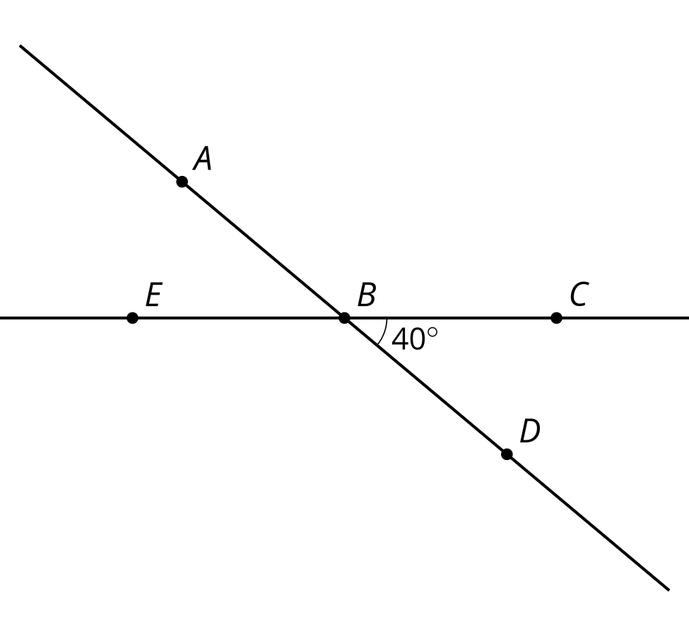
- Select all true statements about the figure.
- 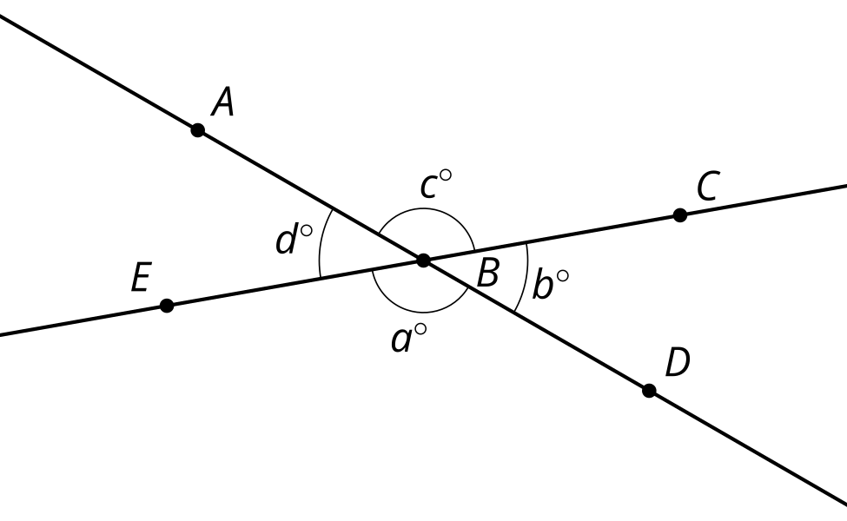
  - $c+b=d+c$
  - $d+b=180$
  - Rotate clockwise by angle $ABC$ using center $B$. Then angle $CBD$ is the image of angle $ABE$.
  - Rotate 180 degrees using center $B$. Then angle $CBD$ is the image of angle $EBA$.
  - Reflect across the angle bisector of angle $ABC$. Then angle $CBD$ is the image of angle $ABE$.
  - Reflect across line $CE$. Then angle $CBD$ is the image of angle $EBA$
- Point $D$ is rotated 180 degrees using $B$ as the center. Explain why the image of $D$ must lie on the ray $BA$.
- 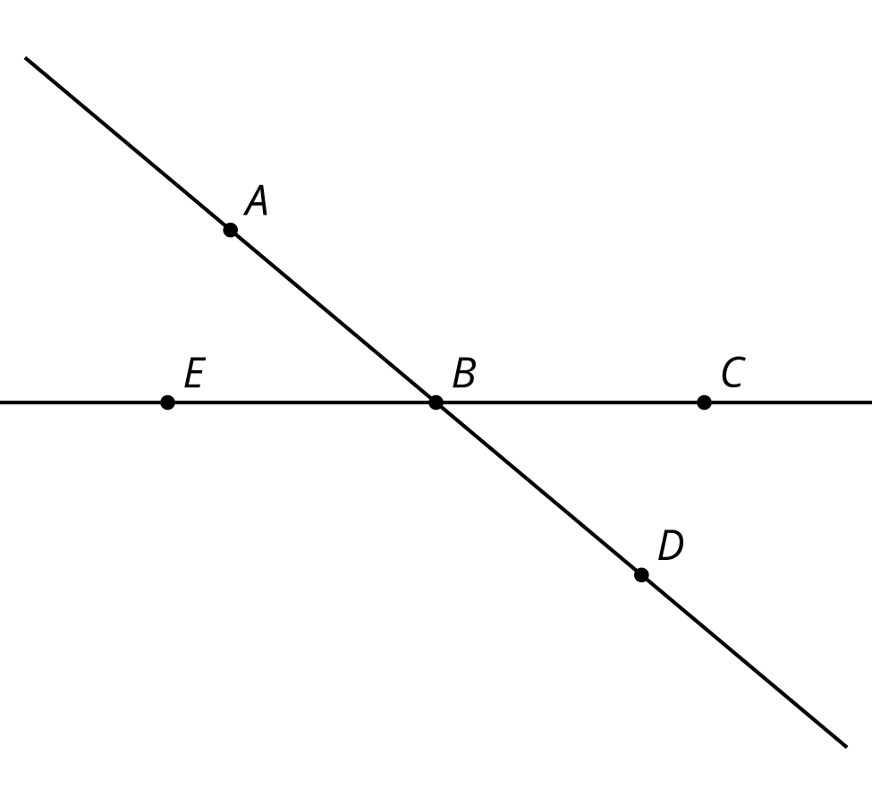
- Draw the result of this sequence of transformations.
  - Rotate $ABCD$ clockwise by angle $ADC$ using point $D$ as the center.
  - Translate the image by the directed line segment $DE$.
- 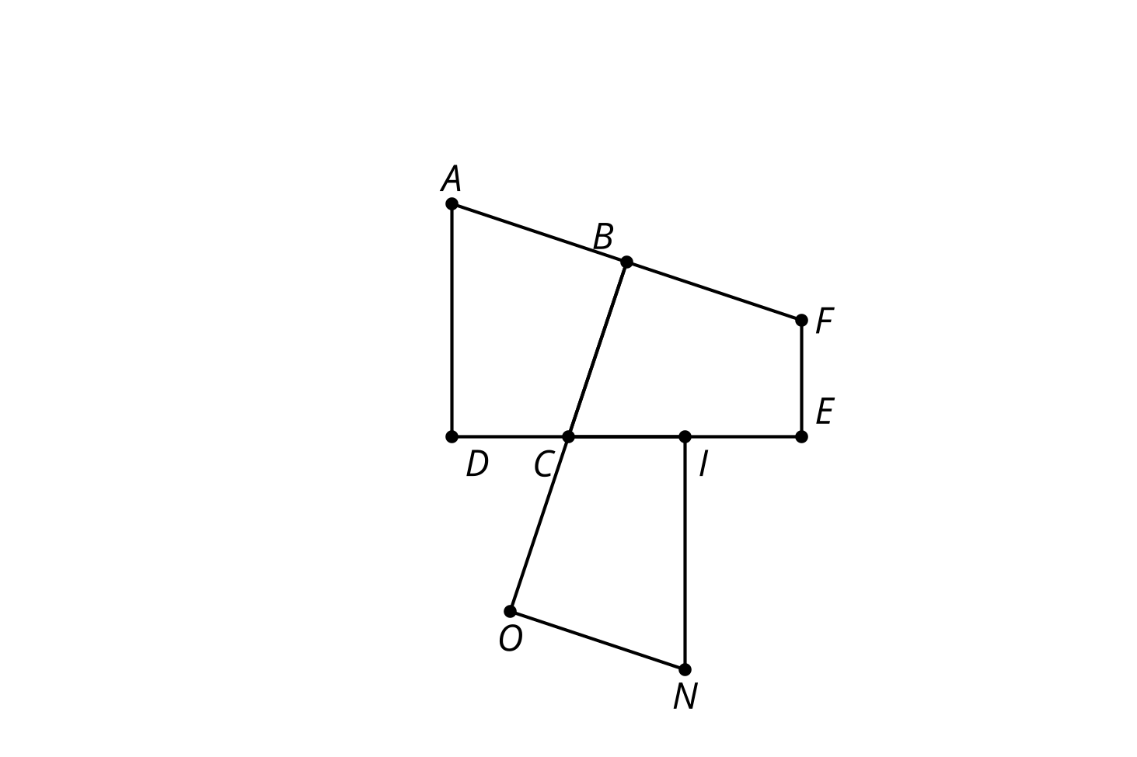
- (From Unit 1, Lesson 18.)
- Quadrilateral $ABCD$ is congruent to quadrilateral $A^{′}B^{′}C^{′}D^{′}$. Describe a sequence of rigid motions that takes $A$ to $A^{′}$, $B$ to $B^{′}$, $C$ to $C^{′}$, and $D$ to $D^{′}$.
- 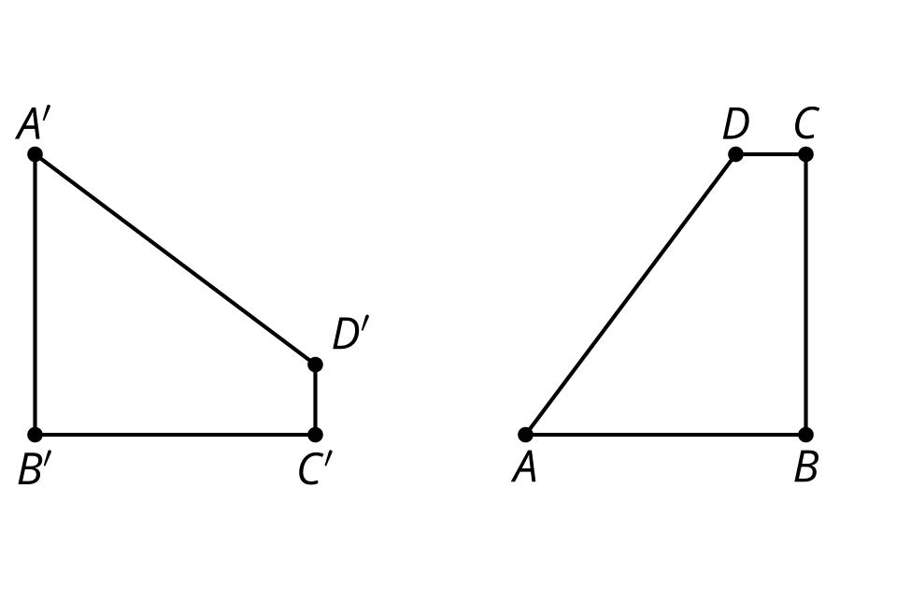
- (From Unit 1, Lesson 17.)
- Triangle $ABC$ is congruent to triangle $A^{′}B^{′}C^{′}$. Describe a sequence of rigid motions that takes $A$ to $A^{′}$, $B$ to $B^{′}$, and $C$ to $C^{′}$.
- 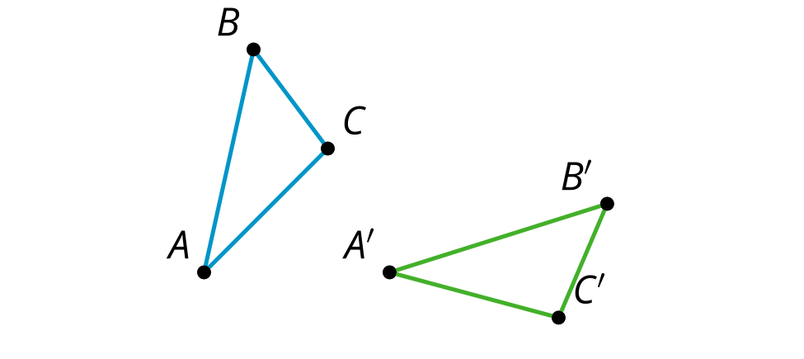

- (From Unit 1, Lesson 17.)
- In quadrilateral $BADC$, $AB=AD$ and $BC=DC$. The line $AC$ is a line of symmetry for this quadrilateral.
- 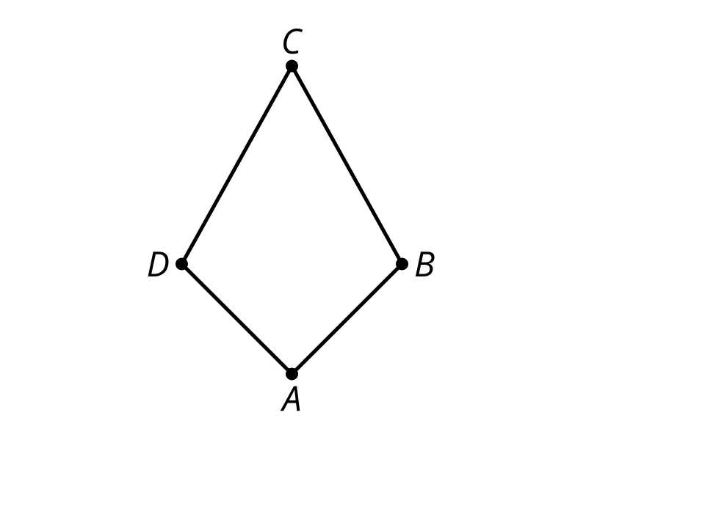
  - Based on the line of symmetry, explain why the diagonals $AC$ and $BD$ are perpendicular.
  - Based on the line of symmetry, explain why angles $ACB$ and $ACD$ have the same measure.
- (From Unit 1, Lesson 15.)
- Here are 2 polygons:
- 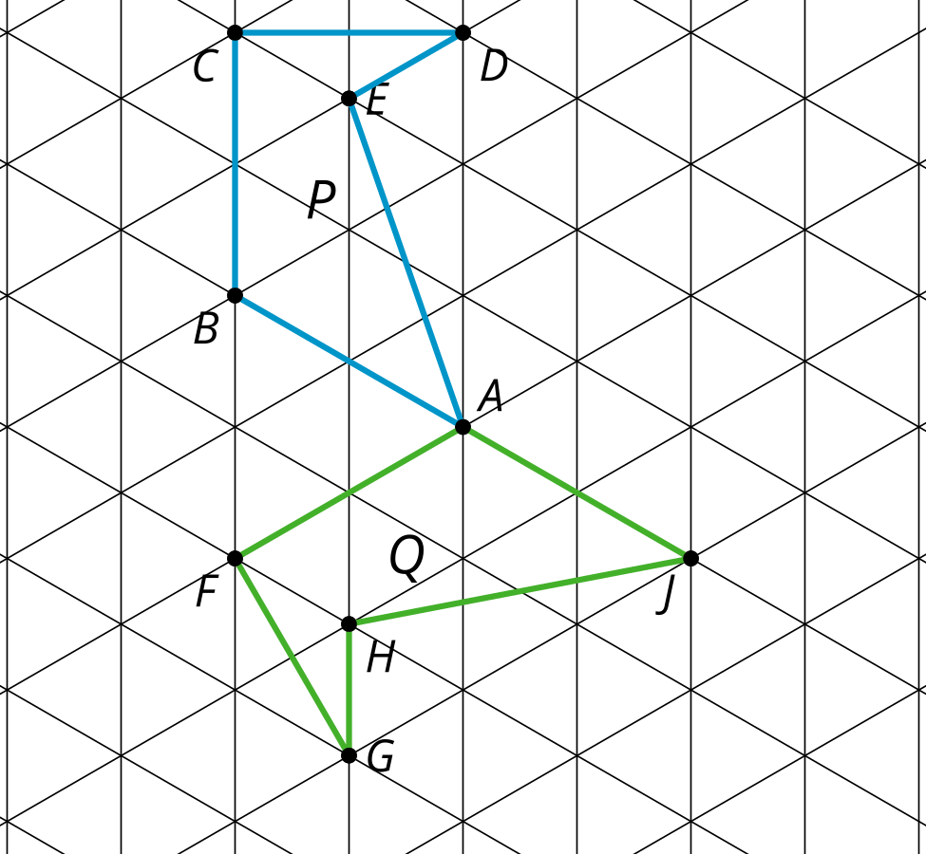
- Select all sequences of translations, rotations, and reflections below that would take polygon $P$ to polygon $Q$.
  - Reflect over line $BA$ and then translate by directed line segment $CB$.
  - Translate by directed line segment $BA$ then reflect over line $BA$.
  - Rotate ${60}^{∘}$ clockwise around point $B$ and then translate by directed line segment $CB$.
  - Translate so that $E$ is taken to $H$. Then rotate ${120}^{∘}$ clockwise around point $H$.
  - Translate so that $A$ is taken to $J$. Then reflect over line $BA$.
- (From Unit 1, Lesson 13.)
© CC BY 2019 by Illustrative Mathematics®

