Unit 7 Lesson 10: Representing Large Numbers on the Number Line

1 Labeling Tick Marks on a Number Line (Warm up)

Student Task Statement
Label the tick marks on the number line. Be prepared to explain your reasoning.

2 Comparing Large Numbers with a Number Line

Student Task Statement
- Place the numbers on the number line. Be prepared to explain your reasoning.
  - 4,000,000
  - $5⋅{10}^{6}$
  - $5⋅{10}^{5}$
  - $75⋅{10}^{5}$
  - $\left(0.6\right)⋅{10}^{7}$
- Trade number lines with a partner, and check each other’s work. How did your partner decide how to place the numbers? If you disagree about a placement, work to reach an agreement.
- Which is larger, 4,000,000 or $75⋅{10}^{5}$? Estimate how many times larger.

3 The Speeds of Light

Images for Launch

Student Task Statement
The table shows how fast light waves or electricity can travel through different materials.
material | speed (meters per second)
space | 300,000,000
water | $\left(2.25\right)⋅{10}^{8}$
copper wire (electricity) | 280,000,000
diamond | $124⋅{10}^{6}$
ice | $\left(2.3\right)⋅{10}^{8}$
olive oil | 200,000,000
- Which is faster, light through diamond or light through ice? How can you tell from the expressions for speed?
Let’s zoom in to highlight the values between $\left(2.0\right)⋅{10}^{8}$ and $\left(3.0\right)⋅{10}^{8}$.
- 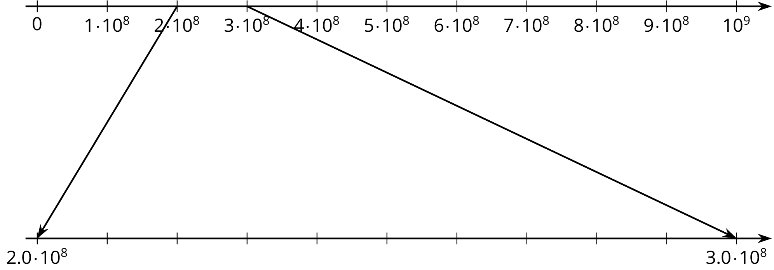
- Label the tick marks between $\left(2.0\right)⋅{10}^{8}$ and $\left(3.0\right)⋅{10}^{8}$.
- Plot a point for each speed on both number lines, and label it with the corresponding material.
- There is one speed that you cannot plot on the bottom number line. Which is it? Plot it on the top number line instead.
- Which is faster, light through ice or light through diamond? How can you tell from the number line?
© CC BY Open Up Resources. Adaptations CC BY IM.

