Lesson 1 Practice Problems
- The Americans with Disabilities Act states that ramps must have an angle less than or equal to 4.8 degrees. Remember, a 4.8 degree angle in a right triangle has a $1:12$ ratio for the legs. Select all ramps that meet the Americans with Disabilities Act requirements.

- Triangle A
- 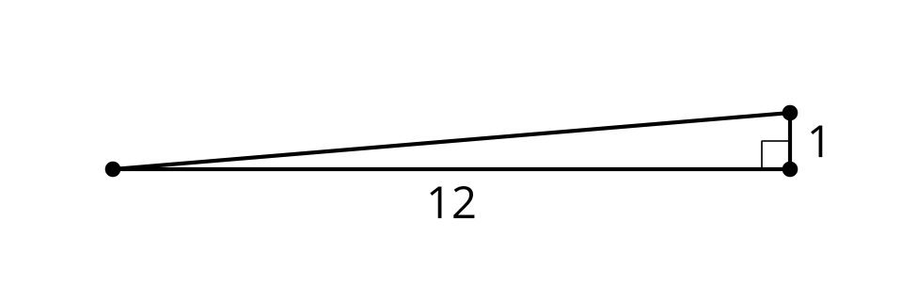

- Triangle B
- 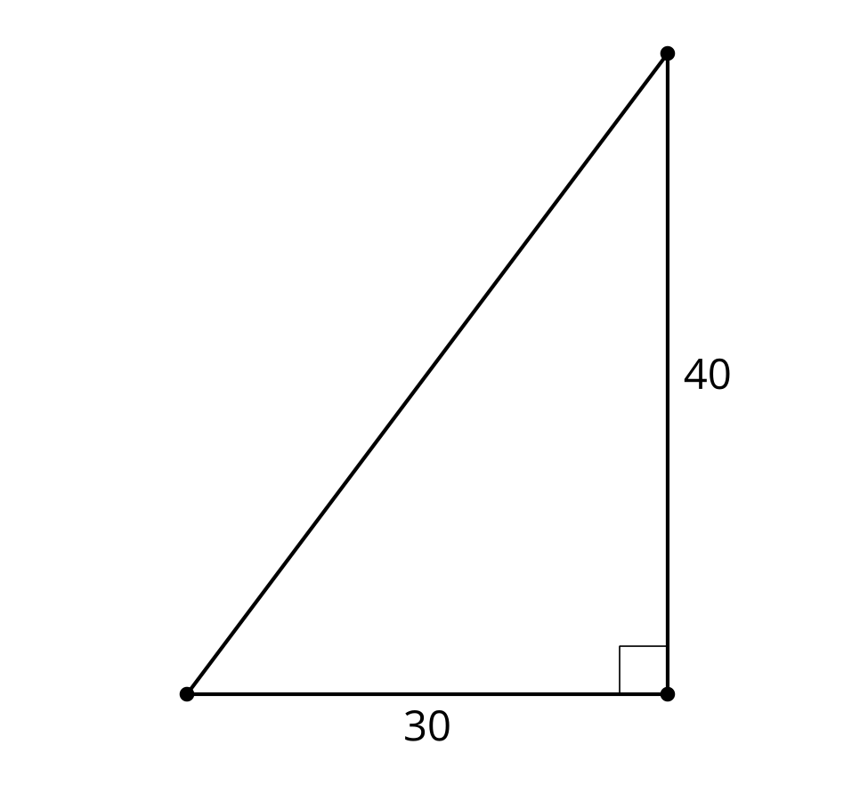

- Triangle C
- 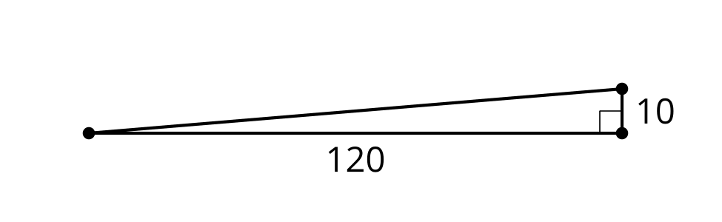

- Triangle D
- 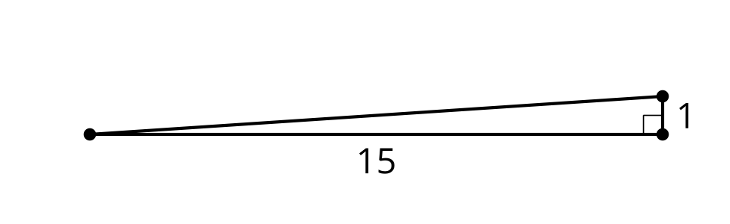

- Triangle E
- 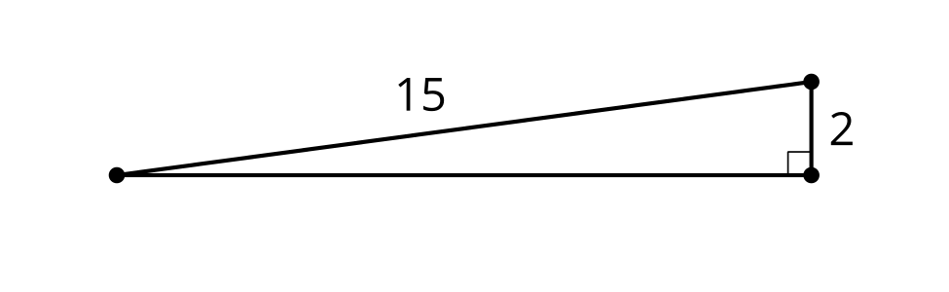
  - Triangle A
  - Triangle B
  - Triangle C
  - Triangle D
  - Triangle E
- Find the missing side in each triangle using any method. Check your answers using a different method.
- 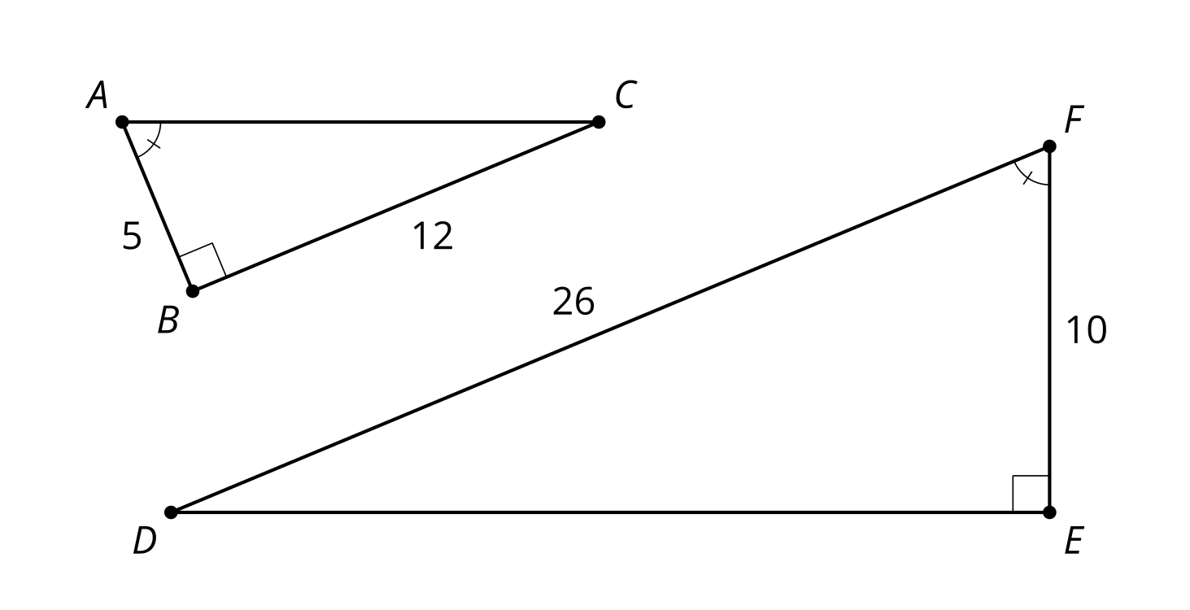
- The Americans with Disabilities Act states that ramps must have an angle less than or equal to 4.8 degrees. Remember, a 4.8 degree angle in a right triangle has a $1:12$ ratio for the legs. Design 2 ramps that meet the Americans with Disabilities Act requirements.
- Kiran is visiting the Statue of Liberty. He wants to test the mirror method of indirect measurement for calculating heights. He is 5.8 feet tall and knows that the Statue of Liberty is 305 feet tall. Sketch a diagram showing where a mirror could be placed to use similar triangles to verify the height of the Statue of Liberty. Make sure to include the distance from Kiran to the mirror and the distance from the mirror to the Statue of Liberty.
- (From Unit 3, Lesson 16.)
- In this diagram, lines $AC$ and $DE$ are parallel, and line $DC$ is perpendicular to each of them. If segment $BD$ has length $\frac{4}{3}$, calculate the length of side $DE$.

- $AC∥DE$, $DC⊥DE$, $DC⊥AC$
- 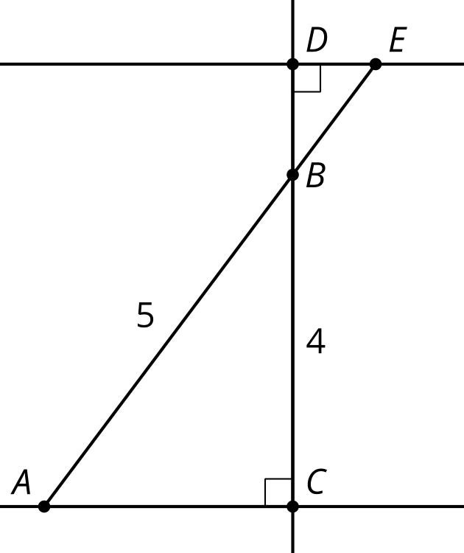
  - $\frac{1}{3}$
  - 1
  - 3
  - 6
- (From Unit 3, Lesson 15.)
- Lin says she has memorized the lengths of a few right triangles, for example, 3, 4, and 5. She is trying to compile a list of several right triangles but needs your help. Find the lengths of at least 2 triangles that are right.
- (From Unit 3, Lesson 14.)
- In triangle $ABC$, the measure of angle $A$ is ${35}^{∘}$ and the measure of angle $B$ is ${20}^{∘}$. In triangle $DEF$, the measure of angle $D$ is ${35}^{∘}$ and the measure of angle $F$ is ${125}^{∘}$. Are triangles $ABC$ and $DEF$ similar? Explain or show your reasoning.
- (From Unit 3, Lesson 9.)
© CC BY 2019 by Illustrative Mathematics®

