Lesson 6 Practice Problems
- Han creates a scatter plot that displays the relationship between the number of items sold, $x$, and the total revenue, $y$, in dollars. Han creates a line of best fit and finds that the residual for the point $\left(12,1,​000\right)$ is 75. The point $\left(13,930\right)$ has a residual of -40. Interpret the meaning of -40 in the context of the problem.
- The line of best fit for a data set is $y=1.1x+3.4$. Find the residual for each of the coordinate pairs, $\left(x,y\right)$.
  - $\left(5,8.8\right)$
  - $\left(2.5,5.95\right)$
  - $\left(0,3.72\right)$
  - $\left(1.5,5.05\right)$
  - $\left(\text{-}3,0\right)$
  - $\left(\text{-}5,\text{-}4.86\right)$
- Plots of the residuals for four different models of the same data set are displayed. Which of the following represents the plot of the residuals from a model that fits its data best?
  - 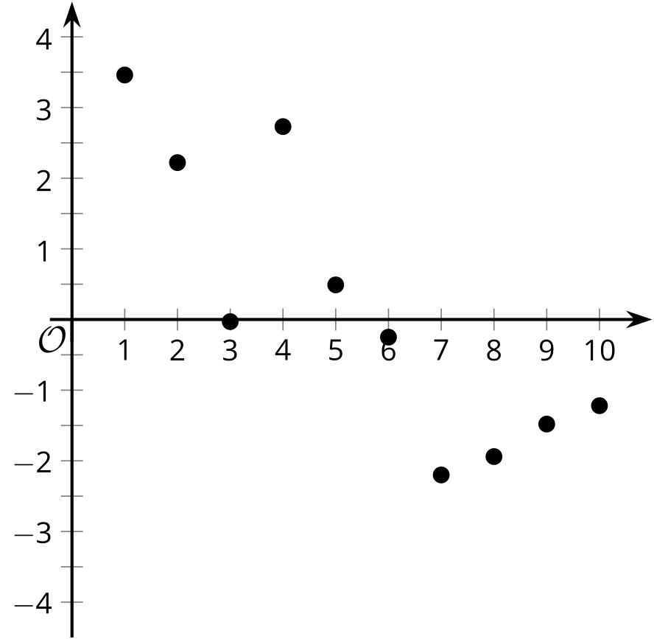
  - 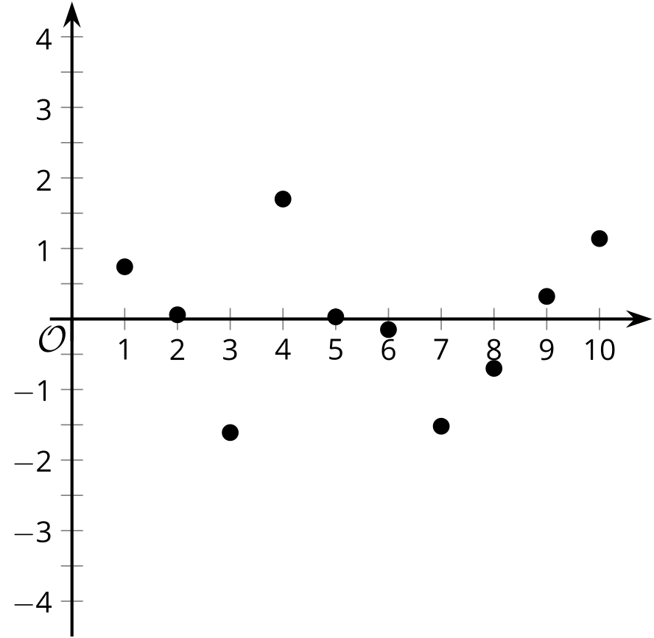
  - 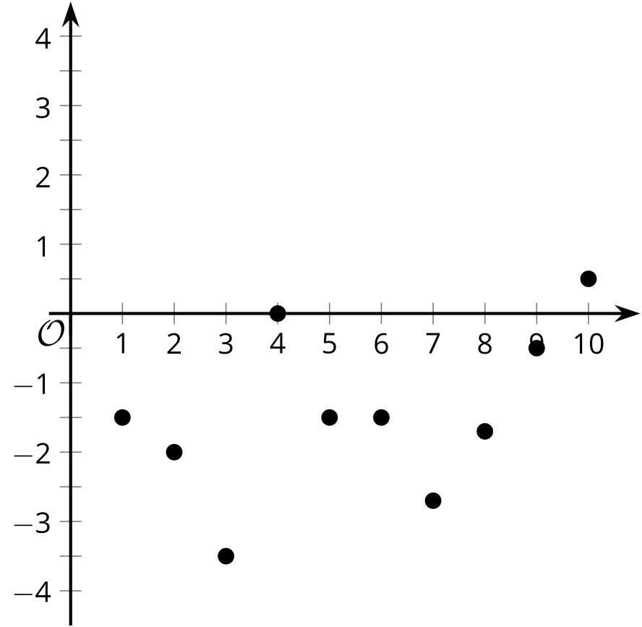
  - 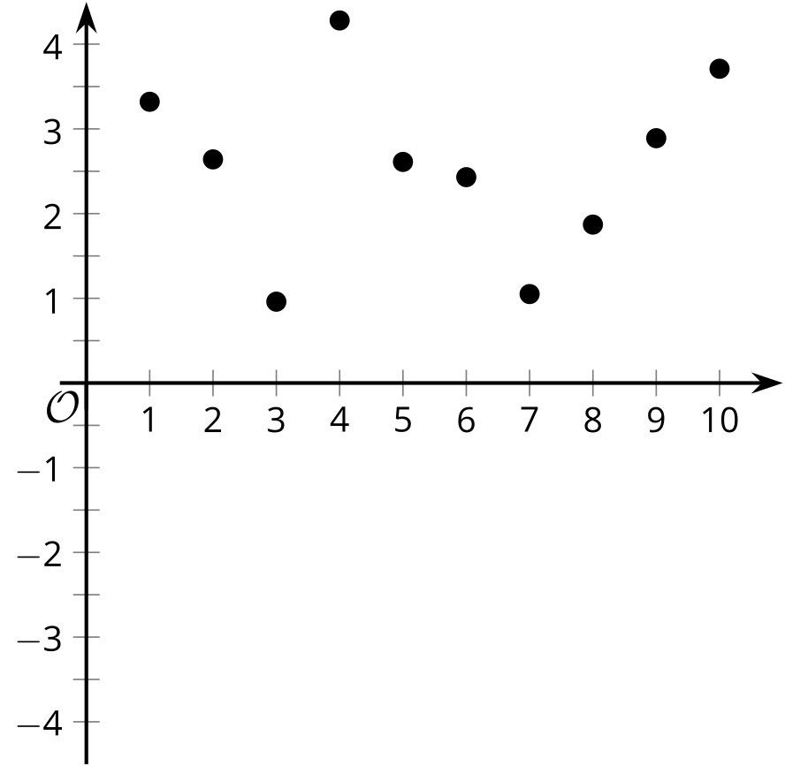
- A local car salesperson created a scatter plot to display the relationship between a car's sale price in dollars, $y$, and the age of the car in years, $x$.
- The scatter plot and the line of best fit are displayed in the graph.
- 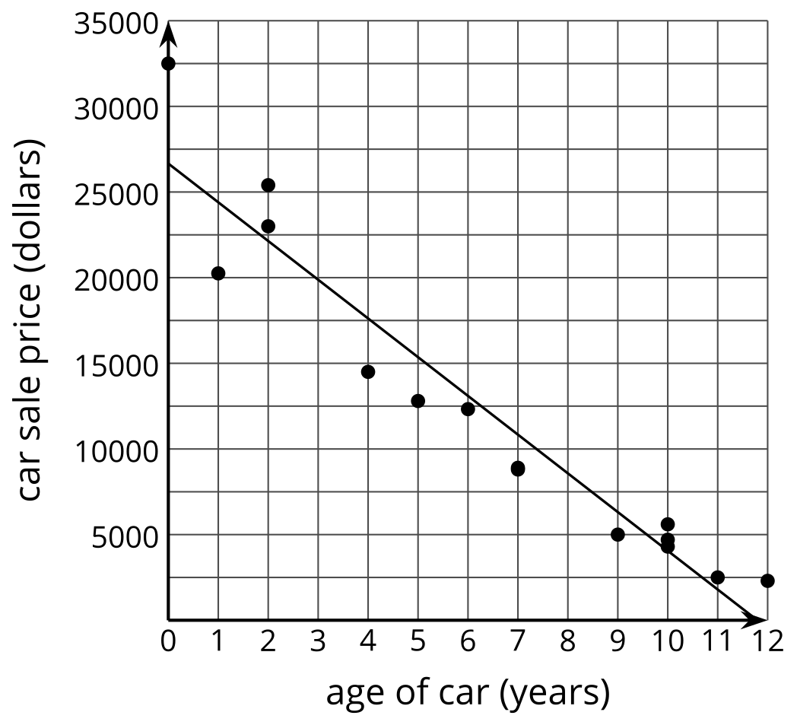
- The car salesperson looks at the residuals for the car sales.
  - For a car that is 4 years old, does the salesperson sell above or below her average selling price? Explain your reasoning.
  - For a car that is 12 years old, does the salesperson sell above or below her average selling price? Explain your reasoning.
- Technology required.
- Data about the outside temperature and gas used for heating a building are given in the table.
- Use a graphing calculator to create the line of best fit for the data.
- temperature  (deg F) $x$ | - gas usage  (therms) $y$
- 58 | - 5,686
- 62 | - 7,373
- 64 | - 5,805
- 67 | - 5,636
- 70 | - 3,782
- 73 | - 3,976
- 74 | - 3,351
- 74 | - 3,396
- 75 | - 2,936
- 73 | - 3,078
- 65 | - 4,549
- 59 | - 7,022
- 58 | - 6,106
- 62 | - 4,566
- 64 | - 4,608
- 67 | - 5,790
- 70 | - 6,501
- 73 | - 3,843
  - What is the equation of the line of best fit for this data? Round numbers to the nearest whole number.
  - What is the slope of the line of best fit? What does it mean in this situation?
  - What does the line of best fit estimate for gas usage when the outside temperature is 59 degrees Fahrenheit?
  - How does the actual gas usage compare to the estimated gas usage when the outside temperature is 59 degrees Fahrenheit?
- (From Unit 3, Lesson 5.)
© CC BY 2019 by Illustrative Mathematics®

